Aim Trainer

1788 – Archie Salmon

Esher Sixth Form College

Contents

Analysis 3

Preface 3

Limitations and constraints 4

Researching Existing Solutions 5

Previous reviews on existing solutions 33

Who is my end user? 38

Preparing for my client 39

My first interactions between me and my client 40

Questionnaires / Online Surveys 43

Score 51

Choice of software 53

Initial UML Planning 59

Player controls 60

Task planning 62

Objectives 66

Documented Design 69

Design Introduction 69

Saving my game 69

Hierarchy Chart 69

Target algorithms 70

Gun algorithms 85

Player Movement Algorithm 92

Complex target movement 94

UML 95

Guns 101

How I intend for the tasks to work 106

UI Initial thoughts 108

Technical Solution 118

Testing 149

Evaluation 165

Comparing my performance against my current objectives 165

Getting feedback from my end user 169

Improvements 172

Appendix 173

# Analysis

## Preface

Creating an effective aim trainer will require preparation and research. To start, I will analyse other popular aim training programs, taking note of what works well and what could be improved. By looking at the strengths and weaknesses of existing programs, I will find areas where I can improve upon my ideas and provide a better experience for users.

In addition to analysing existing programs, I will also engage with my end user during the process of making my aim trainer. By having an end user that is passionate about improving their own aim, they can give me important views into what features and functions they think are most important in aim trainers. Through regular conversations with him and feedback sessions to see what else I may need to include I will improve my aim trainer to better meet the requirements of a good aim trainer.

To further improve the development of my aim trainer, I plan to also include a survey to gather different insights from other people who are interested in aim training. By gaining more feedback from a larger group of people, I can have a better understanding of the features and functionality that are most important. This information will help me make better decisions about what to include in my aim trainer.

## Limitations and constraints

A lot of players struggle with the competitive games online, constantly searching for ways to improve their aim to be able to get an edge on other players. Learning the "meta" of these games, this also may prove to be extremely difficult, particularly for those that are new to playing online games or don’t have skills to win at a high level. An aim trainer can assist with this due to how it can provide users with better aim which will improve their experience in their favourite games.

To solve this problem, I will be working hard to develop an aim trainer that is both efficient and easily available to users of all skill levels. This aim trainer will have many features for all sorts of levels of gamers. I want to help users improve their aim and elevating their gameplay.

In addition to the versatility, I intend for my aim trainer to have, I wish to have, my aim trainer offer a range of customization options to tailor the training experience to each player's specific needs and preferences. From selecting different weapons and tasks to selecting their own crosshair, players will have the ability to create a training program that works best for them.

The aim trainer will also provide detailed analysis of the players stats at the end of the round, allowing players to track their progress and identify areas that they need improvement. This will allow them to see their improvements if they keep playing the task.

Furthermore, I am committed to making this aim trainer accessible for players of all levels. I think that improving your aim should be for everyone and an aim trainer should be available to all who wish to improve their aim when playing video games.

Overall, I am confident that my aim trainer will be useful for players looking to improve their skills. By providing a convenient and customizable way to train your aim, I hope to help players improve their aim and their gameplay and reach the level they seek, improving them along the way.

## Researching Existing Solutions

Before I start to think more deeply about my project I will need to research some existing programs which are similar, I need to figure out what has made them popular, the pros and cons of these programs and also what I want to include in my improved model, so I have gathered multiple screenshots and I will look and analysis them, what I am looking for it the feature for the user that might interest my client the most, such as accessibility feature or general improvements for a better experience for the user.

I have done some research into the following programs:





For some the information I have found on each I have used steam, which is a marketplace of which each of the games reside on.

https://store.steampowered.com/app/714010/Aimlabs/

https://store.steampowered.com/app/1389990/Oblivity__Find_your_perfect_Sensitivity/

https://store.steampowered.com/app/824270/KovaaKs/



**Oblivity:**

**Description:**

Oblivity Aim Trainer is an advanced aim training software developed by Poly Games that was released on March 24, 2022.

The game features a sensitivity finder that helps players find their perfect mouse sensitivity, and an extensive analysis and replay space that detects bad aiming habits. Oblivity provides a realistic simulation of shooting scenarios, offering a variety of weapons and targets to choose from.

One of the most impressive features of Oblivity is its sensitivity finder, which validated the sensitivity preferences of a long-time player who had used a particular sensitivity for 10 years. Oblivity's sensitivity finder helped the player find their ideal sensitivity range quickly, potentially saving them a lot of time.

Users have praised the Poly Games developers as "geniuses" and have called Oblivity a must-have aim trainer. The game's customizable settings and variety of training exercises help players improve their aim, reflexes, speed, and precision. Oblivity is a good choice for anyone looking to improve their aim and accuracy in first-person shooter games.

Why I think my user may be interested:

After looking at oblivity and baring my end users needs in mind, I believe that an aim trainer like Oblivity would fit what they may want. My end user has struggled with using aim trainers previously, but still desires to use them to improve their aiming skills. Therefore, I may take a similar approach to Oblivity, given its really good features and settings that are better than most other aim trainers.

However, it's important to keep in mind that Oblivity presents a vast amount of information, which could be overwhelming to a new user who's unfamiliar with common aiming terminology and methods. As a result, the program's effectiveness may be limited to advanced players and gamers since they may have difficulty interpreting and applying the information to their practice routine.

I suggest adding features like the sensitivity finder and task recommendation system. These could be extremely beneficial to users without a solid starting point in using an aim trainer. The sensitivity finder tool can help users determine their optimal mouse sensitivity settings, while the task recommendation system offers a streamlined approach to target specific areas for improvement. Although this may be too difficult to implement which is why I may not have this included in my objectives later on.

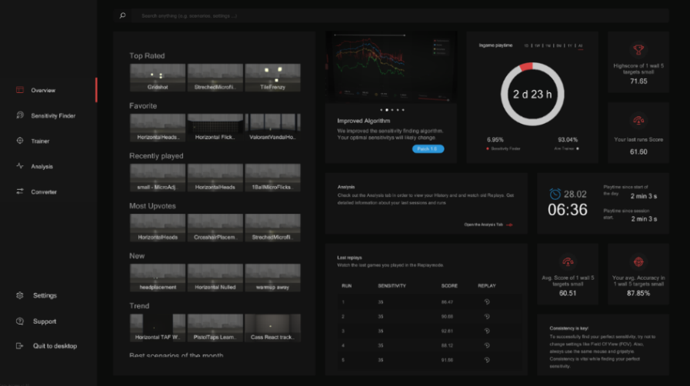

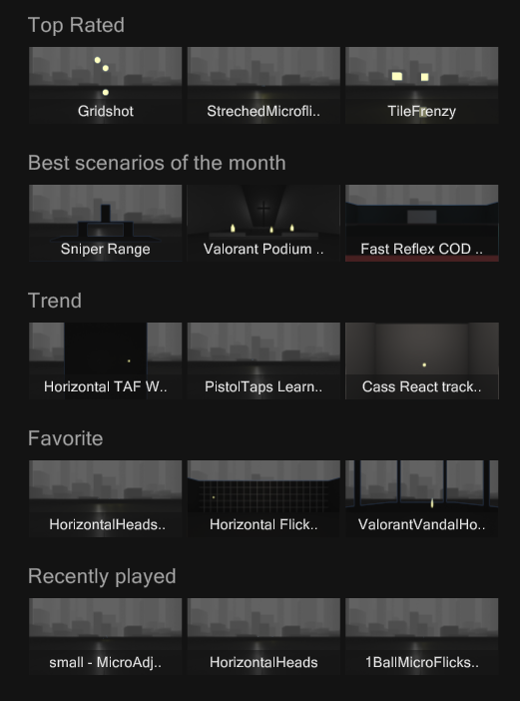

Figure 1.1: Opening Menu Of Oblivity

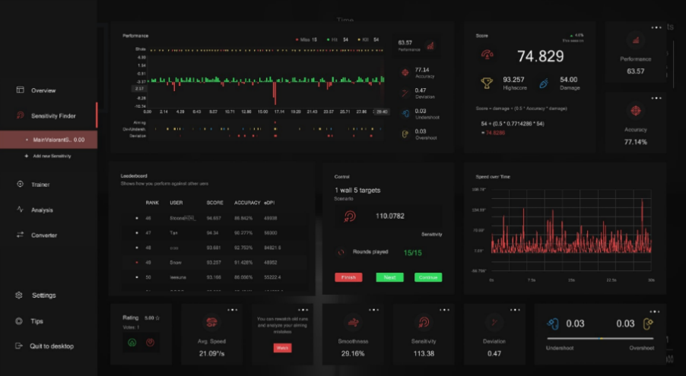

Figure 1.2: Side Tab Screen

Figure 1.3: Post Play View Of Statistics

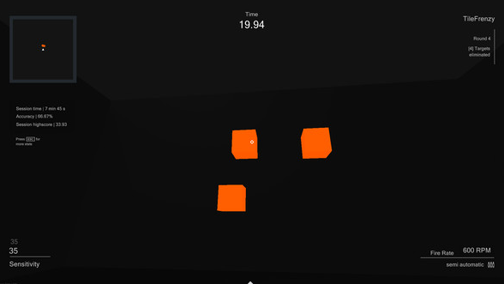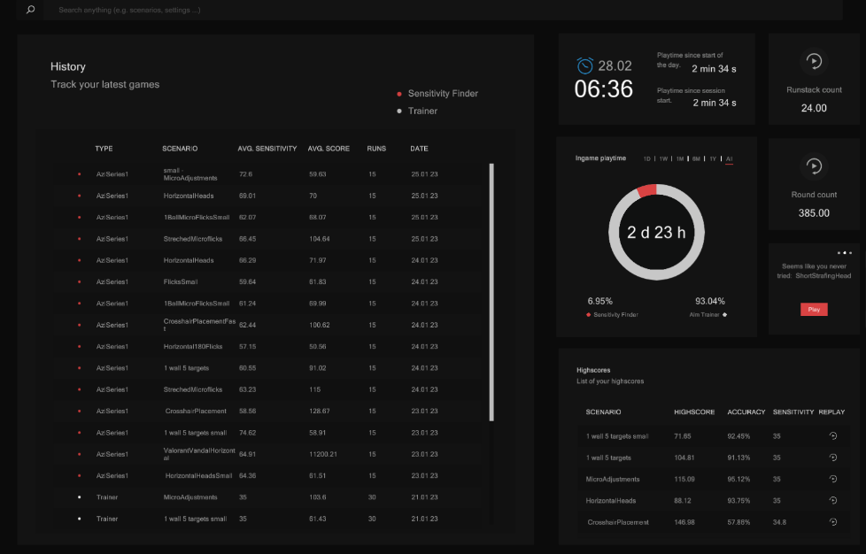

Figure 1.5: In Game UI

Figure 1.4: History Of Past Plays

What I would do similarly:

* The pie chart display allows the user to easily see how much time they have spent on different tasks and areas of improvement.
* Customization options for the targets can provide a more personalized experience and enable the user to group tasks together for easier analysis.
* The graph in Figure 1.3 can provide a visual representation of performance over time or for different sensitivities, helping the user track their progress.
* A tab showing the user's best score can help them identify their strengths and weaknesses more easily.
* The satisfying sound of clicking on targets can improve focus and concentration.
* The tabbed interface in Figure 1.2 allows for easy navigation and organization of different tasks.
* A history feature can help the user track their progress and identify areas where they may need to focus more.

What I would do differently:

* The number of tabs and statistics may feel overwhelming and detract from the user's focus on improving their aim.
* Useless information and clutter on the screen may be distracting and take away from the user's experience.
* Without proper design and user testing, customization options for targets could be confusing or difficult to use.
* The graph in Figure 1.3 may not be useful for all users or may be difficult to interpret.
* The satisfying sound of clicking on targets may be annoying or distracting to some users.
* A history feature may not be necessary for all users or may take up valuable screen space.

My conclusion on oblivity

In my opinion, the aim trainer in Oblivity stands out compared to other aim trainers due to its effective use of visual displays and user-friendly interface. The pie chart display allows users to easily see how much time they have spent on different tasks and areas of improvement, making it easier for them to identify which areas need the most attention.

Another aspect that I appreciate about Oblivity is its customization options for the targets, which can provide a more personalized experience for users. Being able to group tasks together for easier analysis is a feature that I find particularly useful. The tabbed interface also allows for easy navigation and organization of different tasks, making it easy to switch between exercises without losing focus or wasting time.

The graph in Figure 1.3 is also a helpful tool that can provide a visual representation of performance over time or for different sensitivities. This allows users to track their progress and identify areas where they may need to improve.

The satisfying sound of clicking on targets is a small yet effective detail that helps improve focus and concentration. However, I can see how it may be annoying or distracting to some users, so it would be important to provide an option to turn off sound effects.

Although I appreciate the many features and statistics displayed on the screen, I can see how they may feel overwhelming or distracting to some users. Having too much information can take away from the user's experience and make it difficult to focus on improving their aim. The useless information and clutter on the screen could also be simplified or removed to provide a cleaner and more streamlined interface.

In summary, I believe that the aim trainer in Oblivity offers many useful features that can be incorporated into the design of my aim trainer for the end user. While there may be some areas for improvement, such as simplifying the interface and providing more customization options, the overall design and user experience of Oblivity are impressive and effective.



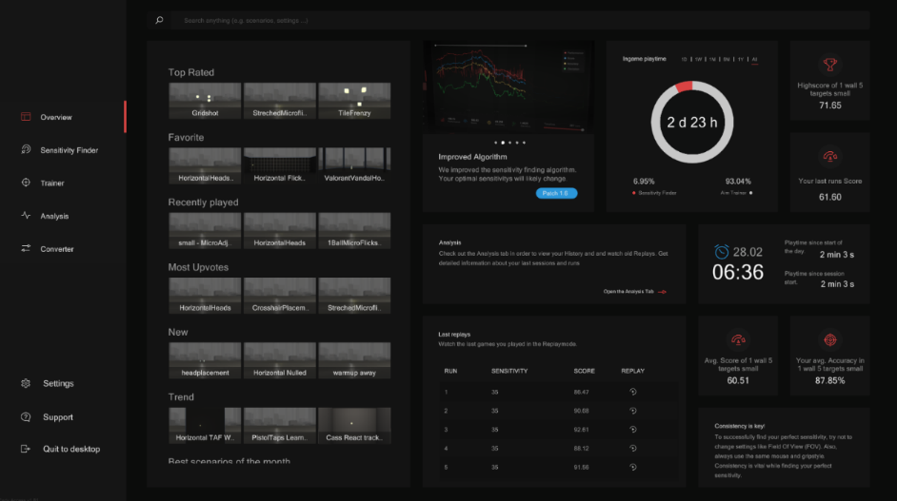

Another feature in the aim trainer is the display of the task name and round number. While this information can be helpful in certain circumstances, such as when completing a playlist, I believe that it may not be necessary for individual tasks. As you click on the task, you should already know which one you are working on. However, it's always good to gather feedback from the end user to see if this feature is important to them.

The time remaining is a crucial aspect of the user interface, as it allows the user to track their progress and adjust their strategy accordingly. I also think it's important to note that each trial is approximately one minute long, which could be the ideal duration for maintaining focus and engagement. However, before finalizing this feature, it would be beneficial to gather feedback from the end user to ensure that the duration is suitable for their needs and preferences.





You can see here all the different tasks they recommend you based on what others found useful or what you have done as the user, I think some sort of algorithm familiar to this would be great to recommend other tasks to help find the right ones and display all the correctly and clearly.



I like how you can see you high score and know what your best sensitivity is for that, some of the information is nice to have and tell the user although too much can make the interface look cluttered up too much and I would like to avoid that in my final design.



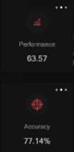

The round rundown is a useful feature for the user as it provides a detailed breakdown of their performance in the just-completed round. By showing how the score was calculated, it allows the user to identify areas where they performed well and areas where they need to improve. This feedback is critical to improving their overall aim, as they can focus on the areas that need the most attention. Additionally, by providing a breakdown of their performance, the user can set more specific goals for improvement, such as improving their accuracy or speed. Overall, the round rundown feature helps the user to better understand their performance and track their progress over time.

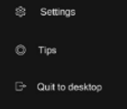

I like how there is a way to find tips, this could ensure the user has help if they need it, also maybe if they need to find something specific throughout the application, they will be able to find it.

This shows you the amount you have spent in your current session, which is the amount of time you spent consecutively on a task, it shows your accuracy which I think is one of the most important things that need to be displayed so you know how well you are doing, and finally your high score that session. I like these features and I think they are the most important, I could add a way to close them and open them such as if you click tab, they disappear and re-appear.

I think this information is not needed as when playing each task this is never a factor you care about or need to know as the standard is normally clicking rather than holding how the button to shoot, I think I will not add this feature to my application.

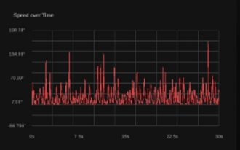

This graph displays your speed over time, allowing you to track your consistency and identify areas for improvement. Consistency is key to improving your aim, and this graph helps you see how well you maintain your speed throughout the trial. Additionally, the data can be used to identify when fatigue sets in, causing a decrease in speed over time. By tracking these patterns, you can adjust your training routine to improve your endurance and ultimately improve your aim.



Seeing your accuracy and score throughout each trial is important to the user as it allows them to track their progress and identify areas where they need to improve. By having a clear understanding of their performance, the user can adjust their training accordingly and set specific goals for improvement. It also provides a sense of accomplishment and motivation when the user sees that their score and accuracy are improving over time. Additionally, being able to compare their performance between different trials or against other users can create a sense of competition and encourage the user to continue training and improving.



The display of scores in comparison to others provides the user with a sense of accomplishment and reward for their performance. In addition to highlighting their rank, the display also presents statistics from their run, such as edpi and accuracy, which can help them identify areas for improvement. This feature can motivate users to continue practicing and striving for better scores.

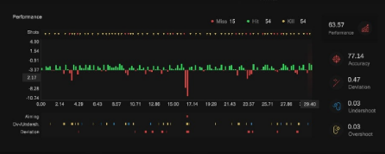

**AimLab:**

**Description:**

Aim Lab is a free-to-play aim training software developed by Statespace that has over 20 million users, including beginners and esports professionals. The software provides users with unlimited scenarios and analysis of their gameplay to optimize their skills for first-person and third-person shooter games. Aim Lab was released in Early Access on February 7, 2018, and is still in development with updates and new features added regularly. The developers prioritize community feedback and have a very interactive relationship with their community through polls, forums, and a Discord community. The full version of Aim Lab will feature more tasks, maps, weapons, customizable physics and behaviours, additional enemy AI behaviours, and more in-depth data visualizations and analysis. Users can improve their FPS skills such as flicking, tracking, speed, perception, and cognition through detailed aim analysis feedback. Aim Lab is a must-have for any FPS player looking to gain a competitive edge, whether they are a beginner or a pro.

Why I think my user may be interested:

I might want to design an aim trainer that is like Aim Lab for a few reasons. Firstly, Aim Lab's compatibility with multiple FPS/TPS games would be convenient for me since I can train my aim for all my favourite games in one place. Additionally, the customization options provided by Aim Lab would allow me to tailor training according to the needs of my clients and their preferences. The detailed analysis and feedback feature would be especially helpful for me to track my progress and identify areas that need improvement. Finally, since Aim Lab is a free-to-play game, it would be an accessible and affordable tool for me to use. If I can design an aim trainer that offers a wide range of games, customization options, analysis and feedback, and is free to use, it would be a valuable tool for me to improve my aim in my preferred FPS/TPS games.

What I would do similarly:

* I want to implement a crosshairs and view feature like the way aimlab has implemented it.
* Clear and simple interface
* Progress tracking system for users to see their improvement over time.
* Bright and visible coloured balls for targets
* Customizable scenarios and playlists
* Ability for users to create and share their own scenarios.
* Wide range of subcategories for different skills
* Custom mode for users to design their own scenarios.
* Ability to search and use playlists made by other users.
* Similarity to other popular training tools like KovaaK's FPS Aim Trainer and Aim Hero

What I would do differently:

* Animations for shooting targets may be distracting and could benefit from an option to turn them off.
* Players model could be distracting and may need an option to enable or disable it.
* In-game background may be too distracting and could benefit from a darker option
* Weapon options may not be necessary for users.
* Lack of clear indication of which round the user is on if they repeat it.
* No information on the cost or availability of the tool for potential users.

My conclusion on AimLab

Aim Lab is an aim trainer that has gained a lot of popularity among gamers in recent years. One of the main advantages of Aim Lab is its compatibility with multiple first-person shooter and third-person shooter games. This is a convenient feature for gamers who want to train their aim for various games in one place. Additionally, Aim Lab provides a wide range of customization options that allow users to tailor their training to their specific needs and preferences. This can be helpful for gamers who want to improve their skills in specific areas such as accuracy or speed.

Another significant advantage of Aim Lab is its detailed analysis and feedback feature. This allows users to track their progress over time and identify areas that need improvement. The analysis and feedback feature also provides users with tips and suggestions to help them improve their skills further. This can be especially beneficial for gamers who want to take their gaming to the next level and compete at a higher level.

On the other hand, there are some potential drawbacks to using Aim Lab. One of these is the lack of realism in some of the scenarios presented. While Aim Lab provides a wide range of scenarios to train in, some of these scenarios may not accurately reflect the gameplay in certain FPS or TPS games. Additionally, the animations used to represent shooting the targets may not be very realistic, and some users may find them distracting.

Another potential disadvantage of Aim Lab is the player model, which may not be necessary for everyone. While some users may find it helpful to see a visible player model during training, others may find it distracting and prefer to focus solely on the targets.

Despite these drawbacks, Aim Lab remains a popular and useful tool for gamers who want to improve their aim. Its compatibility with multiple games, customization options, and detailed analysis and feedback feature make it a valuable resource for gamers who want to hone their skills. Additionally, the fact that it is free-to-play makes it accessible and affordable for anyone who wants to use it. With the right adjustments and improvements, Aim Lab could continue to be a valuable tool for gamers looking to improve their aim in their preferred FPS or TPS games.



Figure 2.1: Leader boards

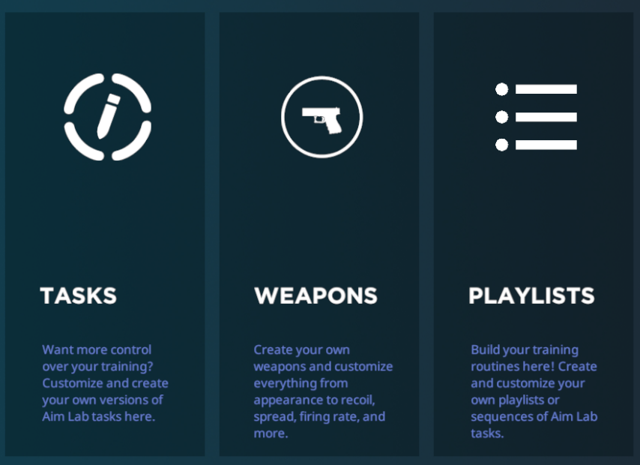



Figure 2.2: Players Options

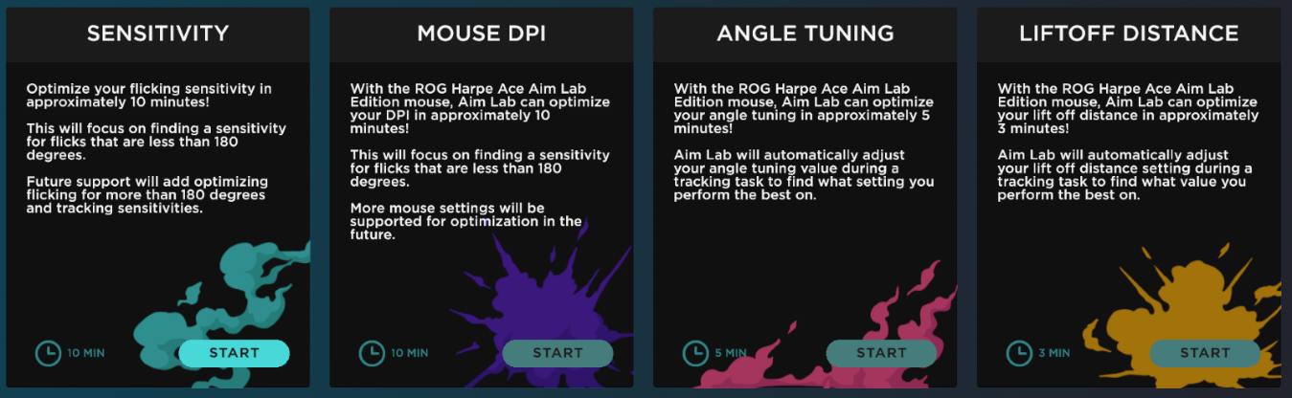

Figure 2.3: Ranked System

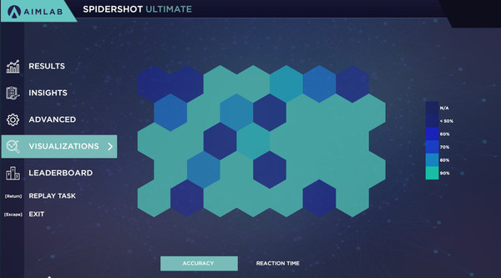

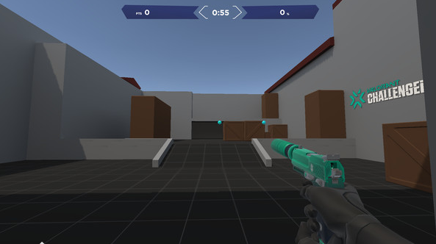

Figure 2.5: More In Game Footage

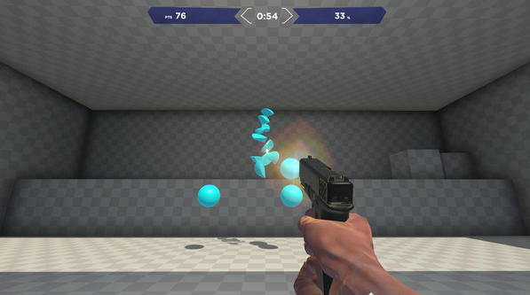

Figure 2.4: Post Round Statistics

Figure 2.6: In Game View

There is a place to see the users’ points go up, which lets them know their progress across the round, although it says the time too it doesn’t show the round they are on if they repeated it, I liked that feature on oblivity.

I do like that also what’s similar from oblivity is that the coloured balls are also bright colours, which is great as you will need to be able to see them clearly, the animations however of shooting the targets could be changed to be better with also settings to turn them off.



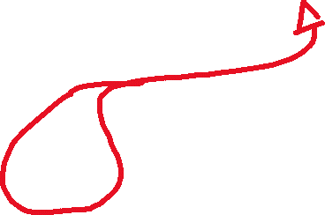

I also can’t forget the players model for example in this you can see it visible but I need to decide on if I want it or not, on one hand it can make it feel a lot more realistic and perhaps make the user feel more included, although its not very necessary and is distracting, perhaps another option for the menu, to have it enabled or disabled.

In Figure 2.5, this is a much more realistic in game related simulation for a game called VALORANT, this is designed specifically for players who dedicated a lot of time into it, I could implement similar things depending on the answers to a survey on which games potential users play the most.

Comparing this to oblivity, I think the interface is much simpler which would give the user a much expectance due to there not being useless statistics around the screen, during playing each round, it has similar features such as the accuracy and the time which are important, but both are at the top of the screen far out of sight from where you user should directly be looking. I do think however the actual place where the player is may be too distracting with the different background but I did notice there is a feature in aimlab and oblivity to change it, I think having a dark background, would be better in comparison, I think having scenarios though to make the player feel like they are in an actual live game would also be good and it would interest them more and be more specific to the game.



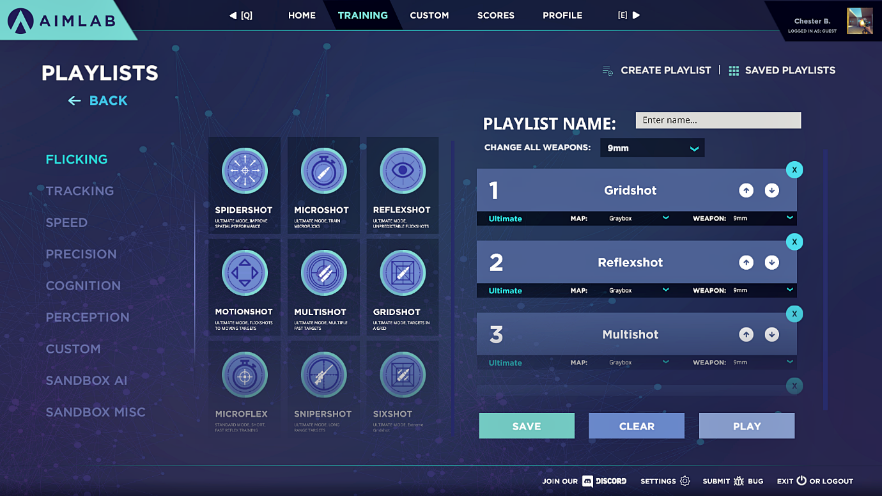

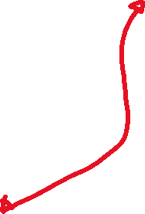

This menu shows all the different types of scenarios on the left side, which allows for a clear view of each task.

You can search playlists previously made, I think the interaction between users is a key thing if many people want to improve, as they will be able to communicate and get their help they want independently.

You can also design a custom playlist, which I think is great if you want to choose specific tasks from each subcategory or build on the skills you want to develop more such as accuracy or speed.

You can also see more at the top, more generalised subheadings for each thing the user might be looking for, I think an interesting concept is having a custom mode allowing the user to design their own scenarios, aim lab has something similar and allows you to share them between users.

**Kovaak’s:**

**Description:**

Kovaak's is a computer game software developed by the company Kovaak, which provides players with a wide variety of aiming and reflex training exercises to improve their skills in first-person shooter games. The software features a range of customizable scenarios, including targets that move and change in size and shape, as well as the ability to create and share custom scenarios with other players. Kovaak's is popular among gamers, particularly in the esports community, to improve their aim and accuracy in games like Fortnite, Apex Legends, Overwatch, and more.

Why I think my user may be interested:

One of the main reasons to choose KovaaK's is the performance it offers. The program is built in Unreal Engine, ensuring the highest possible performance and a smooth, lag-free experience. This means that you can aim train without any delays or interruptions, giving you a competitive edge in your favourite FPS games.

Another benefit of KovaaK's is the authentic game feel it provides. With cloned weapon and movement physics from top FPS titles, you can improve your skills in the game you love, with exact sensitivity matching for a more personalized experience.

KovaaK's also has a partnership with NVIDIA, which provides access to the lowest-level GPU routines, reducing input delay to the absolute minimum. This feature allows for the lowest possible input delay, providing a more responsive and accurate training experience.

Finally, KovaaK's offers infinite flexibility with a new in-game map editor, allowing you to create your own scenarios and customize every aspect of your training. Whether you want to work on flick shots, tracking, or any other aim skills, you can tailor your training experience to your specific needs.

In summary, choosing KovaaK's as your aim trainer can help you improve your skills in a personalized and effective way. With features such as unparalleled performance, authentic game feel, partnership with NVIDIA, and infinite flexibility, KovaaK's is an excellent tool to reach your full potential in your favourite FPS/TPS games.

What I would do similarly:

* Keep the user interface design simple and straightforward, with clear navigation and easy access to features.
* Offer a range of game scenarios, guns, and objects for users to choose from, as this can help them train for specific situations.
* Provide performance analysis tools such as graphs and filters, as these can help users track their progress and identify areas for improvement.
* Include a tutorial or guide to help users navigate the interface and understand the features available.
* Incorporate challenges and leaderboards to motivate users and encourage them to improve.

What I would do differently:

* Consider implementing a feature to group information by different categories, which can help users to find what they need more easily.
* Add more variety to the challenges by incorporating different types of exercises, such as time trials or accuracy challenges.
* Consider allowing users to customize their own playlists or scenarios, giving them more freedom and control over their training.
* Think about incorporating a feature to track and store user data, allowing them to analyse their performance over time and see how they have improved.

My conclusion on KovaaK's

KovaaK's FPS Aim Trainer is another popular aim training software that has gained a significant following among gamers. Like Aim Lab, it offers a range of customization options to tailor the training experience to the user's specific needs and preferences. This includes the ability to adjust the size and speed of targets, as well as the type of scenarios presented. KovaaK's also offers a wide range of presets for popular games, making it easy for users to train specifically for the games they play.

One advantage of KovaaK's is its emphasis on realism in its scenarios. Unlike Aim Lab, which some users criticize for its lack of realism, KovaaK's provides scenarios that more accurately reflect gameplay in popular FPS and TPS games. This can be especially helpful for gamers looking to improve their skills in a specific game, as they can train in scenarios that closely resemble those they will encounter in actual gameplay.

KovaaK's also provides detailed statistics and feedback to help users track their progress and identify areas for improvement. The software offers metrics such as accuracy, reaction time, and speed, and allows users to compare their performance to others through online leaderboards. This can be motivating for users who are looking to improve their skills and compete at a higher level.

However, one potential disadvantage of KovaaK's is its relatively high cost compared to other aim training software. While Aim Lab is free-to-play, KovaaK's requires a one-time purchase of the software. Additionally, some users may find the user interface to be less user-friendly than other aim training software.

In conclusion, KovaaK's FPS Aim Trainer is a popular and effective tool for gamers looking to improve their aim in FPS and TPS games. Its emphasis on realism, customization options, and detailed statistics and feedback make it a valuable resource for gamers who want to take their skills to the next level. While its cost may be a barrier for some users, the investment can be worthwhile for those who are serious about improving their aim. With its continued updates and improvements, KovaaK's has the potential to remain a popular aim training software for years to come.

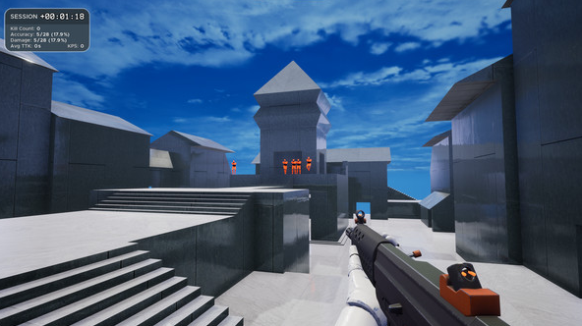

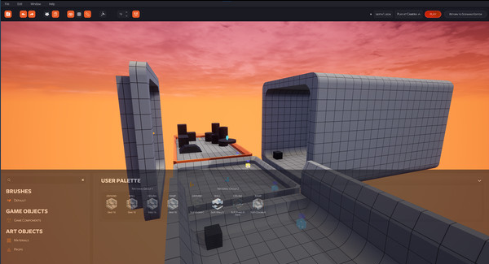

Figure 3.1: In-Game View

Figure 3.2: Task Editor

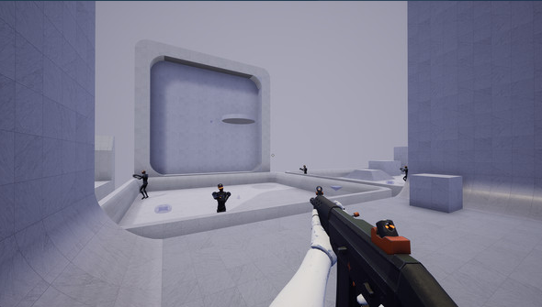

Figure 3.3: In-Game View 2

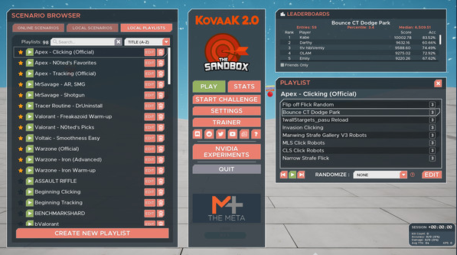

Figure 3.4: Menu View

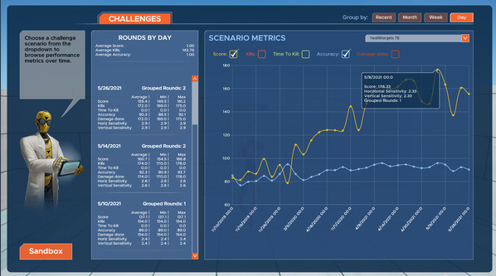

Figure 3.5: Analysis View

There are many different terrains to replicate in game scenarios which have adjacent edges, these are places where the enemy could pop up, I think having this could distract the users but maybe if I had a separate playlist or playlists for game specific scenarios.

Here can see the session time, this is much like how oblivity has done it although in this interface all the information is on one small box, I feel like putting data in closable boxes could be good to implement.





There is a leader board to keep you scores and compare them to other users, which people may want as it’s a way to see how much you have improved by and allows you to compete for better positions. This could motivate the user to further improve their aim. I think this is another feature which will be good to implement.

The names of the playlists have the game or who made them followed by the name of it, this could be provided in another column for more clear navigation, you can also delete the task or edit it, there is also a filter for a-z so you can filter what you want alphabetically, although I could also make a feature to filter by game too.



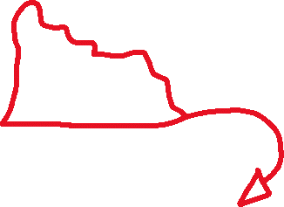

KovaaK’s also has a range of different guns that you can choose from, this is good for times when trying to replicate in game scenarios although I feel if you wanted to only train your raw aim, you might want something simpler in comparison. This really depends on which sort of training the user is looking for scenarios for both sorts should be added to the game.

KovaaK’s has a feature that allows the user to design their own tasks, here we have what props you can use which is a wide range of different things and game objects, this feature is great ensuring the user can find exactly what they want.

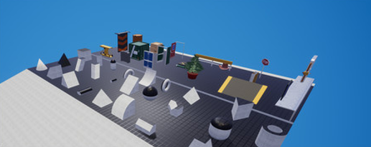

Here you can see more game objects that you can choose from, which include many shapes and sizes, if I made a feature like this, I would need to give the user enough freedom to make exactly what they want.

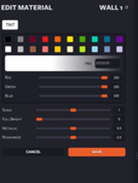

You can also change the colour of each in game object which isn’t really a feature that you need in the editor unless you are making something really specific and detailed, still a good feature to have ensuring the user has enough freedom to do what they want.

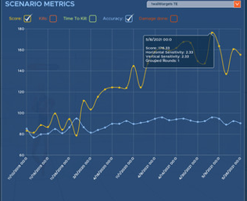

Similar to how oblivity shows your results after the round KovaaK’s shows a graph which represents your performance over time, you can also filter it to the specific information you want to display such as the TTK (time to kill), accuracy and score. This allows you to analyse your gameplay and see what you need to improve on the most which allows the user to have better aim over time.

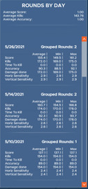

Here you can see the rounds by day and see a similar set of data from the previous screen shot but this is over a longer period of time. Which is more long-term showing the consistencies or improvements that need to be made throughout each task, an algorithm to calculate this could be done and a database to store the user’s information as they log in could also be done allowing then to analyse their own performance, helping them to further improve.



This looks to be a sort of tutorial explaining how the user can navigate, this is important to allow them to understand how to find what they want. This is included in the other aim trainers but not to this extent, I like how KovaaK’s is very user friendly and makes sure you have exactly what you need.

You can also group your information by different category’s, this is a small but very useful feature, it will need to be incorporated somehow.





Challenges can make they player feel more inclined to do more and stay to improve as it will motivate them, I think having various challenges having them be randomly selected each day could be a good feature to implement.

## Previous reviews on existing solutions

As part of my research process, I have taken a comprehensive approach to gather information on potential solutions for my project. Along with exploring the existing solutions, I have also devoted a considerable amount of time to analysing current reviews on several of these solutions. This has been a crucial step in helping me gain a better understanding of what users think about these products, and what features they may prefer over others.

By delving into these reviews, I have been able to uncover valuable insights and observations that are essential for my project's success. I have carefully analysed the language used by the reviewers, paying close attention to their tone and the specific features they praise or criticize. Additionally, I have noted any commonalities or patterns among the reviews to identify the most critical concerns or features that are relevant to my project.

Overall, my review analysis has revealed several common interests and priorities among users. For instance, many users value simplicity and ease of use, particularly when it comes to complex tools or software. They also appreciate customization options that allow them to tailor the solutions to their specific needs. Moreover, reliability and performance are key concerns for users, with many favouring solutions that offer fast and efficient workflows.

In conclusion, my review analysis has been a valuable component of my research process, providing me with a better understanding of user preferences and priorities. By leveraging these insights, I can ensure that my project is aligned with the needs and expectations of its target audience, ultimately leading to a more successful outcome.

Oblivity Reviews

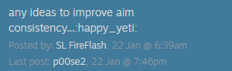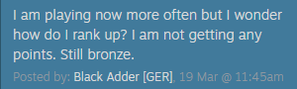

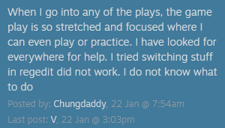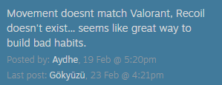

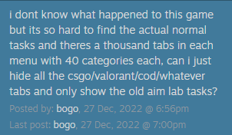

AimLab Reviews

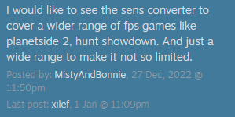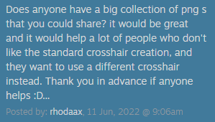

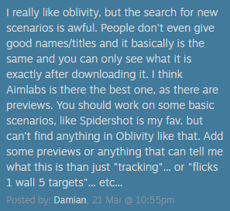

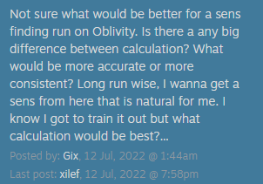

KovaaK’s Reviews

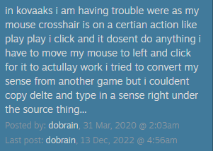

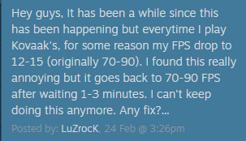

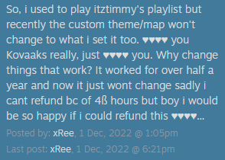

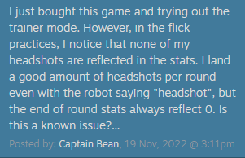

After analysing the reviews of Oblivity, I found that there were several commonalities with other aim trainers in the market. However, there were also some areas of improvement that could improve the user experience. One common concern was the poor navigation of the platform, with users struggling to find what they needed due to a lack of clarity.

In addition, there were also issues with the sensitivity finder/changer not being precise enough and the limited selection of supported games and scenarios. To improve these aspects of the aim trainer, it may be beneficial to implement a more extensive library of supported games and scenarios, along with a more precise sensitivity finder/changer.

Finally, many users also expressed a desire for a wider selection of crosshairs. Adding a library of crosshairs for players to select from could be an easy and effective way to enhance the platform's customization options and improve the overall experience for users.

To summarize, here are some of the key areas for improvement based on user reviews:

* Improve navigation and search function.
* Increase the selection of supported games and scenarios.
* Improve the precision and functionality of the sensitivity finder/changer.
* Add a library of crosshairs for players to choose from.

After analysing the reviews of Aim Lab, several areas of improvement have been identified, including the need for more information on the ranked system, better navigation of tasks, and a more customizable experience.

One common request was for more information on the ranked system, including ways to improve and climb up the ranks. Providing this information in a clear and accessible way would help players understand how to progress and what they need to work on.

Another issue that many users have faced is difficulty navigating the tasks due to a confusing layout. Players want a better way to manage their playlists and have more control over the customization of their experience. Additionally, some tasks do not have a movement system that accurately replicates the movements of certain games, such as VALORANT. Improving the movement system in these tasks could help players prepare more effectively for specific games.

In summary, the following areas of improvement have been identified based on user reviews of Aim Lab:

* Provide more information on the ranked system and ways to improve.
* Improve the navigation of tasks and provide a more customizable experience.
* Implement a more accurate movement system in tasks that replicate specific games.
* Create a more intuitive and user-friendly interface.

After analysing the reviews of Kovaak's, many areas for improvement have been identified. These include the need for a guide to help players find the right tasks for specific games, issues with mouse input and crosshair performance, better tracking of statistics, and improved customization options.

One common request is for a guide or recommendations to help players find the best tasks for their chosen games. This could be a useful addition for players who are looking to improve their skills in specific games and would like a more streamlined way to find relevant tasks.

Another issue that many players have faced is problems with mouse input and crosshair performance, which can impact the accuracy of their aim. It is important to ensure that these aspects of the game are optimized and function well, to provide players with a smooth and enjoyable experience.

Furthermore, players have reported issues with the sensitivity settings not being saved, which can be frustrating. A better way to store players' information and settings could help alleviate this issue.

Tracking statistics is also an important aspect of an aim trainer, and players have reported issues with the accuracy of the headshot tracking. Improving the system to accurately record headshots and other statistics would be beneficial to players who are looking to track their progress and improve their aim.

Finally, players have shown frustration with the customization options for maps, which can be difficult to access or use. Improving accessibility and customization options could help provide players with a more personalized experience.

In summary, the following areas for improvement have been identified based on user reviews of Kovaak's:

* Provide a guide or recommendations to help players find relevant tasks for specific games.
* Optimize mouse input and crosshair performance.
* Ensure sensitivity settings are saved and stored properly.
* Improve tracking of statistics, particularly headshots.
* Enhance accessibility and customization options for maps.
* Addressing these issues could help improve the overall user experience and make Kovaak's a more effective and enjoyable aim trainer for players.

## Who is my end user?

I have always enjoyed shooter games the most among other games. With millions of players worldwide, these games are very popular, it is important for me to design an aim trainer that caters to the needs of shooter game enthusiasts who seek improvement. To ensure that my aim trainer impacts the player performance. I have chosen an end user who is very experienced in these types of games.

My chosen end user is someone I am familiar with he is called ‘Mikhail‘ and goes by the online alias of ‘Demi’, he has spent countless hours playing shooter games, such as VALORANT and Call of Duty. With his experience he has gained over many years of playing, my end user will provide me with valuable insights and feedback that will help me design an aim trainer that is not only engaging but also effective in improving a player's aim.

As I look deeper into the design process, I will work closely with my end user to understand what his specific needs and preferences are. This includes identifying the common challenges he faces while playing shooter games, such as aiming and movement, and exploring ways in which an aim trainer can help him improve these skills.

Furthermore, my end user has already tried several existing aim trainers, such as Aimlabs and KovaaK's. This means that he has a good understanding of what features work and what doesn't. His experience with these aim trainers will help me identify the strengths and weaknesses of each and integrate the best features into my aim trainer.

In summary, by choosing an end user who is extremely experienced playing shooter games, I will be able to design an aim trainer that caters to the specific needs of this genre's players. With his different views and feedback, I can ensure that my aim trainer is both engaging for the player and effective in improving a player's aim.

## Preparing for my client

I have prepared the following questions for my user:

* What features are most important to you in an aim trainer? Are there any specific features from other aim trainers that you particularly like or dislike?
* What kind of targets do you prefer to shoot? Do you prefer static targets or moving targets, or a combination of both? Are there any specific types of targets you would like to see, such as shapes or colours?
* How important is customization to you? Would you like to be able to customize the targets, background, and sound effects? If so, what kind of customization options would be most useful to you?
* What kind of feedback would you like to receive while using the aim trainer? Would you like to see a score or other performance metrics? Would you like to be able to track your progress over time?
* What kind of colour scheme would you prefer? Would you like a dark or light background? Are there any colours that you find particularly distracting or difficult to see?
* Are there any other features or design elements that you would like to see in the aim trainer? For example, would you like to see different modes or difficulty levels, or the ability to compete with other users?

## My first interactions between me and my client

Here I have my first interactions between me and my end user, I was ready to question him on the questions I prepared, I may need to gather more information with a survey to make sure I get any additional data that may not be as relevant to the end user, more generalised things.

Here you can see the following answers from my end-user:

What features are most important to you in an aim trainer? Are there any specific features from other aim trainers that you particularly like or dislike?

I think all aim trainers should have a way to change the difficulty, this is so that depending on that players skill level, they will be able to play the task at a level they are comfortable with.  
What kind of targets do you prefer to shoot? Do you prefer static targets or moving targets, or a combination of both? Are there any specific types of targets you would like to see, such as shapes or colours?

 I think in an aim trainer, it’s great to have both static and moving targets. This is because if they are only static then that limits the range of players that such a program could help, as standing still targets would only help you in tactical FPS games, and even so, it would barely help due to the mechanic counter strafing. this mechanic allows you to change position during your gun fights instead of going for a full-on crouch spray down. You would also need the tracking to practice holding angles wide, as when pre-aiming a person’s peek will never be 100% accurate. For games such as Apex Legends, movement is essentially the bread and butter of the game, and some may argue more important than aiming itself. Practicing tracking opponents is essential for all games that require aiming, anything between Apex Legends, Halo and CS:GO. For shapes of targets, I think it should just either be simply squares or spheres, or maybe an imitation of an actual enemy player in terms of height and width. Colours I don’t think matter that much, but it would be great just as a quality of life to be able to change the colour. 

How important is customization to you? Would you like to be able to customize the targets, background, and sound effects? If so, what kind of customization options would be most useful to you?

I think customising sound and background is probably the not most important, as backgrounds could be distracting, and sounds could get annoying to some people. Targets is optional, but I don’t think it would make much of an impact, being able to change your crosshair would be a cool feature.  
   
What kind of feedback would you like to receive while using the aim trainer? Would you like to see a score or other performance metrics? Would you like to be able to track your progress over time?   
Honestly, many people like to look at their scores in other aim trainers like Aimlabs and care too much about them. I think the main metrics that should be displayed is accuracy and time to kill, as those are the only ones that actually help and matter to improve at the game. I think adding scores per target destroyed would be fine, but if the pure focus of the application is to improve your aim it should purely have ttk and accuracy.

What kind of colour scheme would you prefer? Would you like a dark or light background? Are there any colours that you find particularly distracting or difficult to see?

I personally think that that is a personal preference, but I would love a darker colour scheme. There’s no real benefit or help that a colour scheme would give you but I do think darker is just better.

Are there any other features or design elements that you would like to see in the aim trainer?

As I said previously, I think having a way to change your crosshair is quite important as I believe that it may affect your aim slightly.

Here is the key take away’s I feel I have got from the interview:

1. **Importance of being able to change difficulty:**

* Being able to change your difficulty to match your level is crucial.
* I could have an easy, medium and hard.

1. **Need for both static and moving targets:**

* Static targets alone would limit the range of players that an aim trainer could help.
* Movement is important in many FPS games, and tracking opponents is essential for all games that require aiming.
* Targets could be simple squares or spheres, or an imitation of an actual enemy player in terms of height and width.

1. **Customization options:**

* Customizing sound and background is not that important, as distracting backgrounds and annoying sounds can hinder performance.
* Target customization is optional and may not have much impact.

1. **Performance metrics and progress tracking:**

* Displaying accuracy and time to kill (TTK) are important metrics for improving aim.
* Scores per target destroyed could also be displayed, but the focus should be on TTK and accuracy.
* Tracking progress over time is helpful for setting and achieving goals.

1. **Personal preference for darker colour scheme:**

* No real benefit to colour scheme, but darker is preferred.

1. **Crosshair change ability:**

* Having a way for the user to change their crosshair in game.

## Questionnaires / Online Surveys

To ensure I have as much information as possible I have made up a survey with relevant questions.

Here are the questions:

* How important do you think muscle memory is for improving your aiming skills? (Scale of 1-5)
* Do you find the sensitivity converter feature helpful for building muscle memory of your true sensitivity? (Yes/No)
* How important do you think it is to have both static and moving targets in an aim trainer? (Scale of 1-5)
* Do you prefer targets that are simple squares or spheres, or ones that imitate actual enemy players? (Select one)
* How important do you think customization options are for an aim trainer? (Scale of 1-5)
* Do you find customizing the sound and background helpful in improving your performance? (Yes/No)
* How important do you think it is to display accuracy and time to kill (TTK) metrics in an aim trainer? (Scale of 1-5)
* Do you find displaying scores per target destroyed helpful for improving your aiming skills? (Yes/No)
* How important do you think it is to track progress over time in an aim trainer? (Scale of 1-5)
* Do you prefer a darker colour scheme in the aim trainer? (Yes/No)

I have decided to create these questions based on what my end user has requested in the production of my aim trainer, this should ensure I cover all basis and fully understand the steps I will need to take.

I asked up to 20 people online who play first-person shooters and are familiar with aim trainers to take a survey. The survey asks about various aspects of aim trainers, including the importance of muscle memory and sensitivity, the need for static and moving targets, customization options, performance metrics, and the preference for darker colour schemes. I'm surveying other people because I want to gather different perspectives and opinions on what makes a good aim trainer. By doing so, I hope to improve my aim trainer and make it more effective for its end users.

I have created many charts and graphs to analyse to help have a more visual representation when looking at what data I have. In the following graphs if it’s a how question the options are between 1 and 5, with 1 being the most important and 5 being the least important.

Here are the results:

:

After collecting data from the 20 people I surveyed, it's clear that they place a high value on muscle memory during aiming exercises. This is likely because they prefer to use the same sensitivity settings and are less open to changing them. Of the remaining 13 people, the second and third most important factors were the need for both static and moving targets and the ability to customize the training environment. These findings suggest that many people prioritize consistency in their training and want to practice in an environment that closely mirrors real gameplay. Overall, the data highlights the importance of catering to individual preferences and providing a variety of options for aim trainers to be effective for a range of users.

The data collected from the survey indicates that up to 80% of respondents expressed interest in having a sensitivity converter in the aim trainer. This can be attributed to the likelihood of these individuals playing other games competitively and seeking to maintain their aim consistency across various games.

The survey results indicate that most participants find both static and moving targets to be important in an aim trainer, as demonstrated by the high frequency of responses in favour of option 1 for the question "How important do you think it is to have both static and moving targets in an aim trainer?" This suggests that the players have a strong interest in incorporating both types of targets into their training regimen.

Many participants expressed their preference for targets resembling actual in-game players or circular targets rather than square-shaped targets. This could be because these types of targets are more familiar to them, allowing for better preparation and comfort during training.

People have different preferences when it comes to customizations, such as sound and background. Some people may prefer certain colours or shapes for the targets. With the wide range of individual preferences, it’s hard to come up with a customization that would please everyone. Therefore, it is not surprising that people had mixed opinions on the importance of customizations in the aim trainer. Some may see them as an important feature while others may not find them as necessary.

People want to have features to change the sound and background, likely as they will not want something too distracting and rather have something that interests them more, they also want to be able to feel more comfortable.

The ability to see the time to kill (TTK) and accuracy in-game was identified as important by up to 7 people in the survey. This could be since having access to these metrics allows players to track their progress and identify areas for improvement. TTK can be a particularly important metric in first-person shooter games where being able to quickly eliminate opponents can mean the difference between winning and losing. Accuracy is also a critical metric for developing consistent aim and ensuring that shots are landing where intended. Having these metrics available within an aim trainer can help players to focus on improving their performance in a measurable way.

Just over half of the people surveyed voted to be able to see their score on their screen when completing tasks. This is likely because players enjoy the satisfaction of seeing their progress and improvement over time, as well as having a clear goal to strive towards. However, it is important to note that the focus should be on time to kill and accuracy rather than simply the number of targets destroyed. Additionally, some players may feel demotivated by a low score and may need to be reminded that progress takes time and practice. Overall including a score system can be a useful feature in an aim trainer, but it should not be the sole focus of the training experience in my opinion.

The uncertainty of people on whether to track their score over time could be due to different reasons. It could be that some players may feel that tracking their scores might make them feel more pressured and result in poorer performance. Others may feel that tracking scores can help them set goals and monitor their progress, which can be motivating. Additionally, some players may not be interested in tracking their scores as they view aim training as a casual activity rather than a competitive one. The mixed responses on this question may also indicate that people have different preferences and priorities when it comes to using an aim trainer.

With overwhelming results of ‘yes’, players have expressed a preference for a darker colour scheme in the aim trainer. This could be due to personal preference or the fact that darker colours may provide better contrast and reduce eye strain during long gaming sessions.

Things I may want to add in the development of my aim trainer based of my survey:

* A variety of static and moving targets
* Customization options for targets, sound, and background
* Metrics to track progress, including time to kill and accuracy.
* Score system to provide motivation and goal setting.
* A darker colour scheme for reduced eye strain
* A variety of game modes to simulate different scenarios.
* Replay and analysis features to review and learn from past performance.
* Integration with gaming platforms or tools for seamless practice and tracking
* Access to training resources, such as tutorials or guides, to help players improve their skills.

The interview highlighted the importance of sensitivity conversion and muscle memory for developing aim consistency, the need for both static and moving targets, customization options, performance metrics and progress tracking, personal preference for a darker colour scheme, and avoiding competitive modes between players. The survey results also showed the importance of sensitivity conversion and muscle memory, the need for customization options such as target size and speed, and the usefulness of tracking progress and performance metrics. However, the survey results also showed a preference for gamification elements such as rewards and challenges, and a desire for a more engaging and immersive experience. Overall, both the interview and survey results suggest that an effective aim trainer should focus on providing customizable options for sensitivity, targets, and performance tracking, while also incorporating gamification elements to keep users engaged and motivated.

## Score

In designing the scoring system for the game, I aim to incorporate three key factors that significantly influence the player's overall score. These factors are strategically chosen to enhance the score rewarding system for the players with high precision and accuracy.

Firstly, the base score is determined by a multiplier that varies depending on the type of target engaged. Each target will have two types, a positive and a negative. These will carry their own distinctive impact on the player's score. Some may increase it, while others may deduct points. This dynamic adds an extra layer of challenge and decision-making, encouraging players to make sure they are concentrated on which target they are shooting at before shooting it.

The second factor involves incorporating the player's accuracy into the scoring mechanism. A player's accuracy will be constantly assessed throughout the round after each shot being updated, influencing the score value assigned to each shot. This ensures that players are incentivized not only to act swiftly but also to maintain precision in their actions. Missing shots will result in a diminishing score, emphasizing the importance of careful aim and thoughtful execution.

Lastly, the scoring system considers the spatial accuracy of each shot in relation to the target's centre. This is quantified by calculating the standard deviation from the centre of the target after every shot. Notably, successful hits are prioritized, and the extent of deviation from the target centre plays a pivotal role in adjusting the player's score. Players with more precise aim are rewarded with higher scores, creating a competitive edge for those who prioritize accuracy in their gameplay.

Additionally, in instances where a player successfully destroys a target, the deviation from the centre serves as a crucial determinant. The degree of deviation becomes a pivotal factor in either increasing or decreasing the score, ensuring that players with superior accuracy are not only recognized but also economically rewarded for their skill.

In summary, the scoring system is intricately designed to consider target types, accuracy, and spatial precision. By integrating these factors, the game promotes strategic decision-making, precision, and competitiveness, ultimately enhancing the overall gaming experience for players seeking a balance between speed and accuracy.

The formula to calculate the standard deviation is as follows:

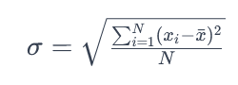

Standard deviation is calculated by taking the square root of the average of the squared differences between each data point and the mean. This measures the spread or dispersion of the data set.

In the case I am using, N which is the number of data points will be the number of shot distances, xi is each data point which will be the shot distances, μ is the mean of the data points.

I intend to implement this by following this pseudocode I have made:

function CalculateDistanceWithStandardDeviation(shotDistances, hitPoint):

if length(shotDistances) <= 0:

return 0

**Calculate the mean (average) distance.**

meanDistance = sum(shotDistances) / length(shotDistances)

**Calculate the sum of squared differences from the mean.**

sumSquaredDifferences = 0

for each distance in shotDistances:

difference = distance - meanDistance

squaredDifference = difference * difference

sumSquaredDifferences += squaredDifference

**Calculate the variance (average of squared differences).**

variance = sumSquaredDifferences / (length(shotDistances) - 1)

**Calculate the standard deviation (square root of variance).**

standardDeviation = sqrt(variance)

return standardDeviation

## Choice of software

Game engines serve as the backbone for creating immersive gaming experiences, managing various aspects such as graphics rendering, physics simulations, sound management, and artificial intelligence. This is why it is important to pick the correct game engine, this will ensure I can complete everything my end user asks of me.

**Here is a list of the key components of a game engine:**

1. **Rendering Engine:** Responsible for generating 2D or 3D graphics, creating the illusion of motion and depth.
2. **Physics Engine:** Simulates in-game movements based on the laws of physics, handling collisions, gravity, and enhancing realism.
3. **Audio Engine:** Manages in-game sound effects and music, creating an immersive audio experience.
4. **Artificial Intelligence (AI):** Controls NPC behaviour and other game elements, using algorithms like finite state machines and neural networks.
5. **Networking:** Enables multiplayer features, allowing players to connect and interact in real-time.

As I will not have networking in my game as it does not require it or make sense to have it in the aim trainer, I do not need to worry about that aspect of the game engine when picking. Likewise with AI as having too complex of algorithms such as complex machine learning is out of the scope of this project therefore will also not be included. The audio aspect is not as important and not a requirement, it will make the game feel more immersive but I don’t think it is needed for my aim trainer.

**Popular Game Engines:**

1. **Unity:** Versatile and user-friendly, suitable for various platforms, with notable games like Monument Valley and Firewatch developed using Unity.
2. **Unreal Engine:** Known for high-quality graphics, robust toolsets, and games like Fortnite and Gears of War.
3. **Godot:** Open-source, gaining popularity for flexibility, ease of use, and suitability for indie game developers.

**Unity**

**I may pick to use unity as it has a wide range of support which are as follows:**

1. **Versatility:** Unity is known for its versatility, allowing developers to create games for a wide range of platforms, including PC, consoles, mobile devices, and virtual reality. This flexibility is useful when developing a wide range of games.
2. **User-Friendly Interface:** Unity also provides an intuitive and user-friendly interface, making it accessible for both beginners and experienced developers. The engine's visual scripting system, known as Unity Visual Scripting, it further simplifies the development process, enabling those without extensive coding experience to create games. This is very useful to me as I will be new to game development, this is good as it will allow me to understand easily and quickly.
3. **Rich Documentation and Community Support:** Unity has a vast and active community of developers, and it offers rich documentation, tutorials, and forums. This allows for there to be plenty of resources online for me to use to help me during development.
4. **Notable Games Developed with Unity:**
   * **Monument Valley:** A puzzle-adventure game that gained widespread acclaim for its unique art style and gameplay.
   * **Firewatch:** A first-person mystery adventure game known for its narrative, visuals, and storytelling.
5. **Asset Store:** Unity's Asset Store is a marketplace where developers can find a variety of assets, plugins, and tools to enhance their game development process. This ecosystem allows developers to save time and resources by leveraging pre-made assets and plugins. This is also super useful as if I need to find something that I may need for visuals I can get it fast without needing to look far, although this may be useful for some games this is not as useful to me as visuals aren’t really that important and based on my end users feedback they don’t mind as much, as long as the games functionality is high.
6. **Regular Updates:** Unity regularly releases updates and new features, ensuring that developers have access to the latest technologies and tools for game development. This will allow me to be making my game on the most up to date systems which is good as this will allow for a smooth game making.

In summary, Unity's versatility, user-friendly interface, strong community support, and notable games developed with the engine make it a compelling choice, especially for someone like me who has no experience in making games.

**Unreal engine**

**I may pick to use unreal engine as of the following reasons:**

1. **High-Quality Graphics and Realism:**
   * Unreal Engine is renowned for its advanced graphics capabilities, providing realistic visuals and high-quality rendering. Although makes it an excellent choice for creating visually stunning and immersive games in my aim trainer this isn’t really that needed as I don’t care about having super insane graphics or effects.
2. **Blueprint Visual Scripting:**
   * Like Unity's visual scripting system, Unreal Engine offers a feature called Blueprint Visual Scripting. This node-based scripting system allows developers to create game logic and functionality without extensive coding knowledge, making it accessible for beginners. This is probably the most important factor for me as I am a beginner, this means that it is a suitable choice for me due to how easy it will be for me as a beginner to use.
3. **Wide Platform Support:**
   * Unreal Engine supports a variety of platforms, including PC, consoles, mobile devices, VR, and AR, just like unity. This broad platform compatibility is beneficial for developers aiming to target diverse audiences but isn’t as beneficial to me as I know the platform which I am making my game on and I do not intend to make it available on different platforms.
4. **Community and Documentation:**
   * Unreal Engine has a strong and active community, contributing to forums, tutorials, and extensive documentation. This wealth of resources can be valuable for learning, troubleshooting, and getting support during the development process. This is like unity having the same options, as I will be new to using this engine if I pick it, this will be crucial.
5. **Notable Games Developed with Unreal Engine:**
   * **Fortnite:** One of the most popular battle royale games globally, known for its vibrant graphics and gameplay.
   * **Gears of War series:** A third-person shooter franchise recognized for its cinematic visuals and intense action.
6. **Marketplace:**
   * Unreal Engine features the Unreal Marketplace, where developers can find assets, plugins, and tools to enhance their projects. This can save time and resources by leveraging pre-made assets, like Unity's Asset Store.
7. **Regular Updates:**
   * Epic Games, the developer of Unreal Engine, regularly releases updates with new features and improvements. Staying up to date ensures access to the latest technologies for game development.
8. **Performance Optimization:**
   * Unreal Engine is known for its performance optimization, making it capable of handling large and complex game environments. This is particularly beneficial for developers aiming to create expansive and detailed game worlds.

In summary, Unreal Engine's emphasis on high-quality graphics, Blueprint Visual Scripting, broad platform support, strong community, and notable games developed with the engine make it a good choice, although I feel like the biggest benefit of unreal engine is its stunning graphics, which is not what I am looking for.

**Godot**

Here are the following reasons on why I may choose Godot over unity and unreal engine:

1. **Flexibility and Open Source:**
   * Godot is an open-source game engine, allowing developers to access and modify its source code. This flexibility is for those who want complete control over their game engine and need to tailor it to specific project requirements. This is far too advanced for me and would not be something I would be doing in my aim trainer.
2. **2D and 3D Rendering:**
   * Godot supports both 2D and 3D game development, making it versatile for various project types. This flexibility is useful for developers who may want to create games in either dimension or a combination of both. I already know that my project will be 3D beforehand, so this flexibility is not as useful to me.
3. **Node-Based Architecture:**
   * Godot utilizes a node-based architecture, where game scenes are constructed using a tree of nodes. This approach simplifies the organization of game elements and facilitates easier development and management of complex game structures.
4. **Built-In Scripting Language:**
   * Godot comes with its own scripting language called GDScript, designed specifically for game development. GDScript is easy to learn and resembles Python, making it accessible for beginners and providing a smooth learning curve. I don’t know if it will be worth my time as a beginner to learn GDScript, I may have to look into it further if I choose this engine.
5. **Community and Documentation:**
   * Godot has a growing and active community, contributing to forums, tutorials, and documentation. While not as extensive as some larger engines, the community is supportive and can offer valuable insights and assistance. Each of the game engines have this in common so I don’t think this is much of an advantage over the rest of the game engines, this is useful to have though.
6. **Ease of Use:**
   * Godot is designed to be user-friendly, and its interface is intuitive. This is beneficial for developers who are new to game development and want a straightforward environment to begin their projects. As a new developer I think this would be the main reason I would choose to use Godot.

In summary, Godot's flexibility, open-source nature, support for both 2D and 3D, node-based architecture, built-in scripting language, ease of use, and regular updates make it a great choice for me.

Out of the game engines I have researched I have chosen to use unity engine, this is as I feel like unreal engine is more orientated around having good graphics and looking nice visuals, that seems like the biggest benefit for using it. For me that is not important, and I think unity will also be better for beginners. I also like how unity has an asset store and I feel like it is used the most widely between the 3 game engines, which will allow me to have more versatility when having to research tutorials and look for help online when making my aim trainer.

## Initial UML Planning

There are 4 main classes, the game manager which will manage the game states, my gun class which manages the things to do with guns, my player class which allows for the player to move and look around, and my target class which will include how the target behaves.

I have drawn a basic UML to show how their connections.

If the game manager doesn’t exist, neither can the player, targets, and guns.

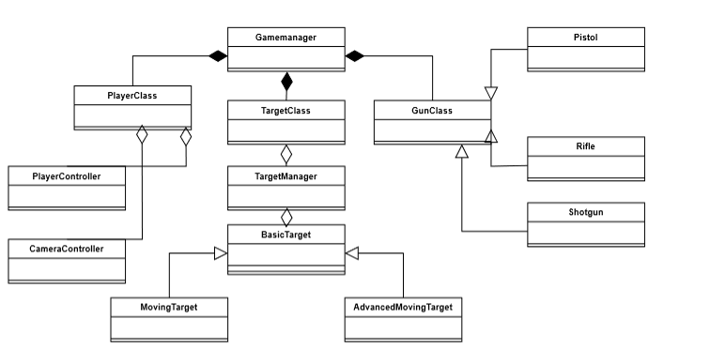

## Player controls

In my aim trainer it is very important I get the controls right, as it’s the main way the player will interact with the interface. To make sure I get this absolutely correct I have asked the user some questions.

I have made sure to highlight my end-user’s answers in a grey tone.

Hello, I have come to ask you some questions about the controls of the user during the aim trainer.

How do you wish for the user to access the gun in the aim trainer?

I want the player to be able to use the number keys for each of the guns, I don’t think there will be too many guns so using the numbers should be fine, although I think it would be cool if you could use the scroll wheel too to change your gun.

Do you want to be able to change the controls in the main menu?

No, I don’t think you need to be able to do that as I feel it will make it feel more like an FPS game rather than an aim trainer.

Do you want to be able to change your sensitivity?

Yes, I think this is very important for an aim trainer, this could be done in the main menu somehow.

Do you want the player to be able to move around?

Yes, as I don’t want the player movement to be too limited, I think you could have some area where the player can move, then have like an invisible barrier stopping the player from leaving it, sort of like a cage. This will make it so that you can't get too close to the targets and cheat.

If the player can move around, are they allowed to jump?

Yes, I think jumping should be allowed.

The main take aways I got from these questions are:

1. **Gun Access:**
   * Allow users to access guns using number keys.
   * Implement the option to switch guns using the scroll wheel for added convenience.
2. **Controls Customization:**
   * Provide the ability to change controls, specifically for gun selection.
3. **Sensitivity Adjustment:**
   * Enable users to adjust sensitivity settings, allowing them to tailor the experience to their preferences. This feature can be implemented in the main menu.
4. **Player Movement:**
   * Allow players to move within a designated area, preventing them from getting too close to targets and potentially cheating. Consider implementing an invisible barrier or "cage" to restrict movement.
5. **Jumping:**
   * Include jumping as a permitted action for added mobility during training.
6. **Main Menu Settings:**
   * Incorporate a user-friendly main menu where players can adjust sensitivity settings and potentially other preferences.
7. **Limited Gun Variety:**
   * Since you mentioned not having too many guns, ensure that the control scheme is straightforward and manageable with number keys and the scroll wheel.
8. **No Control Customization in-Game:**
   * Stick to the decision of not allowing control customization within the game to maintain a focus on the aim training aspect rather than turning it into a traditional FPS game.

## Task planning

In this section I intend to plan how my tasks will work and make choices based on what I think best fits my criteria as well as what seems to be the best approach. Here are my initial thoughts with diagrams.

In this drawing this is the basic layout of how the start of each task will look, there will be a big box of a darker shade which will encapsulate the player and everything in the task, then inside it there will be an inner square, of which the player will be able to move around inside of it, up to the edges, at the edges there will be invisible walls that will keep the player inside and prevent them from moving forward any closer.

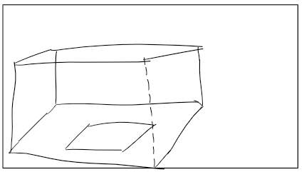

For the way how the player may start the task I have a few options I have thought of initially which I will ask my end-user about later on when finalising the design of the game, one of these options is to have an in game button which you can shoot, then when you shoot it the task will start, there can be multiple so that as the user you can select the specific task and select the difficulty you may want. This will allow you to customise the task you are about to play before playing it in the actual game itself, which may be how my end user wants it.

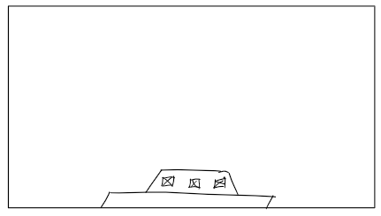

Although alternatively the player could also start the round by shooting a white coloured ball, this would get them facing the right direction and it would also be easy for them, the implications of this method of starting the task this way would mean that the player would have to select the task they are going to play before hand, this could be done in the main menu. If my end-user wants the task to be selected in the main menu anyways this shouldn’t be much of an issue. Another issue of starting the task this way would be that it may not be clear at first why the white target is there and may need to be explained prior. Depending on how the player may interpret the white target will mean that there could be many things the white targets could be.

In the same direction as the way to start the task, if that’s either the white target or internal buttons, there will be a maximum and minimum x, y and z position. Inside this zone the target can spawn.

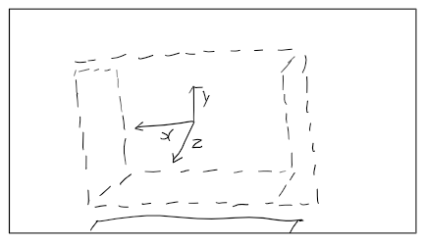

I also intend to have different types of targets; these can include negative and positive targets. They will be distinguished by their colour, with red being a negative target and blue being a positive target. What I want is for the targets to have chances to spawn which will be random, these include the red negative targets having a 20% chance to spawn in and the blue positive targets having an 80% chance to spawn in.

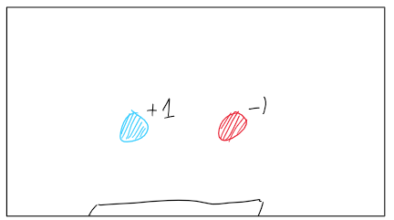

How I want to manage the difficulty is to change the size of each target, with hard being the smallest and easy being the biggest. There will be 3 options to choose from, hard, normal, and easy.

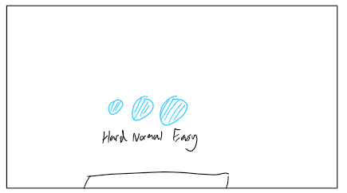

I intend to have 3 different types of targets, I will have a static one, which will be the base targets that all the targets will act like, on top of that I will also have a moving target, this will be just basic movement where the target will move from point A to point B seamlessly at a constant speed. I also may implement an advanced moving target, this will include as well as just moving in the x axis like the basic moving target, I will include movement in the x, y and z. This will make it more difficult to shoot, I also plan to implement a way for the targets speed to change during its movement.

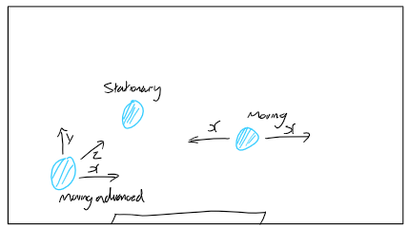

I also plan to add a health bar to each of the targets, this will be a component that each of my targets will have, this will signify the health change, if the user’s gun doesn’t do enough damage to destroy the target, it will show half the targets health. After a time has passed, I intend for the targets health bar to disappear. I also want a way for the target to know when to reset position, this will be when the targets health reaches zero, by default I want the targets position to change after a time has passed, I also want its type to be reset as well. I can do this by having the health decrement over time then when the health reaches zero it gets reset and the player gets no points. I can also just have it reset regardless after two seconds although this would mean the player will have no indication on when the target will be reset which may cause confusion. I think it will be better to have it just reset after two seconds as it doesn’t make sense for the health to diminish over time, and that may change the final score of the user, as each target will have lower health the longer, they are active.

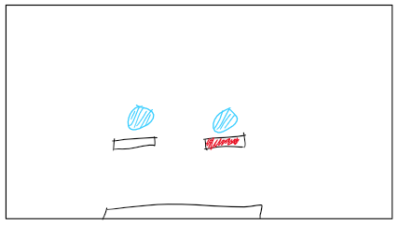

## Objectives

I have made myself some objectives to follow to allow me to meet the criteria needed, for my end user, here are my initial thoughts:

**Game Scenes and Objects Objectives:**

1. **Guns Attributes:**
   * 1.1. Define the physical element of the gun with a GameObject prefab.
   * 1.2 Specify the rate of fire (fireRate) in shots per second.
   * 1.3 Integrate recoil attributes:
     + 1.3.1 recoil: The overall kickback experienced by the gun.
     + 1.3.2 recoilX, recoilY, recoilZ: The individual x, y, z axis recoil after each shot.
     + 1.3.3 aimRecoilX, aimRecoilY, aimRecoilZ: ADS-specific recoil on x, y, z axes.
     + 1.3.4 Have the gun experience different return speeds, based on the gun.
     + 1.3.5 After the recoil have the gun have a variable for reseting recoil.
   * 1.4 Design recoil spray pattern for all guns.
2. **Bullet Attributes:**
   * 2.1 Set the speed of bullets in m/s.
3. **Aim Mechanism:**
   * 3.1 Determine how fast the gun aims in (aimSpeed).
4. **Additional Gun Feature (Rifle Specific):**
   * 4.1 Have burst and automatic gun types.
   * 4.2 Specify the gap between each burst (burstgap).
   * 4.3 Define the number of shots fired in a burst (numberOfShotsPerBurst).
5. **Additional Gun Feature (Shotgun Specific):**
   * 5.1 Integrate a float attribute for the spread.
   * 5.2 Define the number of bullets fired on each shot (bulletsPerShot)Targets
6. **Static Targets (Target Behaviour):**
   * 6.1 Targets stay stationary.
   * 6.2 Targets have a lifetime value you and resets when it reaches zero.
   * 6.3 Targets reset on destruction with bullets, updating the score.
   * 6.4 Targets have a chance to be red or cyan, effecting their base score worth.
7. **Basic Moving Targets:**

* 7.1 Targets move predictably left or right within a specified range.
* 7.2 Targets reset after an amount of time.

1. **Advanced Moving Targets**

* 8.1 Targets have an advanced movement pattern influenced by exponential speed.
* 8.2 Speed increases exponentially, creating acceleration and deceleration.

1. **Each Target Attribute:**

* 9.1 All targets have a health attribute.
* 9.2 Each target has a size that can be changed when increasing the difficulty.

**UI**

1. **Crosshair Changer:**
   * 10.1 Provide an option in the main menu to change the crosshair.
   * 10.2 Include a selection of crosshair styles for players to choose from.
   * 10.3 Ensure the chosen crosshair is reflected in the game.
2. **Exit Button:**
   * 11.1 Implement an exit button on the main menu.
   * 11.2 Provide a confirmation prompt before exiting to prevent accidental exits.
3. **Pause Button:**
   * 12.1 Include a pause button during gameplay.
   * 12.2 Ensure the pause button effectively halts the game.
   * 12.3 Implement a menu overlay when the game is paused, offering resume and exit options.
4. **UI Menu for Starting Tasks:**
   * 13.1 Design a UI for selecting and starting tasks.
   * 13.2 Include options for different tasks.
   * 13.3 Include options for different difficulties.
5. **HUD (Crosshair, Score, Accuracy):**
   * 14.1 Implement a HUD that includes a crosshair.
   * 14.2 Implement a HUD that includes a score, updating in real time.
   * 14.3 Implement a HUD that includes accuracy, that updates in real time.
6. **Timer Display:**
   * 15.1 Display a timer on the HUD during tasks.
   * 15.2 Clearly show the time remaining or elapsed time.

Feedback from my end-user

I shared these objectives with my end user, ‘Demi’, and asked for their feedback. It is important to incorporate their input to ensure that all their needs and expectations are met. I want to make sure that nothing is missed, and my aim trainer meets all of his needs. So, I asked the following.

Hello, I have created some objectives for my aim trainer based on the information you have given to me and prior research, is there any I have missed or any improvements you can make to this?

For the most part you have included everything I want, I do want the player to be able to move and I don’t know if you need it or not but maybe an objective on looking around would be nice just as a reminder. I want the player to be able to jump and move in all directions in a specified area. I also want all the statistics to be displayed at the end of the task.

Based on my users feedback I have added player-based objectives to ensure the player will be able to move and look around.

Here are the objectives I have added:

**Player Movement Objectives:**

1. **Implement basic player movement:**
   * 16.1 Allow the player to move forward, backward, left, and right using the WASD keys.
2. **Enable jumping:**
   * 17.1 Implement a jump mechanic.

**Camera Movement Objectives:**

1. **Implement free-look camera movement:**
   * 18.1 Allow the player to freely move the camera in all directions using mouse input.

**Camera Movement Objectives:**

1. **End game screen**
   * 19.1 Implement an end game screen, which will display all the statistics throughout the round.

I have also added the following extension objectives:

* A player can save their game and save their progress they have made throughout the task to a file.

# Documented Design

## Design Introduction

In this section my main goal is to explain different processes and algorithms, I intend to do this by showing UMLs of my classes, flowcharts of processes or how my algorithms work, and pseudocode of how my algorithms work. I also intend to show my UI and how I changed it to fit my end-users needs. The main parts of this section I will do also include functionality of my game such as where and how my targets will behave. The UI I will make will be simple as it is not the main focus of my project, I will show the OOP and how I intend to save my games progress.

## Saving my game

If I were to proceed with saving the game locally on the player's system, I would leverage Unity's serializable classes to facilitate the conversion of data into either JSON or binary files. Using this approach, the game's state, as well as player-specific data such as high scores, could be efficiently stored. The serialized data could then be saved in binary files, adding a layer of security against potential player alterations. It's worth noting that, due to the single-player nature of the Aim Trainer, the complexity of implementing a database layer seemed unnecessary.

As an extension objective, I would consider implementing a mechanism to save and load player scores, emphasizing that this feature is not crucial for the fundamental functionality of the game. If time permits after completing other essential objectives, I will explore adding this as a cool and additional feature to enhance the overall user experience.

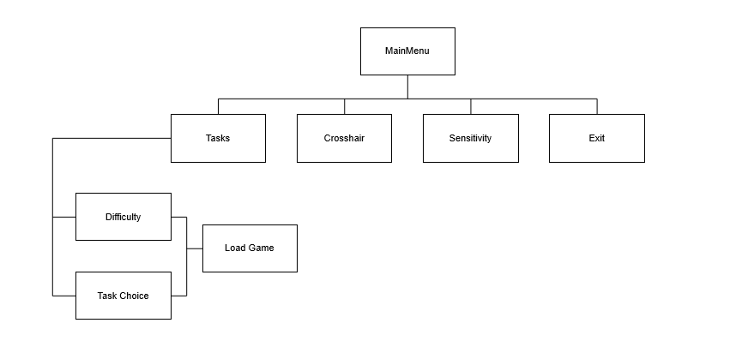

## Hierarchy Chart

Here is a hierarchy chart of how my main menu will work:

## Target algorithms

In this section, my focus is on the implementation strategy for managing and controlling targets in the aim trainer. To achieve this, four key scripts have been designed. These scripts are named TargetManager, TargetBehaviour, MovingTargetBehaviour, and AdvancedTargetBehaviour. Together they show the behaviour and dynamics of targets within the game environment. These scripts show my approach to target management, ranging from instantiation to advanced movement patterns, contributing to the complexity of the aim trainer.

Here is a summary on what each script does:

TargetManager Script

The TargetManager script is responsible for managing the instantiation and destruction of targets within the aim trainer game. Acting as an object pooler, it keeps track of the number of active targets, controls timers for enabling targets, and handles the initialization of targets based on the game's task type. The script uses Unity's serialization to create an array of target prefabs, including static, moving, and complex targets. Through methods such as TaskInitialisation() and TargetManagement(), it dynamically adjusts the game's targets based on the selected task, ensuring a responsive and engaging gaming experience.

TargetBehaviour Script

The TargetBehaviour script serves as the foundational class for various target behaviours within the aim trainer. Featuring fields that define target characteristics, scoring mechanisms, and spawn positions, this script sets the groundwork for target functionality. The methods in this script, such as InitialiseTarget() and ResetTarget(), handle the initialization and reset processes, ensuring targets are appropriately configured and positioned. Additionally, the script incorporates collision detection logic, calculating scores based on accuracy, player performance, and target properties.

AdvancedTargetBehaviour Script

Building upon the MovingTargetBehaviour script, the AdvancedTargetBehaviour script introduces advanced movement patterns to targets. Leveraging an exponential speed function, this script allows targets to accelerate and decelerate in a more dynamic manner. By overriding the MoveTarget() method, the script implements a sophisticated movement algorithm, providing a higher level of challenge for players aiming to enhance their aiming skills. This script contributes to the diversity of target behaviours in the aim trainer, ensuring a varied and engaging training experience.

Now I will begin to explain the pseudocode I have made, here is how I expect the target manager to work:

**Explanation:**

* The class TargetManager has several fields representing variables related to target management, including timers, the number of active targets, and target prefabs.
* The Start method initializes timers and tasks when the game starts.
* The Update method updates the timer and calls TargetManagement if the task is currently active.
* The TaskInitialisation method switches between different task types (0, 1, 2) and creates targets accordingly by calling the CreateTargets method with the appropriate target prefab.
* The TargetManagement method handles the logic of decreasing timers, deactivating targets when the timer reaches 0, and periodically enabling targets based on another timer.
* The TaskChange method is responsible for clearing and replacing targets when there is a change in the task type.
* The CreateTargets method instantiates targets of a specified type at initial positions and sets them as inactive.

Class TargetManager

int noOfActiveTargets

float enableTimerValue, startingEnableTimerValue

float timerValue, startingTimerValue = 60f

int noOfTargets

GameObject[] targets = new GameObject[]

GameObject targetPrefab, movingTargetPrefab, complexTargetPrefab

Method Start()

Initialise timers and task

End Method

Method Update()

Update timer and call TargetManagement if the task is playing

End Method

Method TaskInitialisation()

Switch (GameManager.Instance.taskType)

Case 0

CreateTargets(targetPrefab)

Case 1

CreateTargets(movingTargetPrefab)

Case 2

CreateTargets(complexTargetPrefab)

Default

Log error for unexpected task type

End Switch

End Method

Method TargetManagement()

Decrease timer over time

If timer reaches 0, deactivate all targets, end the task, and reset the timer

Else, enable targets periodically based on the enable timer

End Method

Method TaskChange()

Clear and replace targets for task change

End Method

Method CreateTargets(targetType)

For each target in targets array

Instantiate target of targetType at an initial position and set it as inactive

End For

End Method

End Class

To further show how I intend my target manager to work, I have made flowcharts of parts of my target manager code:

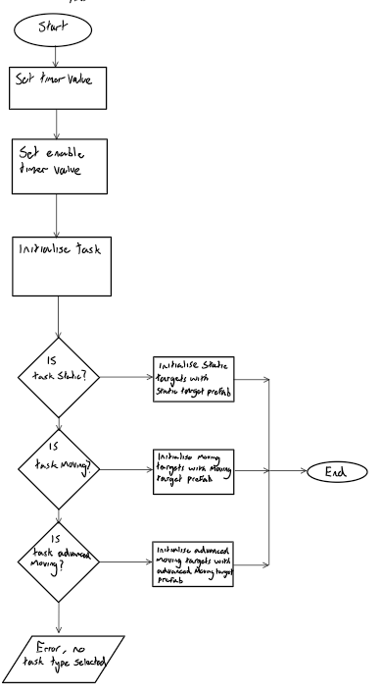Here is how I intend for the task to be initialised:

Here is how I intend for the targets to spawn in:

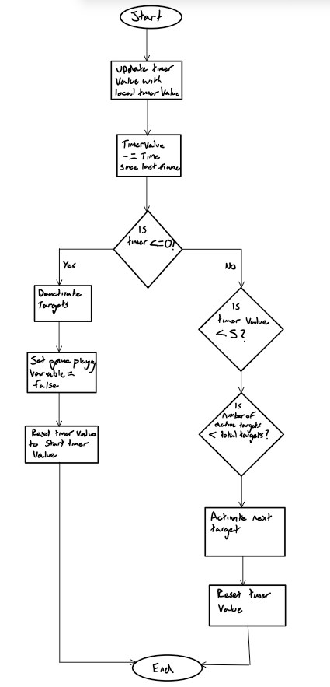



Below is the psuedocode I have made for my target behaviours, I have explained the code before hand in the format of the purpose and functionality of each method to improve clarity.

**TargetBehaviour Class**

* **Description**: This class includes the behavior of individual targets within the aim trainer. It includes attributes such as chance, base score worth, lifetime, spawn positions, health, player accuracy, and a list to monitor shot distances.
* **Fields**:
  + chance: Represents a randomized chance value affecting the target's behavior.
  + baseScoreWorth: Holds the fundamental score value associated with the target.
  + scoreWorth: Reflects the adjusted score worth, considering the player's accuracy.
  + lifetimeValue: Tracks the remaining lifetime of the target.
  + startingLifetimeValue: Specifies the initial lifetime value of the target.
  + randomX, randomY, randomZ: Store randomly generated coordinates for target spawn positions.
  + minSpawnPosition, maxSpawnPosition: Establish the range for random spawn positions.
  + healthComponent: Manages the health of the target.
  + meshRenderer: Responsible for rendering the target's mesh.
  + playerAccuracy: Represents the accuracy of the player.
  + shotDistances: A list to record distances of shots taken at the target.
* **Unity Methods**:
  + **Start Method**:
    - **Purpose**: Executed upon the creation of the target.
    - **Functionality**: Initiates the target by calling InitialiseTarget to set up initial parameters.
  + **Update Method**:
    - **Purpose**: Regularly updates the target's remaining lifetime.
    - **Functionality**: Decreases the lifetime over time. If it reaches zero, triggers the ResetTarget method.
  + **OnCollisionStay Method**:
    - **Purpose**: Manages collisions with other game objects.
    - **Functionality**: Ensures that the collision is not with another target. If the target's health drops to zero, calculates the distance to the center of the target from the collision point, updates the score based on accuracy, "kills" the target by making it invisible, and invokes the ResetTarget method after a short delay.
* **Non-Unity Methods**:
  + **InitialiseTarget Method**:
    - **Purpose**: Establishes initial parameters for the target.
    - **Functionality**: Retrieves health and mesh renderer components, adjusts the scale of the target, and calls the ResetTarget method.
  + **ResetTarget Method**:
    - **Purpose**: Resets the target's parameters.
    - **Functionality**: Resets the remaining lifetime, player accuracy, color, base score worth, and position. The reset is influenced by a random chance, determining the base score worth and color of the target.

Class TargetBehaviour

int chance

float baseScoreWorth

float scoreWorth

float lifetimeValue

float startingLifetimeValue

float randomX

float randomY

float randomZ

Vector3 minSpawnPosition

Vector3 maxSpawnPosition

HealthComponent healthComponent

MeshRenderer meshRenderer

float playerAccuracy

List<float> shotDistances = List<float>()

Method Start()

InitialiseTarget()

End Method

Method Update()

lifetimeValue -= Time.deltaTime

If lifetimeValue <= 0

ResetTarget()

End If

End Method

Method OnCollisionStay(Collision collision)

If collision.collider.gameObject.tag != "Target"

float hp = healthComponent.GetHealth()

If hp <= 0

float distanceToCenter = Vector3.Distance(transform.position, collision.GetContact(0).point)

shotDistances.Add(distanceToCenter)

float accuracyMultiplier = GameManager.Instance.accuracyValue

float scalingFactor = 0.5f + 0.5f * playerAccuracy

float distanceFactor = 1.0f

float scoreChange = baseScoreWorth * accuracyMultiplier * scalingFactor * distanceFactor

float score = GameManager.Instance.scoreValue + scoreChange

GameManager.Instance.scoreValue = score

GameManager.Instance.UpdateScore()

meshRenderer.enabled = false

Invoke("ResetTarget", 0.2f)

End If

End If

End Method

Method InitialiseTarget()

healthComponent = GetComponent<HealthComponent>()

meshRenderer = GetComponent<MeshRenderer>()

transform.localScale = transform.localScale * GameManager.Instance.targetSizeMultiplier

ResetTarget()

End Method

Method ResetTarget()

lifetimeValue = startingLifetimeValue

playerAccuracy = GameManager.Instance.accuracyValue

float scalingFactor = 0.5f + 0.5f * playerAccuracy

chance = Random.Range(0, 100)

If chance <= 20

meshRenderer.material.color = Color.red

baseScoreWorth = -1f

Else

meshRenderer.material.color = Color.cyan

baseScoreWorth = 1f

End If

scoreWorth = baseScoreWorth * scalingFactor

randomX = Random.Range(minSpawnPosition.x, maxSpawnPosition.x)

randomY = Random.Range(minSpawnPosition.y, maxSpawnPosition.y)

randomZ = Random.Range(minSpawnPosition.z, maxSpawnPosition.z)

transform.position = Vector3(randomX, randomY, randomZ)

healthComponent.SetHealth(healthComponent.GetMaxHealth())

meshRenderer.enabled = true

End Method

End Class

**MovingTargetBehaviour Class**

* + **Description**: This class is responsible for managing the behavior of moving targets in an aim trainer game. It extends the functionality of the base TargetBehaviour class to introduce dynamic movement patterns.
  + **Fields**:
    - standardBaseSpeed: Represents the standard speed of the target.
    - advancedBaseSpeed: A secondary speed parameter (currently set to the same value as standardBaseSpeed).
    - minSpeed, maxSpeed: Establish a range for variable speed.
    - speedAmplitude: Defines the amplitude of the speed variation.
    - endDistanceFromPoint: Stores the distance from the current position to the destination point.
    - t: Keeps track of the current time during movement.
    - leftMoving: Flags if the target is moving to the left.
    - pointA, pointB: Define two points between which the target moves.
    - waypointPosition: Stores the current waypoint position.
    - movingToB: Flags if the target is currently moving towards point B.
  + **Unity Methods**:
    - **Start Method**:
      * **Purpose**: Invoked upon target creation.
      * **Functionality**: Initializes the target by calling SetWaypoint.
    - **Update Method**:
      * **Purpose**: Regularly updates the target's movement.
      * **Functionality**: Manages the target's dynamic movement using the MoveTarget method.
  + **My Non-Unity Methods**:
    - **InitialiseTarget Method**:
      * **Purpose**: Sets up initial parameters for the target.
      * **Functionality**: Calls the base class's InitialiseTarget method and determines the initial movement direction based on chance.
    - **ResetTarget Method**:
      * **Purpose**: Resets the target's parameters.
      * **Functionality**: Calls the base class's ResetTarget method and sets random positions for pointA and pointB, influencing the movement pattern.
    - **MoveTarget Method**:
      * **Purpose**: Manages the target's movement behavior.
      * **Functionality**: Updates the target's position using linear interpolation, changes direction when reaching the destination, and sets a new waypoint.
    - **SetWaypoint Method**:
      * **Purpose**: Establishes a new waypoint for the target.
      * **Functionality**: Resets the time variable and calculates a new waypoint based on the current movement direction.
    - **EaseInOutQuad Method**:
      * **Purpose**: Defines an easing function for smooth acceleration and deceleration.
      * **Functionality**: Implements a quadratic easing function to enhance the smoothness of acceleration and deceleration during movement.

# MovingTargetBehaviour class, inheriting from TargetBehaviour

Class MovingTargetBehaviour : TargetBehaviour

float standardBaseSpeed = 0.01f

float advancedBaseSpeed = 0.01f

float minSpeed = 0.001f

float maxSpeed = 0.002f

float speedAmplitude = 0.01f

float endDistanceFromPoint

float t = 0f

bool leftMoving

Vector3 pointA

Vector3 pointB

Vector3 waypointPosition

bool movingToB = true

Method Start()

base.Start()

SetWaypoint()

End Method

Method Update()

base.Update()

MoveTarget()

End Method

Method InitialiseTarget()

base.InitialiseTarget()

If chance > 50

leftMoving = true

End If

End Method

Method ResetTarget()

base.ResetTarget()

float spawnRange = 5f

# Set pointA more to the left for standard movement

pointA = Vector3(Random.Range(-spawnRange, spawnRange), randomY, randomZ)

# Reduce the distance for the standard movement

pointB = Vector3(Random.Range(-spawnRange, spawnRange), randomY, randomZ)

movingToB = true # Start by moving towards point B

End Method

Method MoveTarget()

t += Time.deltaTime

float distance = Vector3.Distance(pointA, pointB)

float totalDuration = distance / standardBaseSpeed

# Calculate the position based on constant speed

Vector3 newPosition

If movingToB

newPosition = Vector3.Lerp(pointA, pointB, t / totalDuration)

Else

newPosition = Vector3.Lerp(pointB, pointA, t / totalDuration)

End If

# Update the position

transform.position = newPosition

If t >= totalDuration

SetWaypoint()

t = 0f

movingToB = Not movingToB # Change direction

End If

End Method

Method SetWaypoint()

t = 0.0f

float randomFactor = Random.Range(0.3f, 0.7f)

# Choose the destination based on the current direction

waypointPosition = movingToB ? Vector3.Lerp(pointA, pointB, randomFactor) : Vector3.Lerp(pointB, pointA, randomFactor)

End Method

End Class

**AdvancedTargetBehaviour Class**

* **Description**: This class extends the behavior of moving targets to introduce advanced movement patterns. It inherits from the MovingTargetBehaviour class and overrides certain methods to enhance the target's dynamics.
* **Unity Methods**:
  + **Start Method**:
    - **Purpose**: Invoked upon the creation of the advanced target.
    - **Functionality**: Calls the Start method of the base class (MovingTargetBehaviour).
  + **Update Method**:
    - **Purpose**: Regularly updates the advanced target's movement.
    - **Functionality**: Calls the Update method of the base class (MovingTargetBehaviour).
  + **MoveTarget Method**:
    - **Purpose**: Overrides the base class method to implement advanced movement.
    - **Functionality**: Updates the target's position based on eased time and current speed using an exponential function. It also employs an easing function for smoother acceleration and deceleration. If the target reaches its destination (t >= 1.0f), it sets a new waypoint, resets the time variable, and changes the direction of movement.
  + **CalculateCurrentSpeed Method**:
    - **Purpose**: Helper method to calculate the current speed using an exponential function.
    - **Functionality**: Utilizes an exponential function to determine the current speed, ensuring smooth acceleration and deceleration. The result is clamped to fall within the specified minimum and maximum speed.
  + **CalculateNewPosition Method**:
    - **Purpose**: Helper method to calculate the new position based on eased time and current speed.
    - **Functionality**: Uses linear interpolation (Lerp) to calculate the new position based on eased time (easedT) and the current speed. The result is used to update the target's position.

# Define AdvancedTargetBehaviour class, inheriting from MovingTargetBehaviour

Class AdvancedTargetBehaviour : MovingTargetBehaviour

Method Start()

base.Start()

End Method

Method Update()

base.Update()

End Method

# Override MoveTarget method for advanced movement

Method MoveTarget()

t += Time.deltaTime

# Calculate the current speed using an exponential function

float currentSpeed = CalculateCurrentSpeed()

# Use an easing function for smoother acceleration and deceleration

float easedT = EaseInOutQuad(t)

Vector3 newPosition = CalculateNewPosition(easedT, currentSpeed)

# Update the position

transform.position = newPosition

If t >= 1.0f

SetWaypoint()

t = 0f

movingToB = Not movingToB # Change direction

End If

End Method

# Helper method to calculate the current speed using an exponential function

Method CalculateCurrentSpeed()

Return Mathf.Clamp(advancedBaseSpeed + Mathf.Exp(t * speedAmplitude) * speedAmplitude, minSpeed, maxSpeed)

End Method

# Helper method to calculate the new position based on eased time and current speed

Method CalculateNewPosition(easedT, currentSpeed)

Return Vector3.Lerp(transform.position, waypointPosition, easedT * currentSpeed)

End Method

End Class

## Gun algorithms

Here I will explain how my psuedocode will work, and show a flowchart to show how I intend for my guns to behave, this will include how they shoot, aim down sight, and equip different guns.

I also have a brief description of all my methods and fields I will be using:

**FPSGunController Class**

**Unity Methods:**

* Awake(): Initializes the gun data, camera, and layer mask. Sets readyToShoot to true.
* Update(): Handles weapon cycling, selection, shooting logic, recoil, cooldowns, aiming, and other effects.

**Non-Unity Methods:**

* Shoot(): Implements shooting logic, handles different gun types, updates game statistics, triggers effects, and sets cooldown.
* Equip(int p_ind): Equips the specified weapon from the loadout.
* Aim(bool p_isAiming): Handles aiming logic based on the aiming input.
* ResetShot(): Resets the readyToShoot flag.
* GetShootingDirection(): Calculates shooting direction based on gun range and spread.
* HandleBurstShooting(): Handles burst shooting logic, triggers burst shooting coroutine.
* BurstShoot(): Coroutine for handling burst shooting.
* ShotCooldown(): Coroutine for handling shot cooldown.
* CycleWeapon(int direction): Cycles to the next/previous weapon in the loadout.

The methods in my gun scipt collectively manage the behavior of the FPS gun controller, handling weapon selection, shooting mechanics, aiming, and related visual and game state effects.

My psuedocode:

Structure GunData

// Fields representing properties of a gun

End Structure

Structure RifleData

// Additional fields specific to rifles

End Structure

Structure ShotgunData

// Additional fields specific to shotguns

End Structure

Class GunController

# Fields

GunData[] loadout

GunData gunData

float currentCooldown

int currentIndex

int layerMask

bool gunInHand

bool shooting

bool readyToShoot

int currentWeaponIndex

Transform weaponParent

Transform gunTip

Camera mainCamera

ParticleSystem muzzleFlash

FPSCameraController cameraData

GameObject currentWeapon

int currentBurstCount

Method Awake()

gunData = loadout[0]

mainCamera = GetComponent<Camera>()

cameraData = GetComponent<FPSCameraController>()

layerMask = LayerMask.GetMask("Target", "ShootableSurface", "Ground")

readyToShoot = true

End Method

Method Update()

// Handle weapon cycling using scroll wheel

float scrollWheelInput = Input.GetAxis("Mouse ScrollWheel")

If scrollWheelInput > 0

CycleWeapon(1)

ElseIf scrollWheelInput < 0

CycleWeapon(-1)

End If

// Handle weapon selection using number keys

If Input.GetKeyDown(1)

Equip(0)

gunInHand = true

ElseIf Input.GetKeyDown(2)

Equip(1)

gunInHand = true

ElseIf Input.GetKeyDown(3)

Equip(2)

gunInHand = true

ElseIf Input.GetKeyDown(4)

Equip(3)

gunInHand = true

ElseIf Input.GetKeyDown(5)

Equip(4)

gunInHand = true

End If

If gunInHand

// Handle shooting logic

RifleData rifleData = gunData as RifleData

If rifleData != null

If rifleData.automatic

shooting = Input.GetKey(KeyCode.Mouse0)

ElseIf rifleData.canBurst

HandleBurstShooting()

Else

shooting = Input.GetKeyDown(KeyCode.Mouse0)

End If

Else

shooting = Input.GetKeyDown(KeyCode.Mouse0)

End If

If readyToShoot And shooting

Shoot()

End If

// Handle recoil and other effects

currentWeapon.transform.localPosition = Vector3.Lerp(currentWeapon.transform.localPosition, Vector3.zero, Time.deltaTime * 4f)

If currentCooldown > 0

currentCooldown -= Time.deltaTime

End If

End If

If currentWeapon != null

Aim(Input.GetMouseButton(1))

End If

End Method

Method Shoot()

// Shooting logic based on gun type

// Handle shotgun and other gun types

// Update GameManager statistics

// Trigger effects like muzzle flash, recoil, and kickback

// Set cooldown for next shot

End Method

Method Equip(int p_ind)

// Equip the specified weapon

// Instantiate new weapon object and set its properties

End Method

Method Aim(bool p_isAiming)

// Handle aiming logic

End Method

Method ResetShot()

// Reset readyToShoot flag

End Method

Method GetShootingDirection()

// Calculate shooting direction based on gun range and spread

End Method

Method HandleBurstShooting()

// Handle burst shooting logic

// Trigger burst shooting coroutine

End Method

Coroutine BurstShoot()

// Coroutine for handling burst shooting

End Coroutine

Coroutine ShotCooldown()

// Coroutine for handling shot cooldown

End Coroutine

Method CycleWeapon(int direction)

// Cycle to the next/previous weapon in the loadout

End Method

End Class

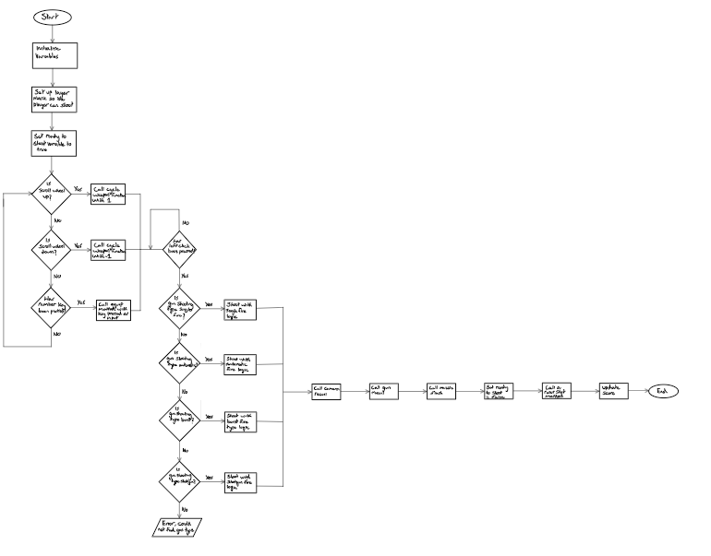

Below I have my flowchart on parts of my gun algorithm, I have the whole flowchart and zoomed in screen shots of it in 3 parts thoughout the process.

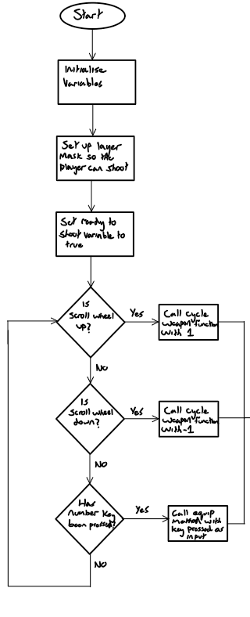

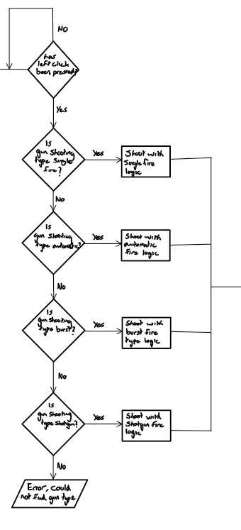Here zoomed in parts of my flowchart:

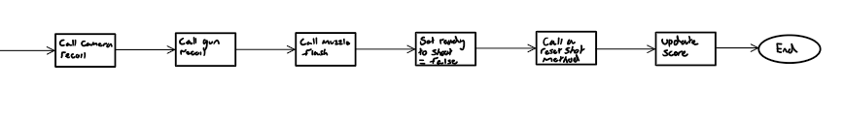

## Player Movement Algorithm

In my game I intend for my player to also have movement, this will be done like this:

Class FPSPlayerController

# Fields

LayerMask ground

Transform groundCheck

float moveSpeed

float jumpHeight

float gravity

float x, z

Vector3 moveDirectionHorizontal, jumpDirection

bool isGrounded

CharacterController charCont

# Unity Methods

Method Update()

HorizontalMovement()

VerticalMovement()

End Method

# Non-Unity Methods

Method HorizontalMovement()

x = Input.GetAxis("Horizontal")

z = Input.GetAxis("Vertical")

moveDirectionHorizontal = transform.right * x + transform.forward * z

If Input.GetKey(KeyCode.LeftShift)

charCont.Move(moveDirectionHorizontal * (moveSpeed * 2f) * Time.deltaTime)

Else

charCont.Move(moveDirectionHorizontal * (moveSpeed * 2f) * Time.deltaTime)

End If

End Method

Method VerticalMovement()

groundCheck.position = transform.position + Vector3(0, -1.44f, 0)

isGrounded = Physics.CheckSphere(groundCheck.position, 0.3f, ground)

If isGrounded And jumpDirection.y < 0

jumpDirection.y = -10f

End If

jumpDirection.y += gravity * Time.deltaTime

If Input.GetKeyDown(KeyCode.Space) And isGrounded

jumpDirection.y = Sqrt(jumpHeight * -2 * gravity)

End If

charCont.Move(jumpDirection * jumpHeight * Time.deltaTime)

End Method

Here is a description on how the methods will work and how I will use them:

* Update: Unity method called every frame. Calls HorizontalMovement and VerticalMovement methods.
* HorizontalMovement: Handles horizontal movement based on user input. Doubles the movement speed when the Left Shift key is pressed.
* VerticalMovement: Manages vertical movement, including jumping and gravity.
  + Updates the groundCheck position to be just below the player's position.
  + Checks if the player is grounded using a sphere cast with Physics.CheckSphere.
  + Adjusts the vertical movement (jumpDirection.y) based on gravity.
  + If the Space key is pressed and the player is grounded, applies a jump using the physics formula for jump height.
  + Moves the character controller based on the calculated jump direction.

## Complex target movement

**Time Increment:** I will have a variable called t to represent time. With each frame, I will add the time that has passed since the last frame to t. This way, I can keep track of how much time has passed.

**Exponential Speed Calculation:** I will calculate the currentSpeed using an exponential function. As time (t) increases, the exponential function will make the speed grow rapidly. This growth will be added to a base speed (advancedBaseSpeed), and I will make sure the result stays within a specified speed range (minSpeed to maxSpeed) by clamping it.

**Easing Function and Position Update:** I will apply an easing function to t to achieve smoother acceleration and deceleration. Then, I will update the position of my object using linear interpolation (Lerp). This process ensures a smooth transition between the current position and the target waypoint position, considering the eased time and the calculated speed.

**Waypoint and Direction Handling:** When my eased time (t) surpasses or equals 1.0, it signals that my object has reached its current target waypoint. At this point:

* I will set a new waypoint.
* I will reset the time variable (t) to 0 to initiate the movement towards the new waypoint.
* I will change the direction of movement by toggling the movingToB variable.

In summary, my code will create a system where my object moves smoothly, dynamically accelerating and decelerating over time. This movement will be controlled by an exponential function for speed growth, an easing function for smoothness, and waypoint handling to change direction and set new targets.

This will cause the targets to move unpredictably and make them difficult to track as the combination of exponential growth introduced by the Mathf.Exp function as the time increases, the easing function that brings acceleration and deceleration for smoother movement, potential randomness I initialise the variable. There also may be external factors influencing the system, and the speed clamping mechanism that can collectively contribute to unpredictable behaviour in the movement.

The growth from the exponential function may result in sudden and unexpected changes in speed. The easing function will add variability to the speed, making it less predictable. Randomness in initialization or external factors can introduce additional unpredictability, and when the speed is clamped, it may lead to sudden shifts in direction or behaviour, especially when the speed approaches the minimum or maximum allowed values.

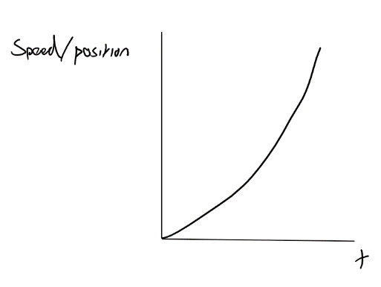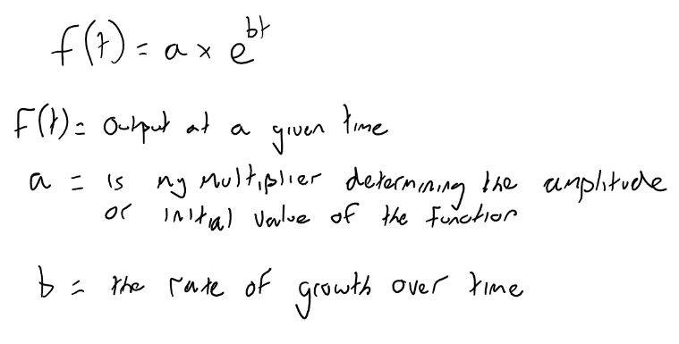

## UML

Here I have my UML diagram, how I have laid it out is without the variables inside as some of my classes get quite big and it’s easier to explain them separately. Here I have my connections without my variables.

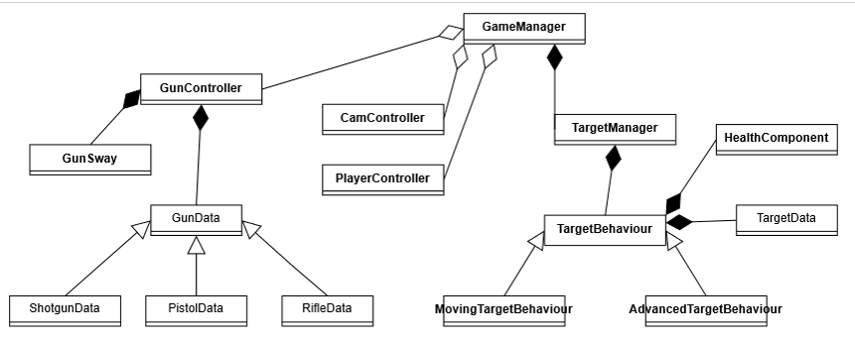

For my classes I have them split up into 3 main classes, the game manager, the target manager and the gun controller. The game manager class will manage the game states, for example when changing from the main menu to the main game to the end game screen. It will also be responsible for tasks such as keeping track of the score and the timer value. The target manager will be what will spawn in each of my targets, this will include the different types of targets and when in the round they will spawn in, as well as the target manager there are 3 main target classes, these include the target behaviour, moving target behaviour and the advanced target behaviour. Each of these are ways in which the target will act if the corresponding scenario is picked. I also have a gun manager class, this will carry out how I need my gun to act, this includes shooting ray casts to the target to know of the target has been shot, equipping weapons of the users choice, and managing what type of shooting the gun will be doing.

Here is a more detailed list on what my main classes do:

GameManager Class

**Responsibilities**:

* Manages the overall game states, transitioning between the main menu, main game, and end game screens.
* Tracks and updates critical game parameters, such as the score and timer values.
* Handles the flow of the game, orchestrating transitions and interactions between different components.

TargetManager Class

**Responsibilities**:

* Orchestrates the spawning of various target types based on game scenarios and round timings.
* Manages the behavior and properties of targets during the game, ensuring diversity in target dynamics.
* Acts as a mediator between the game logic and individual target instances.

TargetBehaviour Class

**Responsibilities**:

* Defines the basic behavior of a target, encompassing attributes like chance, base score worth, and lifetime.
* Manages the visual and health aspects of the target, including rendering and health component interaction.
* Handles collision events, calculating shot distances, updating the score, and determining target "kill" conditions.
* Provides methods for initializing and resetting target parameters.

MovingTargetBehaviour Class

**Responsibilities**:

* Extends the behavior of a target to include movement patterns during the game.
* Introduces fields for controlling various aspects of movement, such as speed and waypoints.
* Overrides methods from the base TargetBehaviour class to incorporate movement logic.
* Introduces advanced movement patterns.

AdvancedTargetBehaviour Class

**Responsibilities:**

* Extends the behavior of a target to include advanced movement patterns during the game.
* Overrides the MoveTarget method from the base MovingTargetBehaviour class to implement advanced movement logic.
* Utilizes an exponential function to calculate current speed, enhancing movement dynamics.
* Applies an easing function for smoother acceleration and deceleration.
* Updates the target's position based on eased time, current speed, and waypoint position.
* Manages the change of direction upon reaching the target's destination.
* Inherits functionalities from the base MovingTargetBehaviour class to maintain cohesive behavior.

Now I will go more in depth about each class and the variables inside of each:

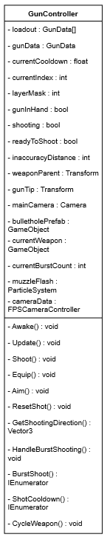

* loadout: An array of GunData representing the available weapons.
* gunData: Current gun data for the equipped weapon.
* currentCooldown: Cooldown timer for shot intervals.
* currentIndex: Index representing the current weapon in the loadout.
* layerMask: Layer mask for raycasting (targets, shootable surfaces, ground).
* gunInHand: Flag indicating if a gun is currently equipped.
* shooting: Flag indicating whether the player is currently shooting.
* readyToShoot: Flag indicating if the gun is ready to shoot.
* currentWeaponIndex: Index representing the currently equipped weapon.
* weaponParent: Transform representing the parent object for the weapons.
* gunTip: Transform representing the tip of the gun.
* mainCamera: Camera component used for raycasting.
* muzzleFlash: Particle system for muzzle flash effects.
* cameraData: FPSCameraController component for handling camera movements.
* currentWeapon: GameObject representing the currently equipped weapon.
* currentBurstCount: Counter for the number of shots in a burst.

The GunController class has the essential mechanics of firing weapons in my aim trainer.

The Shoot() method manages the details of shooting, accommodating multiple gun types and triggering very minor visual effects.

Equip() facilitates the switching of weapons within the loadout, instantiating and configuring the chosen weapon.

Aiming logic is handled by the Aim() method, adjusting camera and gun positions based on player input.

ResetShot() controls the cooldown between shots, while GetShootingDirection() calculates the trajectory of bullets.

For burst-capable guns, HandleBurstShooting() initiates a burst shooting coroutine (BurstShoot()), controlling the timing and sequence of shots. The ShotCooldown() coroutine manages the cooldown period between consecutive shots.

Finally, CycleWeapon() enables the cycling through different weapons, offering players choices during the task.

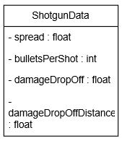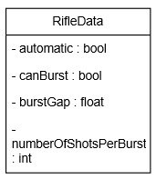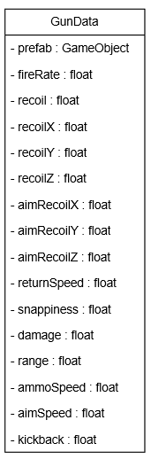

* The TargetBehaviour class serves as a base class for target behaviour.
* It contains a Vector3 field currentPosition to track the target's position.
* The Update method is a Unity method called every frame, and it currently invokes the Move method.
* The Move method my own method providing basic target behaviour. However, it is designed to be overridden by specific target movement implementations.

By keeping the base class simple and defining a method (Move) meant to be overridden, it provides a more flexible framework for different types of target movements to inherit from TargetBehaviour and customize their specific movement logic. For example, my MovingTargetBehaviour class will inherit from TargetBehaviour and override the Move method to implement specific movement behaviours.

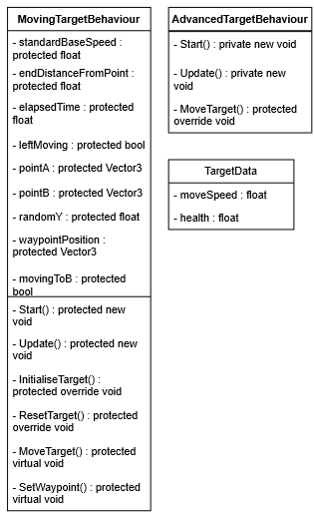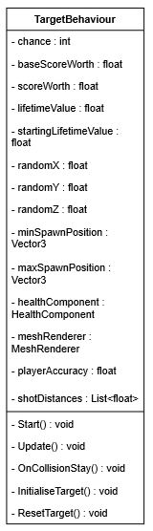

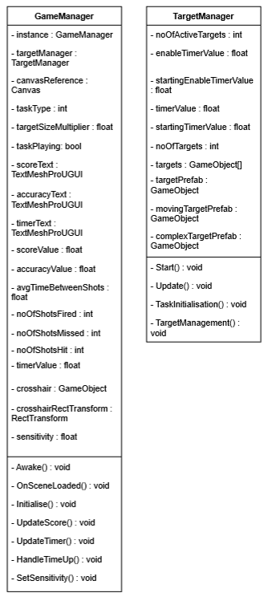

The TargetBehaviour class serves as a template for target movements, allowing specific target movement classes like MovingTargetBehaviour to inherit and customize it. For example, MovingTargetBehaviour can override the Move method for distinct movement logic. Meanwhile, the GameManager acts as a centralized control hub, managing game activities, initializing elements (including target behaviours), and coordinating interactions. It updates states, often in the Update method or a game loop, contributing to a modular and organized game development structure, separating concerns for target behaviour and overall game management.

1. **Health Component:**
   * The health component tracks and manages the targets health within the game, handling damage.
2. **Gun Sway:**
   * The gun sway component introduces realistic weapon movement, simulating a subtle swaying motion when the player aims and holds the gun.
3. **Camera Controller:**
   * The camera controller governs the movement and behaviour of the in-game camera, controlling where the player looks.
4. **Player Controller:**
   * The player controller orchestrates the overall movement and input responses of the player character, integrating user inputs for both horizontal and vertical movement, managing interactions like jumping, and facilitating communication between various gameplay components.

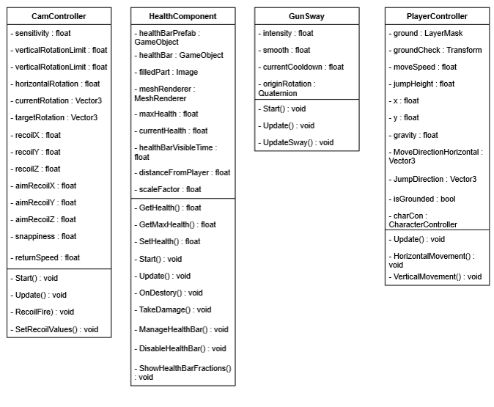

## Guns

**Base Gun Data:**

1. **Prefab:**
   * Physical element of the gun.
2. **Fire Rate:**
   * The rate of fire of the gun in shots per second.
3. **Recoil:**
   * The recoil value for the gun transform, actualizes kickback.
4. **Recoil Axes:**
   * The amount of x, y, z-axis recoil experienced after each shot.
5. **Aim Recoil Axes:**
   * The amount of x, y, z-axis recoil experienced after each shot while in ADS.
6. **Return Speed:**
   * How fast the gun resets after said recoil.
7. **Snappiness:**
   * Snappiness of the gun.
8. **Damage:**
   * The damage inflicted by each bullet.
9. **Range:**
   * The range of the gun.
10. **Ammo Speed:**
    * The speed our bullets travel at in m/s.
11. **Aim Speed:**
    * How fast the gun will aim in.
12. **Kickback:**
    * How much the gun kicks back.

**Shotgun Data (Additional):**

**Spread:** - The spread or deviation of bullets when fired.

**Bullets Per Shot:** - Number of bullets fired on each shot.

**Damage Drop-Off:** - The multiplier for decreasing damage over distance.

**Damage Drop-Off Distance:** - Distance that damage starts to decrease at.

**Rifle Data (Additional):** **Automatic:** - Whether the gun is automatic or semi-automatic.

**Can Burst Fire:** - Whether the gun can burst fire or not.

**Burst Gap:** - Gap between each burst.

**Number of Shots Per Burst:** - Number of shots fired in a burst.

My values I will use on my guns, I have set them correspondingly based on what I think the targets health may be, I have also set them compared to each other as depending on the gun they will have different stats.

Some values I have set to a default value as I initially thought I would use them but decided to change it, for example I set the range to a base stat of 1000, this will give my guns an infinite range or at least the range that every gun will be able to shoot every target.

AK47

* **Fire Rate:**
  + 0.1
* **Recoil:**
  + 20
* **Recoil Axes:**
  + X: -2
  + Y: 2
  + Z: 0.35
* **Aim Recoil Axes:**
  + X: -1.5
  + Y: 1
  + Z: 0.3
* **Return Speed:**
  + 2
* **Snappiness:**
  + 6
* **Damage:**
  + 160
* **Range:**
  + 10000
* **Ammo Speed:**
  + 980
* **Aim Speed:**
  + 20
* **Kickback:**
  + 0.15
* **Automatic:**
  + true
* **Can Burst:**
  + false
* **Burst Gap:**
  + 0
* **Number of Shots Per Burst:**
  + 0

My BurstFire Gun

* **Fire Rate:**
  + 0.1
* **Recoil:**
  + 20
* **Recoil Axes:**
  + X: -1
  + Y: 1
  + Z: 0.2
* **Aim Recoil Axes:**
  + X: -0.5
  + Y: 0.5
  + Z: 1
* **Return Speed:**
  + 2
* **Snappiness:**
  + 6
* **Damage:**
  + 160
* **Range:**
  + 10000
* **Ammo Speed:**
  + 980
* **Aim Speed:**
  + 20
* **Kickback:**
  + 0.15
* **Automatic:**
  + false
* **Can Burst:**
  + true
* **Burst Gap:**
  + 0.1
* **Number of Shots Per Burst:**
  + 3

My Shotgun Type Gun

* **Fire Rate:**
  + 0.1
* **Recoil:**
  + 20
* **Recoil Axes:**
  + X: -2
  + Y: 2
  + Z: 0.2
* **Aim Recoil Axes:**
  + X: -1.5
  + Y: 1.5
  + Z: 0.3
* **Return Speed:**
  + 2
* **Snappiness:**
  + 6
* **Damage:**
  + 40
* **Range:**
  + 10000
* **Ammo Speed:**
  + 980
* **Aim Speed:**
  + 20
* **Kickback:**
  + 0.15
* **Automatic:**
  + false
* **Can Burst:**
  + false
* **Burst Gap:**
  + 0.1
* **Bullets Per Shot:**
  + 20

## How I intend for the tasks to work

I will explain how I expect my task to be started and how each target will work, I intend to show how the player will see each entity and describe how I want them to interact with them.

Here is my initial white target, the user is to shoot this target to start the task:

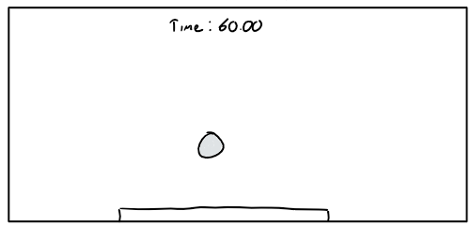

Once my user has clicked the target, the target will break and the timer will begin to count down from 60.

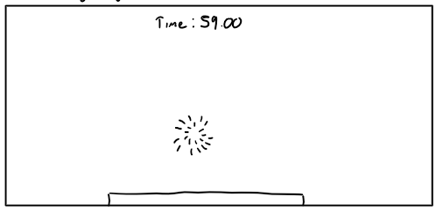

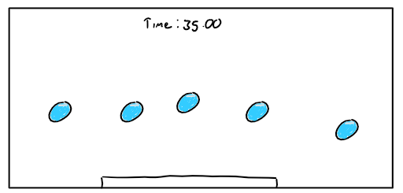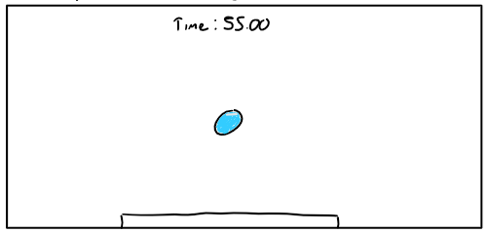After 5 seconds the first target will spawn, during the countdown at 5 second intervals the targets will spawn in, this means that after the initial 25 seconds all the targets will be spawned in.

Each of my targets will have a heal bar below them, this will show their current health out of their max health, the basic target will have no movement. Once the targets health is zero, it will reset, having its health back up to its maximum and its position reset.

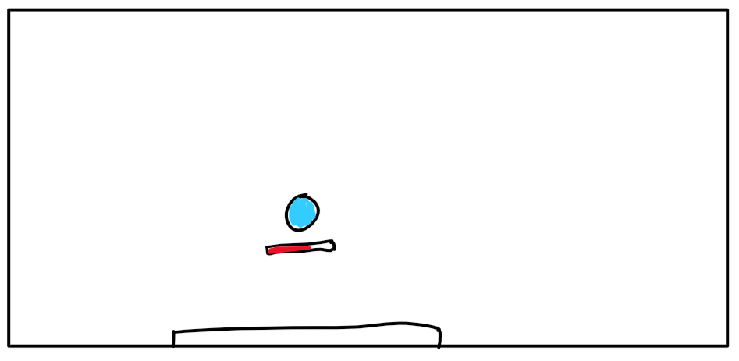

I will also have 2 other types of targets; these will be my moving and advanced moving targets. My advanced moving targets will move in all directions and change speed based on an exponential curve, while my basic moving targets will just move left and right between a predefined point A and point B.

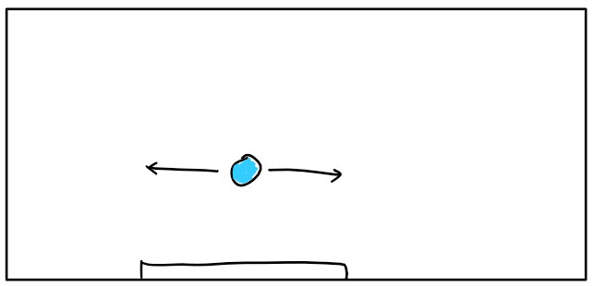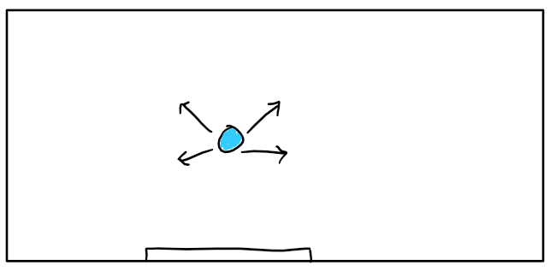

## UI Initial thoughts

My first interaction with my end user discussing the UI

Hello, Mikhail I have come to you with some questions about the UI of the aim trainer, I would like you to be as specific as you can and make sure to include and features and how you may want them implemented in the UI.

Here are my questions:

What colours would you want the UI to include? please provide examples

I don’t care that much about the visual aspect of the menu, the colour I don’t mind as the main priority should be how the in game looks rather than the menu, As long as I can clearly see what buttons do what and it feels easy to navigate the menu, I will be happy as I don’t want to get lost in the menu due to its complexity.

What main functions would you like to access from the main menu?

I think being able to access the game view where you can see your tasks, being able to see your sensitivity and crosshair are important too. As well as that having a way to exit the game should also be on the menu too.

How would you like to have different options to change your crosshair?

I think maybe you should just have the pictures of them then you can click on them and just do apply, I don’t think I want to be able to make my own crosshair as it may take up too much time and its one of the less important factors in training my aim in my opinion.

Would you like to see all the stats on your screen in your game or after?

Well the score and accuracy should both be on your screen during the game throughout the round, although I don’t think all the other statistics should be shown as it will make the screen feel clustered.

Do you want to change the difficulty from the main menu or from the main game?

I think having it accessible from inside the game would be cool but it makes more sense to do to before the actual task, rather than inside the game, it will also look more clean to have all the buttons together, it will help with clarity for new users of the aim trainer.

UI Initial thoughts

Here are my initial thoughts on how I intended for my UI to look like:

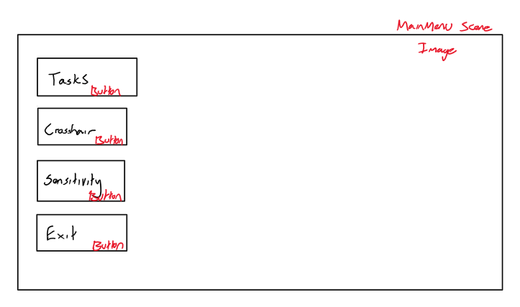Main Menu

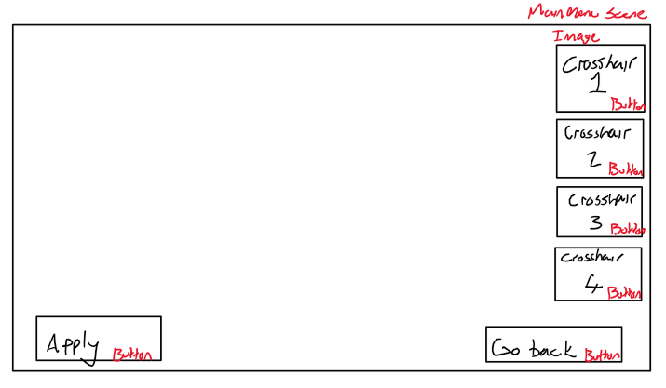Crosshair Screen

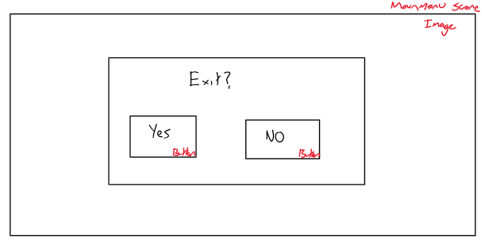Exit

Tasks

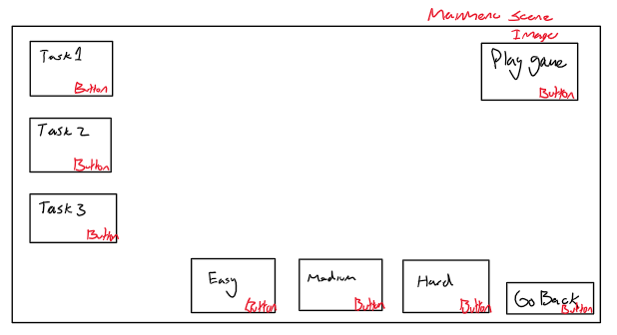

As well as my main menu I also have my Game UI and Post Round Screens initial designs:

Pause Menu

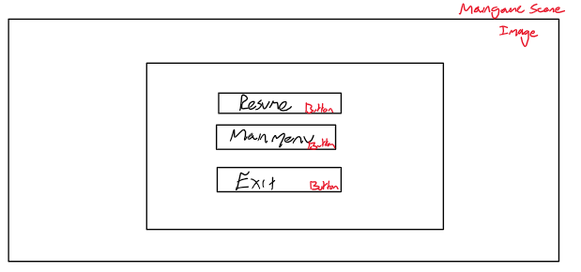

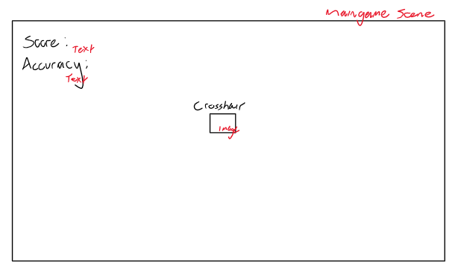

In Game UI

Post Round Statistics

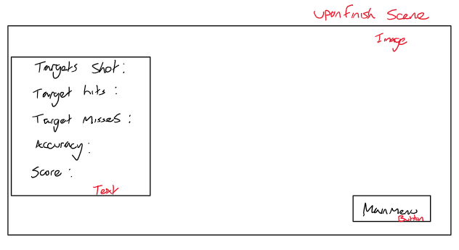

After designing these I went back to my end user and asked them questions based on the UI, this is to ensure I have met what they are looking for, here is how our conversation went:

My second interaction with my end user discussing the UI

Hello again, based on your answers to my previous questions I have made some initial designs from each of the interfaces of the aim trainer, for each one can you provide feedback, be as specific as you can about what you like and don’t like.

Main Menu

I like how the screen is very minimal and isn't clustered at all, the only downside would be how plain it looks but in my opinion that isn't really a bad things as it gives the feeling the main menu is more concise and streamlines to what the game is rather than having other features that aren't really needed in an aim trainer.

Based off my end users feedback I will keep this design, as I also don’t think it's an issue that it looks plain, I'm happy with how simple it looks and I think it demonstrates well how to access each of my functions in my aim trainer.

Crosshair

I think the design is fine, it fits my criteria of what I asked for, I think you could make it so that on the left the buttons are like the actual images of the crosshairs, so that to select each of them you click which one you want then you can click apply to get it in the game.

I think I will ensure that the images have a button component, this will make it so that each crosshair is the button its self and will allow the user to click on each of the crosshairs that they may want.

Tasks

I think that below on the bottom each of the difficulties should be directly below the tasks, I like them being next to each over but would prefer if they were shifted to the left, you could also make the buttons smaller so that it fits. I just think that it would be better to have difficulty right after the task you select, rather than having it further away on the screen.

I will change the button layout based on my users feedback.

Exit

The exit is also good as its simple, it's good that it doesn’t kick you out the game straight away and instead it asks you if you are sure you want to exit.

The exit part of the menu will also remain the same, with added details for the final design.

General UI notes

I think you could add more text, that way it will improve how clear the interface is and help new users know what does what, besides from that the interface you provided covers all the basic functions I wanted.

I will do this for each of my menu screens to help be more specific.

Main Game UI

The pause menu looks good it's very basic but I don’t think you need to add much more functionality in it, it allows for the game to pause and that’s fine, although in the in game interface I think the accuracy should be moved over to the right side as I don’t like how the score and accuracy are sort of layered on top of each other like that, it feels like something I would want to avoid to prevent not being able to see parts of the screen.

I will move the accuracy to the top right rather than the top left.

Post Round UI

I like the statistics you have included, I think you should also include an average ttk across the whole game and how long on average it take the user to shoot each target, besides from that I can't think of any more stats you might want to include so I think that’s enough for now.

I will include a statistic to see how long it takes you to shoot each target

My finalising the UI with my end user

Here I have shown you my design for my UI, I intend to use this, for now it is black and white but I may change the colour of the back round to a grey, so that the interface looks cleaner. What do you think of this user interface?

I think that it is great and it includes everything I want.

Are you sure there is nothing else you want to add before I implement it?

No thank you, I am happy with what it is currently.

Now that I have got more insight in what my end-user is looking for, I have made my final UI designs:

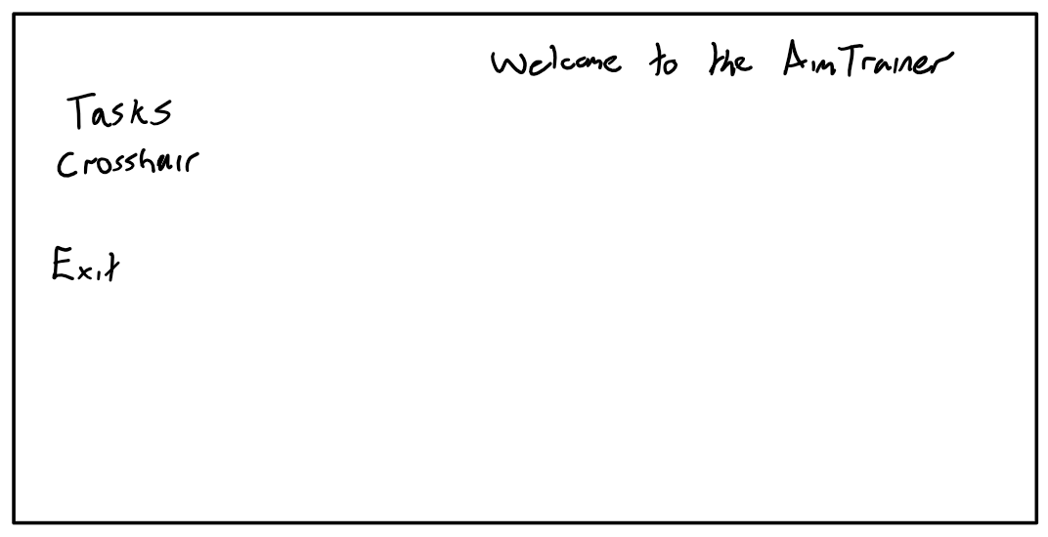Main Menu

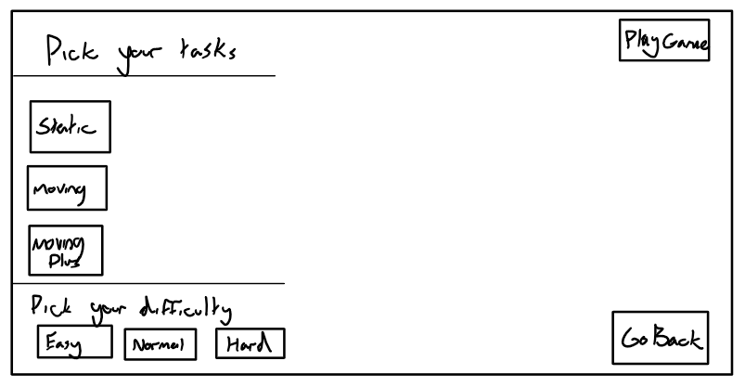Tasks

Crosshair

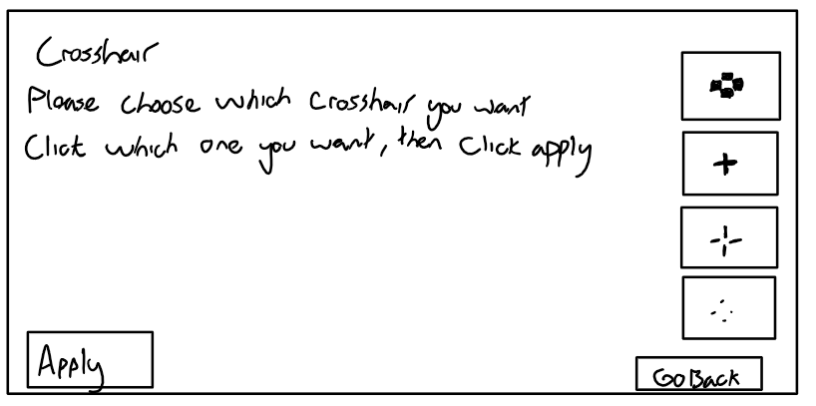

Exit

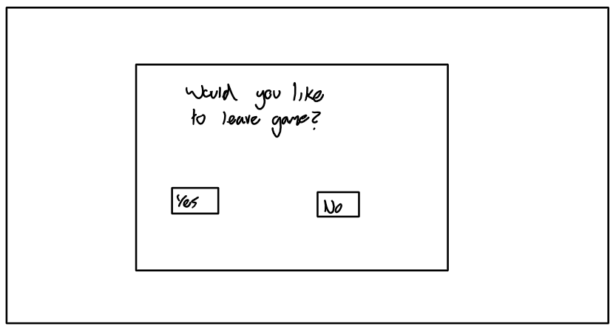

Pause Menu

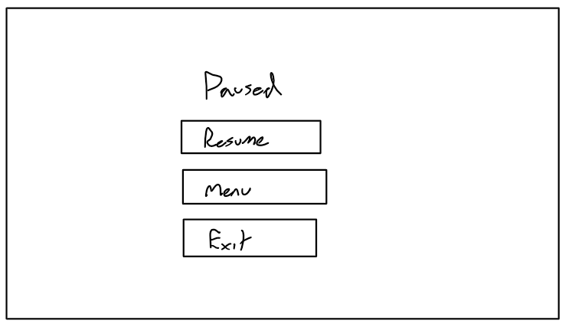

Main Game

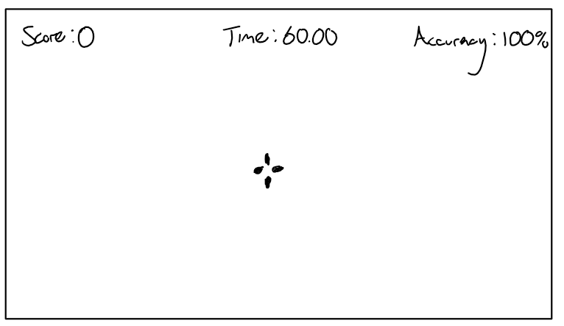

Post Game

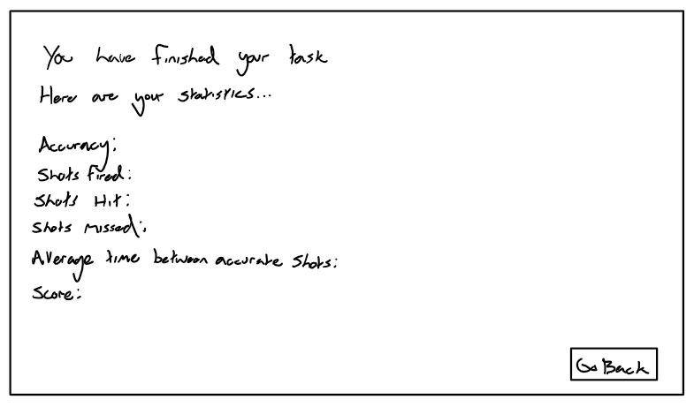

# Technical Solution

In this section I will show my code and explain what it does, in case I forget to add code I have an appendix at the end which includes each script I used:

Here I have my base target script, it will be what the other targets inherit from and override:

using UnityEngine;

using System.Collections.Generic;

public class TargetBehaviour : MonoBehaviour

{

#region Fields

protected int chance;

protected float baseScoreWorth;

protected float lifetimeValue;

protected float startingLifetimeValue = 3f;

protected float randomX;

protected float randomY;

protected float randomZ;

protected Vector3 minSpawnPosition = new Vector3(-20f, 2f, 10f);

protected Vector3 maxSpawnPosition = new Vector3(20f, 12f, 40f);

protected HealthComponent healthComponent;

protected MeshRenderer meshRenderer;

float playerAccuracy;

// List to store shot distances

List<float> shotDistances = new List<float>();

#endregion

#region Methods

#region UnityMethods

protected void Start()

{

InitialiseTarget();

}

protected void Update()

{

lifetimeValue -= Time.deltaTime;

if (lifetimeValue <= 0)

{

ResetTarget();

}

}

private void OnCollisionStay(Collision collision)

{

// Make sure we don't collide with other targets

if (collision.collider.gameObject.tag != "Target")

{

float hp = healthComponent.GetHealth();

if (hp <= 0)

{

// Calculate distance from the bullet impact point to the center of the target

float distanceToCenter = Vector3.Distance(transform.position, collision.GetContact(0).point);

// Add the distance to the list

shotDistances.Add(distanceToCenter);

// Calculate score based on standard deviation

float scoreChange = CalculateScoreBasedOnDeviation();

// Update the score

float score = GameManager.Instance.scoreValue + scoreChange;

GameManager.Instance.scoreValue = score;

GameManager.Instance.UpdateScore();

// "Kill" the target

meshRenderer.enabled = false;

Invoke("ResetTarget", 0.2f);

}

}

}

#endregion

#region NonUnityMethods

protected virtual void InitialiseTarget()

{

healthComponent = GetComponent<HealthComponent>();

meshRenderer = GetComponent<MeshRenderer>();

transform.localScale = transform.localScale * GameManager.Instance.targetSizeMultiplier;

playerAccuracy = GameManager.Instance.accuracyValue;

ResetTarget();

}

protected virtual void ResetTarget()

{

lifetimeValue = startingLifetimeValue;

playerAccuracy = GameManager.Instance.accuracyValue;

chance = Random.Range(0, 100);

if (chance <= 20)

{

meshRenderer.material.color = Color.red;

baseScoreWorth = -1f;

}

else

{

meshRenderer.material.color = new Color(0, 1, 1, 1);

baseScoreWorth = 1f;

}

randomX = Random.Range(minSpawnPosition.x, maxSpawnPosition.x);

randomY = Random.Range(minSpawnPosition.y, maxSpawnPosition.y);

randomZ = Random.Range(minSpawnPosition.z, maxSpawnPosition.z);

transform.position = new Vector3(randomX, randomY, randomZ);

healthComponent.SetHealth(healthComponent.GetMaxHealth());

meshRenderer.enabled = true;

}

// New method to calculate the score based on the standard deviation

protected float CalculateScoreBasedOnDeviation()

{

// Calculate mean

float mean = 0f;

foreach (float distance in shotDistances)

{

mean += distance;

}

mean /= shotDistances.Count;

// Calculate variance

float variance = 0f;

foreach (float distance in shotDistances)

{

variance += Mathf.Pow(distance - mean, 2);

}

variance /= shotDistances.Count;

// Calculate standard deviation

float standardDeviation = Mathf.Sqrt(variance);

// You can modify this factor based on your requirements

float deviationFactor = 1.0f;

// Calculate the score based on the standard deviation and apply the deviation factor

float score = baseScoreWorth * deviationFactor / (standardDeviation + 1);

return score;

}

#endregion

#endregion

}

This code defines the behaviour of a target in a shooting game. The TargetBehaviour class encapsulates various fields and methods for managing target characteristics, such as score worth, lifetime, and spawn positions. The class utilises Unity's MonoBehaviour, containing methods like Start and Update for initialization and updating the target's state, respectively. The OnCollisionStay method handles collisions with projectiles, calculating the accuracy, distance, and updating the score based on the impact. Additionally, non-Unity methods like InitialiseTarget and ResetTarget manage the target's initialization and reset, considering factors such as accuracy and spawn positions.

In my aim trainer, I've integrated a method to calculate the standard deviation of shot distances from the target's center. Each time a bullet hits the target, the distance from the impact point to the center is recorded in a list. The standard deviation is then computed, offering insights into the spread or consistency of these distances. This statistical metric serves as a factor in determining the final score, directly influenced by the players' accuracy and shot precision. A lower standard deviation, indicating tighter shot grouping, contributes to a higher score, encouraging players to enhance their shooting precision for better performance in the aim trainer.

Here I have my moving target script:

using System.Collections;

using System.Collections.Generic;

using UnityEngine;

public class MovingTargetBehaviour : TargetBehaviour

{

#region Fields

[Header("Movement Settings")]

[SerializeField] protected float standardBaseSpeed = 0.01f;

[SerializeField] protected float advancedBaseSpeed = 0.01f;

[SerializeField] protected float minSpeed = 0.001f;

[SerializeField] protected float maxSpeed = 0.002f;

[SerializeField] protected float speedAmplitude = 0.01f;

protected float endDistanceFromPoint;

protected float t = 0f;

protected bool leftMoving;

protected Vector3 pointA;

protected Vector3 pointB;

protected Vector3 waypointPosition;

protected bool movingToB = true; // Indicates whether the target is moving towards point B

#endregion

#region Methods

#region UnityMethods

protected new void Start()

{

base.Start();

SetWaypoint();

}

protected new void Update()

{

base.Update();

MoveTarget();

}

#endregion

#region NonUnityMethods

protected override void InitialiseTarget()

{

base.InitialiseTarget();

if (chance > 50) leftMoving = true;

}

protected override void ResetTarget()

{

base.ResetTarget();

float spawnRange = 5f;

// Set pointA more to the left for standard movement

pointA = new Vector3(Random.Range(-spawnRange, spawnRange), randomY, randomZ);

// Reduce the distance for the standard movement

pointB = new Vector3(Random.Range(-spawnRange, spawnRange), randomY, randomZ);

movingToB = true; // Start by moving towards point B

}

protected virtual void MoveTarget()

{

t += Time.deltaTime;

float distance = Vector3.Distance(pointA, pointB);

float totalDuration = distance / standardBaseSpeed;

// Calculate the position based on constant speed

Vector3 newPosition;

if (movingToB)

newPosition = Vector3.Lerp(pointA, pointB, t / totalDuration);

else

newPosition = Vector3.Lerp(pointB, pointA, t / totalDuration);

// Update the position

transform.position = newPosition;

if (t >= totalDuration)

{

SetWaypoint();

t = 0f;

movingToB = !movingToB; // Change direction

}

}

protected virtual void SetWaypoint()

{

t = 0.0f;

float randomFactor = Random.Range(0.3f, 0.7f);

// Choose the destination based on the current direction

waypointPosition = movingToB ? Vector3.Lerp(pointA, pointB, randomFactor) : Vector3.Lerp(pointB, pointA, randomFactor);

}

// Easing function for smooth acceleration and deceleration

protected float EaseInOutQuad(float t)

{

return t < 0.5 ? 2 * t * t : -1 + (4 - 2 * t) * t;

}

#endregion

#endregion

}

This script, MovingTargetBehaviour, extends the functionality of the base TargetBehaviour. The script introduces additional movement-related fields and methods to handle the dynamic behaviour of targets. Fields include settings for movement speed, amplitude, and the range of speed variation. The script utilises Unity's MonoBehaviour with overridden Start and Update methods for initialization and continuous updating, respectively. Non-Unity methods, such as InitialiseTarget, ResetTarget, MoveTarget, and SetWaypoint, manage the target's unique characteristics and movement patterns. The MoveTarget method employs linear interpolation to smoothly move the target between two predefined points, allowing for a seamless transition and change in direction. The script incorporates a waypoint system for calculating the next destination based on the current movement direction. Overall, this script enhances the base target behaviour by introducing dynamic movement patterns for a more engaging gameplay experience.

Here I have my advanced moving target script:

using System.Collections;

using System.Collections.Generic;

using UnityEngine;

public class AdvancedTargetBehaviour : MovingTargetBehaviour

{

// Start is called before the first frame update

private new void Start()

{

base.Start();

}

// Update is called once per frame

private new void Update()

{

base.Update();

}

protected override void MoveTarget()

{

t += Time.deltaTime;

// Calculate the current speed using an exponential function

float currentSpeed = Mathf.Clamp(advancedBaseSpeed + Mathf.Exp(t * speedAmplitude) * speedAmplitude, minSpeed, maxSpeed);

// Use an easing function for smoother acceleration and deceleration

float easedT = base.EaseInOutQuad(t);

Vector3 newPosition = Vector3.Lerp(transform.position, waypointPosition, easedT * currentSpeed);

// Update the position

transform.position = newPosition;

if (t >= 1.0f)

{

SetWaypoint();

t = 0f;

movingToB = !movingToB; // Change direction

}

}

}

This script, AdvancedTargetBehaviour, further extends the functionality of the MovingTargetBehaviour script for an advanced moving target. It introduces additional advanced movement characteristics by manipulating the speed of the target using exponential and easing functions. Similar to the previous scripts, it overrides the Start and Update methods of Unity's MonoBehaviour.

The MoveTarget method in this script calculates the current speed using an exponential function, resulting in a speed that gradually increases over time. It also incorporates an easing function for smoother acceleration and deceleration, enhancing the overall movement experience. The method uses linear interpolation to smoothly move the target towards the waypoint, considering the adjusted speed.

My base gun class:

using UnityEngine;

[CreateAssetMenu(fileName = "NewGunData", menuName = "GunType/GunData")]

public class GunData : ScriptableObject

{

[Tooltip("Physical element of the gun")]

public GameObject prefab;

[Tooltip("The rate of fire of the gun in shots per second.")]

public float fireRate;

[Tooltip("The recoil value for the gun transform, actualises kickback")]

public float recoil;

[Tooltip("The amount of x,y,z axis recoil experienced after each shot.")]

public float recoilX, recoilY, recoilZ;

[Tooltip("The amount of x,y,z axis recoil experienced after each shot while in ADS.")]

public float aimRecoilX, aimRecoilY, aimRecoilZ;

[Tooltip("How fast the gun resets after said recoil.")]

public float returnSpeed, snappiness;

[Tooltip("The damage inflicted by each bullet.")]

public float damage;

[Tooltip("The range of the gun.")]

public float range;

[Tooltip("The speed our bullets travel at in m/s.")]

public float ammoSpeed;

[Tooltip("How fast the gun will aim in.")]

public float aimSpeed;

[Tooltip("How much the gun kicks back.")]

public float kickback; }

The GunData script is a ScriptableObject, designed to store and manage essential attributes and characteristics of various guns within a game. By utilizing this script, I can easily create and customize different types of guns without modifying code directly. Each instance of GunData represents a specific gun type and encapsulates key properties such as the gun's physical model (prefab), rate of fire (fireRate), recoil values for transforming the gun during firing (recoil, recoilX, recoilY, recoilZ), additional recoil values while aiming down sights (aimRecoilX, aimRecoilY, aimRecoilZ), return speed after recoil, bullet damage (damage), effective range (range), bullet speed (ammoSpeed), aiming speed (aimSpeed), and kickback intensity (kickback). This approach improves modularity and maintainability in game development, allowing easy adjustments to individual gun attributes and promoting a more flexible and efficient workflow.

My Rifle Data

using System.Collections;

using System.Collections.Generic;

using UnityEngine;

[CreateAssetMenu(fileName = "NewRifleData", menuName = "GunType/RifleData")]

public class RifleData : GunData

{

[Tooltip("Whether the gun is automatic or semi-automatic.")]

public bool automatic;

[Tooltip("Whether the gun can burst fire or not")]

public bool canBurst;

[Tooltip("Gap inbetween each burst.")]

public float burstgap;

[Tooltip("Number of shots fired in a burst")]

public int numberOfShotsPerBurst;

}

My Shotgun Data

using System.Collections;

using System.Collections.Generic;

using UnityEngine;

[CreateAssetMenu(fileName = "NewShotgunData", menuName = "GunType/ShotgunData")]

public class ShotgunData : GunData

{

[Tooltip("The spread or deviation of bullets when fired.")]

public float spread;

[Tooltip("Number of bullets fired on each shot")]

public int bulletsPerShot;

[Tooltip("The multiplier for decreasing damage over distance")]

public float damageDropOff;

[Tooltip("Distance that damage starts to decrease at")]

public float damageDropOffDistance;

}

The creation of subclasses like RifleData and ShotgunData inheriting from the base class GunData, promotes code reusability, modularity, and consistency. This design choice allows for a centralized and standardized approach to defining common gun attributes and behaviours, minimizing redundancy and easing maintenance. The hierarchy my enhances code organization, providing a clear and extensible structure for incorporating different gun types into my aim trainer while ensuring updates or modifications can be efficiently applied across all gun variants.

My Gun Shooting Script

using System.Collections;

using System.Collections.Generic;

using System.Runtime.CompilerServices;

using Unity.VisualScripting;

using UnityEngine;

using UnityEngine.Animations;

public class FPSGunController : MonoBehaviour

{

#region Fields

[SerializeField] private GunData[] loadout;

private GunData gunData;

private float currentcooldown;

private int currentIndex;

private int layerMask;

// Booleans

private bool gunInhand;

private bool shooting;

private bool readyToShoot;

private int currentWeaponIndex;

//shotgun

[SerializeField] int inaccuracyDistance;

// Unity Components

public Transform weaponParent;

private Transform gunTip;

private Camera mainCamera;

ParticleSystem muzzleFlash;

// Other Components

FPSCameraController cameraData;

[SerializeField] private GameObject bulletholePrefab;

private GameObject currentWeapon;

[SerializeField] private GameObject bulletPrefab;

//burstfire

[SerializeField] private int currentBurstCount;

#endregion

#region UnityMethods

void Awake()

{

gunData = loadout[0];

mainCamera = GetComponent<Camera>();

cameraData = GetComponent<FPSCameraController>();

layerMask = LayerMask.GetMask("Target", "ShootableSurface", "Ground"); // Add the "CanBeShot" layer to the layerMask

readyToShoot = true;

}

void Update()

{

float scrollWheelInput = Input.GetAxis("Mouse ScrollWheel");

if (scrollWheelInput > 0f)

{

// Scroll up, cycle to the next weapon

CycleWeapon(1);

}

else if (scrollWheelInput < 0f)

{

// Scroll down, cycle to the previous weapon

CycleWeapon(-1);

}

// Weapon selection using number keys

if (Input.GetKeyDown(KeyCode.Alpha1))

{

Equip(0);

gunInhand = true;

}

if (Input.GetKeyDown(KeyCode.Alpha2))

{

Equip(1);

gunInhand = true;

}

if (Input.GetKeyDown(KeyCode.Alpha3))

{

Equip(2);

gunInhand = true;

}

if (Input.GetKeyDown(KeyCode.Alpha4))

{

Equip(3);

gunInhand = true;

}

if (Input.GetKeyDown(KeyCode.Alpha5))

{

Equip(4);

gunInhand = true;

}

if (gunInhand == true)

{

RifleData rifleData = gunData as RifleData;

if (rifleData != null)

{

if (rifleData.automatic)

{

shooting = Input.GetKey(KeyCode.Mouse0);

}

else if (rifleData.canBurst)

{

HandleBurstShooting();

}

else

{

// Add logic for non-automatic, non-burst rifles

shooting = Input.GetKeyDown(KeyCode.Mouse0);

}

}

else

{

// Add logic for non-rifle guns

shooting = Input.GetKeyDown(KeyCode.Mouse0);

}

if (readyToShoot && shooting)

{

Shoot();

}

//recoil

//weapon position elasticity

currentWeapon.transform.localPosition = Vector3.Lerp(currentWeapon.transform.localPosition, Vector3.zero, Time.deltaTime * 4f);

//cooldown

if (currentcooldown > 0)

{

currentcooldown -= Time.deltaTime;

}

// 1/how many shots you want per second = how long it will take to reset

}

if (currentWeapon != null)

{

Aim(Input.GetMouseButton(1));

}

}

#endregion

#region NonUnityMethods

private void Shoot()

{

if (GameManager.Instance.taskPlaying) { GameManager.Instance.noOfShotsFired++; }

readyToShoot = false;

if (gunData is ShotgunData shotgunData)

{

for (int i = 0; i < shotgunData.bulletsPerShot; i++)

{

var hitSuccess = Physics.Raycast(new Ray(transform.position, GetShootingDirection()), out RaycastHit hit, gunData.range, layerMask);

if (!hitSuccess)

{

if (GameManager.Instance.taskPlaying) { GameManager.Instance.noOfShotsMissed++; }

return;

}

if (hit.collider.gameObject.layer == LayerMask.NameToLayer("Target"))

{

hit.collider.SendMessage("TakeDamage", gunData.damage, SendMessageOptions.DontRequireReceiver);

if (GameManager.Instance.taskPlaying) { GameManager.Instance.noOfShotsHit++; }

} else

{

GameObject t_newHole = Instantiate(bulletholePrefab, hit.point + hit.normal * 0.001f, Quaternion.identity);

t_newHole.transform.LookAt(hit.point + hit.normal);

if (GameManager.Instance.taskPlaying) { GameManager.Instance.noOfShotsMissed++; }

Destroy(t_newHole, 2f);

}

//bullet coming out of gun

GameObject b = GameObject.Instantiate(bulletPrefab, gunTip.position, Quaternion.identity);

b.GetComponent<BulletBehaviour>().SetTarget(hit.point, gunData.ammoSpeed);

b.SetActive(true);

}

} else

{

var hitSuccess = Physics.Raycast(new Ray(transform.position, GetShootingDirection()), out RaycastHit hit, gunData.range, layerMask);

if (!hitSuccess)

{

if (GameManager.Instance.taskPlaying) { GameManager.Instance.noOfShotsMissed++; }

return;

}

//if bullet hits a target

if (hit.collider.gameObject.layer == LayerMask.NameToLayer("Target"))

{

hit.collider.SendMessage("TakeDamage", gunData.damage, SendMessageOptions.DontRequireReceiver);

if (GameManager.Instance.taskPlaying) { GameManager.Instance.noOfShotsHit++; }

}

//if bullet doesnt hit a target

else

{

GameObject t_newHole = Instantiate(bulletholePrefab, hit.point + hit.normal * 0.001f, Quaternion.identity);

t_newHole.transform.LookAt(hit.point + hit.normal);

if (GameManager.Instance.taskPlaying) { GameManager.Instance.noOfShotsMissed++; }

Destroy(t_newHole, 2f);

}

//bullet coming out of gun

GameObject b = GameObject.Instantiate(bulletPrefab, gunTip.position, Quaternion.identity);

b.GetComponent<BulletBehaviour>().SetTarget(hit.point, gunData.ammoSpeed);

b.SetActive(true);

}

//muzzle flash

muzzleFlash.Play();

//camera recoil

cameraData.RecoilFire(Input.GetMouseButton(1));

//prefab recoil and kickback

currentWeapon.transform.Rotate(-loadout[currentIndex].recoil, 0, 0);

currentWeapon.transform.position -= currentWeapon.transform.forward * loadout[currentIndex].kickback;

//cooldown

Invoke("ResetShot", gunData.fireRate);

if (gunData is RifleData rifleData && rifleData.canBurst)

{

StartCoroutine(ShotCooldown());

}

GameManager.Instance.UpdateScore();

}

void Equip(int p_ind)

{

if (currentWeapon != null) Destroy(currentWeapon);

currentIndex = p_ind;

GameObject t_newWeapon = Instantiate(loadout[p_ind].prefab, weaponParent.position, weaponParent.rotation, weaponParent);

gunData = loadout[p_ind];

cameraData.SetRecoilValues(gunData.returnSpeed, gunData.snappiness, gunData.recoilX, gunData.recoilY, gunData.recoilZ, gunData.aimRecoilX, gunData.aimRecoilY, gunData.aimRecoilZ);

t_newWeapon.transform.localPosition = Vector3.zero;

t_newWeapon.transform.eulerAngles = Vector3.zero;

// allows the gun to be pulled out to the correct place on the screen based on the cameras orientation

t_newWeapon.transform.rotation = Camera.main.transform.rotation;

// Really stupid, means the particle system has to be the 3rd child of the 1st child of the t_newWeapon gameobject

gunTip = t_newWeapon.transform.GetChild(0).GetChild(2);

muzzleFlash = gunTip.gameObject.GetComponent<ParticleSystem>();

currentWeapon = t_newWeapon;

}

// will be how the player can ads

void Aim(bool p_isAiming)

{

Transform t_anchor = currentWeapon.transform.Find("Anchor");

Transform t_state_ads = currentWeapon.transform.Find("States/ADS");

Transform t_state_hip = currentWeapon.transform.Find("States/Hip");

if (p_isAiming)

{

// Aim

t_anchor.position = Vector3.Lerp(t_anchor.position, t_state_ads.position, Time.deltaTime * loadout[currentIndex].aimSpeed);

}

else

{

// Hip

t_anchor.position = Vector3.Lerp(t_anchor.position, t_state_hip.position, Time.deltaTime * loadout[currentIndex].aimSpeed);

}

}

void ResetShot()

{

readyToShoot = true;

}

Vector3 GetShootingDirection()

{

Vector3 targetPos = transform.position + transform.forward * gunData.range;

if (gunData is ShotgunData shotgunData) targetPos = new Vector3(

targetPos.x + Random.Range(-shotgunData.spread, shotgunData.spread),

targetPos.y + Random.Range(-shotgunData.spread, shotgunData.spread),

targetPos.z + Random.Range(-shotgunData.spread, shotgunData.spread));

Vector3 direction = targetPos - transform.position;

return direction.normalized;

}

void HandleBurstShooting()

{

if (Input.GetKeyDown(KeyCode.Mouse0) && readyToShoot)

{

if (gunData is RifleData rifleData)

{

currentBurstCount = rifleData.numberOfShotsPerBurst;

StartCoroutine(BurstShoot());

}

}

}

IEnumerator BurstShoot()

{

while (currentBurstCount > 0)

{

Shoot();

currentBurstCount--;

if (currentBurstCount > 0)

{

if (gunData is RifleData rifleData)

{

yield return new WaitForSeconds(rifleData.burstgap);

}

}

}

}

IEnumerator ShotCooldown()

{

if (gunData is RifleData rifleData)

{

yield return new WaitForSeconds(rifleData.burstgap);

}

readyToShoot = true;

}

//cycle weapons with scroll wheel

void CycleWeapon(int direction)

{

// Adjust the current weapon index based on the direction

currentWeaponIndex += direction;

// Ensure the index is within valid bounds

currentWeaponIndex = Mathf.Clamp(currentWeaponIndex, 0, loadout.Length - 1);

// Equip the weapon at the new index

Equip(currentWeaponIndex);

gunInhand = true;

}

#endregion

}

The FPSGunController script serves a vital role in my aim trainer as it allows for the user to shoot the target. It is responsible for managing player interactions with various guns. The script utilises an array of GunData objects to represent different weapons in the game.

It has a modular design, allowing easy addition and customization of guns. The script handles player inputs for weapon selection through both number keys and mouse scroll wheel. It incorporates logic for shooting, recoil, cooldowns, and aiming, adapting its behaviour based on the type of gun equipped.

The code also includes features such as burst firing for rifles, shotgun spread mechanics, and dynamic cooldowns. It also integrates visual elements like muzzle flashes and bullet holes for a more immersive experience. The script carefully tracks the player's accuracy and shot statistics, updating them as the game progresses.

My game manager scipt

using System.Collections;

using System.Collections.Generic;

using UnityEngine;

using TMPro;

using UnityEngine.SceneManagement;

using Microsoft.Unity.VisualStudio.Editor;

// Class to manage the game state

public class GameManager : MonoBehaviour

{

#region Fields

// Singleton

private static GameManager instance = null;

private TargetManager targetManager;

// Canvas reference

private Canvas canvasReference;

// Task values

public int taskType = 0;

public float targetSizeMultiplier = 0;

// Is the task playing?

public bool taskPlaying;

// Score

private TextMeshProUGUI scoreText;

private TextMeshProUGUI accuracyText;

public float scoreValue, accuracyValue, avgTimeBetweenShots;

public int noOfShotsFired, noOfShotsMissed, noOfShotsHit;

//Timer

public TextMeshProUGUI timerText;

public float timerValue;

//Crosshair

public GameObject crosshair;

private RectTransform crosshairRectTransform;

#endregion

#region Properties

public static GameManager Instance

{

get

{

if (instance == null)

{

instance = FindObjectOfType<GameManager>();

}

return instance;

}

}

public Canvas CanvasReference()

{

return canvasReference;

}

public Transform CanvasTransform => canvasReference != null ? canvasReference.transform : null;

#endregion

#region Methods

#region UnityMethods

void Awake()

{

Initialise();

SceneManager.sceneLoaded += OnSceneLoaded;

}

void OnSceneLoaded(Scene scene, LoadSceneMode mode)

{

switch (SceneManager.GetActiveScene().buildIndex)

{

case 0:

accuracyValue = 0; noOfShotsHit = 0; noOfShotsFired = 0; noOfShotsMissed = 0; avgTimeBetweenShots = 0;

break;

case 1:

taskPlaying = false;

targetManager = FindObjectOfType<TargetManager>();

canvasReference = FindObjectOfType<Canvas>();

Transform hudTransform = canvasReference.transform.Find("HUD");

if (hudTransform != null)

{

GameObject instantiatedCrosshair = Instantiate(GameManager.Instance.crosshair, Vector3.zero, Quaternion.identity);

Transform parentTransform = canvasReference.transform.GetChild(0);

// Set parent

instantiatedCrosshair.transform.SetParent(parentTransform);

// Set local position to (0, 0, 0) relative to its parent

instantiatedCrosshair.transform.localPosition = Vector3.zero;

// Move it to the last sibling in the hierarchy

instantiatedCrosshair.transform.SetAsLastSibling();

scoreText = hudTransform.GetChild(0).GetComponent<TextMeshProUGUI>();

timerText = hudTransform.GetChild(1).GetComponent<TextMeshProUGUI>();

accuracyText = hudTransform.GetChild(2).GetComponent<TextMeshProUGUI>();

scoreText = hudTransform.GetChild(0).GetComponent<TextMeshProUGUI>();

timerText = hudTransform.GetChild(1).GetComponent<TextMeshProUGUI>();

accuracyText = hudTransform.GetChild(2).GetComponent<TextMeshProUGUI>();

}

else

{

Debug.LogError("HUD object not found under Canvas.");

}

break;

case 2:

canvasReference = FindObjectOfType<Canvas>();

canvasReference.transform.GetChild(0).GetChild(2).GetComponent<TextMeshProUGUI>().text = "Accuracy: " + accuracyValue.ToString("F2") + "%";

canvasReference.transform.GetChild(0).GetChild(3).GetComponent<TextMeshProUGUI>().text = "Shots Fired: " + noOfShotsFired.ToString();

canvasReference.transform.GetChild(0).GetChild(4).GetComponent<TextMeshProUGUI>().text = "Shots Hit: " + noOfShotsHit.ToString();

canvasReference.transform.GetChild(0).GetChild(5).GetComponent<TextMeshProUGUI>().text = "Shots Missed: " + noOfShotsMissed.ToString();

canvasReference.transform.GetChild(0).GetChild(6).GetComponent<TextMeshProUGUI>().text = "Average Time Between Accurate Shots: " + avgTimeBetweenShots.ToString("F2") + "s";

canvasReference.transform.GetChild(0).GetChild(7).GetComponent<TextMeshProUGUI>().text = "Score: " + scoreValue.ToString("F2");

taskPlaying = false;

Cursor.lockState = CursorLockMode.None;

Cursor.visible = true;

break;

default:

break;

}

}

#endregion

#region NonUnityMethods

private void Initialise()

{

if (instance == null)

{

instance = this;

DontDestroyOnLoad(this);

} else

{

Destroy(this);

}

}

public void UpdateScore()

{

scoreText.text = "Score: " + scoreValue.ToString();

accuracyValue = (noOfShotsFired > 0) ? ((float)noOfShotsHit / noOfShotsFired) * 100f : 0f;

accuracyText.text = "Accuracy: " + accuracyValue.ToString("F2") + "%";

}

public void UpdateTimer()

{

// Decrease the timer over time

timerValue -= Time.deltaTime;

// Clamp the timer to never go below 0

timerValue = Mathf.Max(timerValue, 0f);

// Update the UI text

timerText.text = "Time: " + timerValue.ToString("F2");

// Check if the timer has reached 0

if (timerValue <= 0)

{

HandleTimeUp();

}

}

private void HandleTimeUp()

{

SceneManager.LoadScene("gameOver");

avgTimeBetweenShots = Mathf.Round((60f / noOfShotsHit) * Mathf.Pow(10f, 5)) / Mathf.Pow(10f, 5);

}

#endregion

#endregion

}

The GameManager script serves as a central controller managing various aspects of my aim trainer game. It incorporates a Singleton pattern for easy access across scenes and handles scene transitions. In each scene, it manages different functionalities such as initializing the game variables, updating scores, timers, and handling game over conditions. It dynamically adjusts UI elements based on the active scene, ensuring a consistent and coherent user interface. The script also calculates and displays accuracy, score, and average time between accurate shots, contributing to the overall functionality and feedback system in the aim trainer.

My target manager scipt

using System.Collections;

using System.Collections.Generic;

using UnityEngine;

public class TargetManager : MonoBehaviour

{

// Class needs to instantiate targets and destroy targets as needed

// Acts as object pooler

#region Fields

int noOfActiveTargets;

float enableTimerValue;

float startingEnableTimerValue;

float timerValue;

float startingTimerValue = 60f;

[SerializeField] private int noOfTargets = 5;

private GameObject[] targets = new GameObject[5];

[SerializeField] private GameObject targetPrefab;

[SerializeField] private GameObject movingTargetPrefab;

[SerializeField] private GameObject complexTargetPrefab;

#endregion

#region Methods

#region UnityMethods

void Start()

{

timerValue = startingTimerValue;

enableTimerValue = 5f;

TaskInitialisation();

}

// Update is called once per frame

void Update()

{

GameManager.Instance.timerValue = timerValue;

GameManager.Instance.UpdateTimer();

if (GameManager.Instance.taskPlaying)

{

TargetManagement();

}

}

#endregion

#region NonUnityMethods

private void TaskInitialisation()

{

switch (GameManager.Instance.taskType)

{

case 0:

for (int i = 0; i < noOfTargets; i++)

{

GameObject newTarget = Instantiate(targetPrefab, new Vector3(0, -10, 0), Quaternion.identity);

newTarget.SetActive(false);

targets[i] = newTarget;

}

break;

case 1:

for (int i = 0; i < noOfTargets; i++)

{

GameObject newTarget = Instantiate(movingTargetPrefab, new Vector3(0, -10, 0), Quaternion.identity);

newTarget.SetActive(false);

targets[i] = newTarget;

}

break;

case 2:

for (int i = 0; i < noOfTargets; i++)

{

GameObject newTarget = Instantiate(complexTargetPrefab, new Vector3(0, -10, 0), Quaternion.identity);

newTarget.SetActive(false);

targets[i] = newTarget;

}

break;

default:

Debug.Log("Something's wrong.");

break;

}

}

private void TargetManagement()

{

timerValue -= Time.deltaTime;

if (timerValue <= 0)

{

for (int i = 0; i < targets.Length; i++)

{

targets[i].SetActive(false);

}

GameManager.Instance.taskPlaying = false;

timerValue = startingTimerValue;

}

else

{

enableTimerValue += Time.deltaTime;

if (enableTimerValue > 5f && noOfActiveTargets < targets.Length)

{

targets[noOfActiveTargets].SetActive(true);

enableTimerValue = startingEnableTimerValue;

noOfActiveTargets++;

}

}

}

#endregion

#endregion

}

The TargetManager script in my aim trainer game instantiates and manages targets based on the selected task type. It serves as an object pooler for different target prefabs, including static, moving, and complex targets. The script dynamically activates targets at intervals while counting down a timer. When the timer reaches zero, all active targets are deactivated, signalling the end of the task. The TargetManager interacts with the GameManager to update the timer and control the overall game state, contributing to the core functionality of the aim training experience.

Player movement

using System.Collections;

using System.Collections.Generic;

using UnityEngine;

// A class for controlling the player

public class FPSPlayerController : MonoBehaviour

{

#region Fields

[SerializeField] private LayerMask ground; // contains ground layer mask, currently layer 6

[SerializeField] private Transform groundCheck; // At base of player by default

[SerializeField] private float moveSpeed; // 4f by default

[SerializeField] private float jumpHeight; //1.25f by default

private float x; // takes x input

private float z; // takes z input

private float gravity = -9.81f; // is gravity

private Vector3 moveDirectionHorizontal; // takes inputs for char controller method

private Vector3 jumpDirection; // takes inputs for char controller method

private bool isGrounded; // bool for if we're on the ground

[SerializeField] private CharacterController charCont; // contains char controller on player

#endregion

#region Methods

#region UnityMethods

void Update()

{

HorizontalMovement();

VerticalMovement();

}

#endregion

#region NonUnityMethods

// Enacts horizontal movement and checks for input

void HorizontalMovement()

{

x = Input.GetAxis("Horizontal");

z = Input.GetAxis("Vertical");

moveDirectionHorizontal = transform.right * x + transform.forward * z;

if (Input.GetKey(KeyCode.LeftShift)) charCont.Move(moveDirectionHorizontal * (moveSpeed * 2f) * Time.deltaTime);

else charCont.Move(moveDirectionHorizontal * (moveSpeed * 2f) * Time.deltaTime);

}

// Enacts vertical movement and checks for input

void VerticalMovement()

{

groundCheck.position = transform.position + new Vector3(0, -1.44f, 0);

isGrounded = Physics.CheckSphere(groundCheck.position, 0.3f, ground);

if (isGrounded && jumpDirection.y < 0)

{

jumpDirection.y=-10f;

}

jumpDirection.y += gravity * Time.deltaTime;

if (Input.GetKeyDown(KeyCode.Space) && isGrounded)

{

jumpDirection.y = Mathf.Sqrt(jumpHeight * -2 * gravity);

}

charCont.Move(jumpDirection * jumpHeight * Time.deltaTime);

}

#endregion

#endregion

}

The FPSPlayerController script controls the player's movement in a first-person perspective. It utilizes the CharacterController component for smooth and efficient character movement. The player can move horizontally using the arrow keys or "W," "A," "S," "D" keys, with the movement speed adjusted, when they sprint which is based on whether the left shift key is held down. The script handles vertical movement, incorporating gravity and jump functionality. The player can jump by pressing the spacebar when grounded. The groundCheck object is used to detect whether the player is on the ground using a sphere check. This script provides a basic and responsive control system for the player character in a first-person view.

For my FPSPlayerController script, the Update method is used to call the HorizontalMovement and VerticalMovement methods, updating the player's movement based on user input. The HorizontalMovement method captures input for horizontal movement, adjusting the character controller's position accordingly.

The VerticalMovement method manages vertical movement, including jumping and gravity. It checks for grounded status, applies gravity, and enables jumping when the player is on the ground. The script combines these functionalities to create a coherent and responsive first-person player control system.

# Testing

Test plan

Test Video Link:

https://youtu.be/mnx77MWKfOM

Below is the following tests I have done and the test plan I have followed, In the actual outcome collum I have used the letter s, this stands for same. Meaning that my actual outcome was the same as my expected outcome. If it is not the same I will use the letter d. This stands for different from expected outcome.

Guns Attributes

|  |  |  |  |  |  |  |
| --- | --- | --- | --- | --- | --- | --- |
| Test Number | Test Data | Purpose of Test | Expected Outcome | Actual Outcome | Resolution (if needed) | Video Time Stamp |
| 1.1 | Define the physical element of the gun with a GameObject prefab. | Test if gun model shows in players hand. | Gun model shows in hand. | S | No resolution needed. | 0:09 |
| 1.2 | Specify the rate of fire (fireRate) in shots per second. | Test if I can change the rate of fire of my gun. | Gun fire rate changes based on the attribute. | S | No resolution needed. | 0:33 |
| 1.3 | Integrate recoil attributes. | Check if recoil values change how the gun acts. | Recoil experianced changes based on the value on the gun. | S | No resolution needed. | 1:22 |
| 1.3.1 | recoil: The overall kickback experienced by the gun. | Test if gun model experiances any kickback. | Gun moves back after each shot. | S | No resolution needed. | 1:32 |
| 1.3.2 | recoilX, recoilY, recoilZ: The individual x, y, z axis recoil after each shot. | Test If gun experiances recoil in the camera and when shooting. | Camera moves up based on recoil when shooting. | S | No resolution needed. | 1:45 |
| 1.3.3 | aimRecoilX, aimRecoilY, aimRecoilZ: ADS-specific recoil on x, y, z axes. | Test If gun experiances recoil in the camera and while in ads. | Camera moves up based on recoil when ads shooting. | S | No resolution needed. | 2:08 |
| 1.3.4 | Have the gun experience different return speeds, based on the gun. | To test if how fast guns return back to original position. | Gun moves back to original position after shooting. | S | No resolution needed. | 2:45 |
| 1.3.5 | After the recoil have the gun have a variable for reseting recoil. | See if camera recoil resets after initial recoil is experianced. | After shooting and experiancing recoil have the cameras position reset. | S | No resolution needed. | 3:17 |
| 1.4 | Design a recoil spreay pattern. | See how bullets deviate. | Bullets follow a pattern when shooting. | S | No resolution needed. | 3:47 |

Bullet Attributes

|  |  |  |  |  |  |  |
| --- | --- | --- | --- | --- | --- | --- |
| Test Number | Test Data | Purpose of Test | Expected Outcome | Actual Outcome | Resolution (if needed) | Video Time Stamp |
| 2.1 | Set the speed of bullets in m/s. | See speed if speed of bullets correspond to the value set. | Bullet come out the gun slower when the value is changed. | S | No resolution needed. | 4:10 |

Aim Mechanism

|  |  |  |  |  |  |  |
| --- | --- | --- | --- | --- | --- | --- |
| Test Number | Test Data | Purpose of Test | Expected Outcome | Actual Outcome | Resolution (if needed) | Video Time Stamp |
| 3.1 | Determine how fast the gun aims in (aimSpeed). | Determine if value set for aimdown sight changes ads speed. | Guns can aimdown the sight faster based on aimSpeed attribute. | S | No resolution needed. | 5:00 |

Additional Gun Feature (Rifle Specific)

|  |  |  |  |  |  |  |
| --- | --- | --- | --- | --- | --- | --- |
| Test Number | Test Data | Purpose of Test | Expected Outcome | Actual Outcome | Resolution (if needed) | Video Time Stamp |
| 4.1 | Have burst and automatic gun types. | Test if rifle has different types. | Rifle and BurstRifes behave like their names suggest and shoot differently. | S | No resolution needed. | 5:33 |
| 4.2 | Specify the gap between each burst (burstgap) | Test if gap between busts is constant and corresponds to the value set. | The burstGap value changes how long the time is between each burst. | S | No resolution needed. | 6:00 |
| 4.3 | Define the number of shots fired in a burst (numberOfShotsPerBurst). | Test if the number if shots fired in the burst is constant and corresponds to the value set. | The number of shots in each burst corresponds to the value in the guns data. | S | No resolution needed. | 6:27 |

Additional Gun Feature (Shotgun Specific)

|  |  |  |  |  |  |  |
| --- | --- | --- | --- | --- | --- | --- |
| Test Number | Test Data | Purpose of Test | Expected Outcome | Actual Outcome | Resolution (if needed) | Video Time Stamp |
| 5.1 | Integrate a float attribute for the spread. | Test if my shotgun bullets have spread based on the value set for it. | Shotguns bullets all deviate from center point where player is looking. | S | No resolution needed. | 6:53 |
| 5.2 | Define the number of bullets fired on each shot (bulletsPerShot)Targets | Test if my shotgun shoots the amount of bullets corresponding to the value set. | Shotgun shoots the amount of bullets specified in the guns data. | S | No resolution needed. No resolution needed. | 7:18 |

Static Targets (Target Behaviour)

|  |  |  |  |  |  |  |
| --- | --- | --- | --- | --- | --- | --- |
| Test Number | Test Data | Purpose of Test | Expected Outcome | Actual Outcome | Resolution (if needed) | Video Time Stamp |
| 6.1 | Targets stay stationary. | Test I targets remain still. | Targets don’t move. | S | No resolution needed. | 7:41 |
| 6.2 | Targets have a lifetime value you and resets when it reaches zero. | Targets health resets when it reaches zero, position also resets. | Targets position and health get reset when destroyed. | S | No resolution needed. | 8:09 |
| 6.3 | Targets reset destruction with bullets, updating the score | Score is updated when target is destroyed. | When target gets destroyed players score updates. | S | No resolution needed. | 8:30 |
| 6.4 | Targets have a chance to be red or cyan, effecting their base score worth. | Targets have a chance to be red or cyan when spawning in. | Targets spawn in being both cyan and red. | S | No resolution needed. | 9:02 |

Basic Moving Targets

|  |  |  |  |  |  |  |
| --- | --- | --- | --- | --- | --- | --- |
| Test Number | Test Data | Purpose of Test | Expected Outcome | Actual Outcome | Resolution (if needed) | Video Time Stamp |
| 7.1 | Targets move predictably left or right within a specified range. | Test if moving targets follow basic movements to the left and right at a constant speed. | Targets move left and right at a constant speed. | S | No resolution needed. | 9:44 |
| 7.2 | Targets reset after an amount of time. | Test if targets reset after a 2 seconds. | After 2 seconds the targets health and position get reset. | S | No resolution needed. | 10:17 |

Advanced Moving Targets

|  |  |  |  |  |  |  |
| --- | --- | --- | --- | --- | --- | --- |
| Test Number | Test Data | Purpose of Test | Expected Outcome | Actual Outcome | Resolution (if needed) | Video Time Stamp |
| 8.1 | Targets have an advanced movement pattern influenced by exponential speed. | Check if targets speed increases exponentially. | Targets speed changes thoughout its lifetime. | S | No resolution needed. | 10:58 |
| 8.2 | Speed increases exponentially, creating acceleration and deceleration. | Targets accelerates and decelerates. | The targets accelerates and decelerates during its lifetime. | S | No resolution needed. | 11:27 |

Each Target Attribute

|  |  |  |  |  |  |  |
| --- | --- | --- | --- | --- | --- | --- |
| Test Number | Test Data | Purpose of Test | Expected Outcome | Actual Outcome | Resolution (if needed) | Video Time Stamp |
| 9.1 | All targets have a health attribute. | Check if my targets have health. | Targets each have their own health. | S | No resolution needed. | 12:04 |
| 9.2 | Each target has a size that can be changed when increasing the difficulty. | Check if the size of the targets can be changed based off of difficulty. | Targets size changes based off of the difficulty of the round. | S | No resolution needed. | 12:28 |

Crosshair Changer

|  |  |  |  |  |  |  |
| --- | --- | --- | --- | --- | --- | --- |
| Test Number | Test Data | Purpose of Test | Expected Outcome | Actual Outcome | Resolution (if needed) | Video Time Stamp |
| 10.1 | Provide an option in the menu to change the crosshair. | Test if there is a change crosshair screen. | When crosshair button is clicked the user is brought to a crosshairs screen. | S | No resolution needed. | 13:20 |
| 10.2 | Include a selection of crosshair styles for players to choose from. | Test if there are options for the user to change their crosshair to. | The user has multiple choices of crosshairs to pick from. | S | No resolution needed. | 13:40 |
| 10.3 | Ensure the chosen crosshair is reflected in the game. | Test if selected crosshair is shown in game. | When the user selects their crosshair and clicks apply, their crosshair will appear in game. | S | No resolution needed. | 14:08 |

Exit Button

|  |  |  |  |  |  |  |
| --- | --- | --- | --- | --- | --- | --- |
| Test Number | Test Data | Purpose of Test | Expected Outcome | Actual Outcome | Resolution (if needed) | Video Time Stamp |
| 11.1 | Implement an exit button on the main menu. | Test if the player can leave game via an exit button screen. | When the user clicks the exit button it brings them to a prompt. | S | No resolution needed. | 14:47 |
| 11.2 | Provide a confirmation prompt before exiting to prevent accidental exits. | Check if there is a prompt before clicking the exit button. | Once the user is on the prompt screen they can select either yes or no. | S | No resolution needed. | 15:20 |

Pause Button

|  |  |  |  |  |  |  |
| --- | --- | --- | --- | --- | --- | --- |
| Test Number | Test Data | Purpose of Test | Expected Outcome | Actual Outcome | Resolution (if needed) | Video Time Stamp |
| 12.1 | Include a pause button during gameplay. | Check if the player can pause their game. | When escape is clicked the pause menu comes up. | S | No resolution needed. | 15:33 |
| 12.2 | Ensure the pause button effectively halts the game. | Check if the game functions are paused then resumed when unpaused. | When the game is paused the in game functions will also pause. | S | No resolution needed. | 16:04 |
| 12.3 | Implement a menu overlay when the game is paused, offering resume and exit options. | Test if there is a pause menu UI with buttons the user can pick from. | The user is provided with buttons that they can select from. | S | No resolution needed. | 16:04 |

UI Menu for Starting Tasks

|  |  |  |  |  |  |  |
| --- | --- | --- | --- | --- | --- | --- |
| Test Number | Test Data | Purpose of Test | Expected Outcome | Actual Outcome | Resolution (if needed) | Video Time Stamp |
| 13.1 | Design a UI for selecting and starting tasks. | Check if theres a screen that the user can pick their task in. | When clicking the task button, the user is brought to a tasks screen. | S | No resolution needed. | 16:49 |
| 13.2 | Include options for different tasks. | Test if there are buttons to select each task. | When the user clicks what task they want it will select it. | S | No resolution needed. | 17:24 |
| 13.3 | Include options for different difficulties. | Test if there are buttons which change the difficulty. | When the user clicks which difficulty they want it will select it. | S | No resolution needed. | 17:35 |

HUD (Crosshair, Score, Accuracy)

|  |  |  |  |  |  |  |
| --- | --- | --- | --- | --- | --- | --- |
| Test Number | Test Data | Purpose of Test | Expected Outcome | Actual Outcome | Resolution (if needed) | Video Time Stamp |
| 14.1 | Implement a HUD that includes a crosshair. | Test if the HUD includes a crosshair. | User has crosshair on their screen in game. | S | No resolution needed. | 17:58 |
| 14.2 | Implement a HUD that includes a score, updating in real time. | Test if the HUD has a real time updateing score value. | User has the score value on their screen that updates constantely in game. | S | No resolution needed. | 18:10 |
| 14.3 | Implement a HUD that includes accuracy, that updates in real time. | Test if the accuaracy changes and updates on screen in real time. | User has updating accuracy on their screen in game. | S | No resolution needed. | 18:17 |

Timer Display

|  |  |  |  |  |  |  |
| --- | --- | --- | --- | --- | --- | --- |
| Test Number | Test Data | Purpose of Test | Expected Outcome | Actual Outcome | Resolution (if needed) | Video Time Stamp |
| 15.1 | Display a timer on the HUD during tasks. | Test if there is a timer on the HUD. | There will be a timer on the top of the users screen. | S | No resolution needed. | 18:47 |
| 15.2 | Clearly show the time remaining or elapsed time. | Check if timer shows remaining amount of time. | The timer will count down on the users screen. | S | No resolution needed. | 18:54 |

Player Movement Objectives, Implement basic player movement

|  |  |  |  |  |  |  |
| --- | --- | --- | --- | --- | --- | --- |
| Test Number | Test Data | Purpose of Test | Expected Outcome | Actual Outcome | Resolution (if needed) | Video Time Stamp |
| 16.1 | Allow the player to move forward, backward, left, and right using the WASD keys. | To see if ther player can move around in all directions using WASD keys. | When the player clicks WASD the player will move in the corresponding direction. | S | No resolution needed. | 19:15 |

Enable Jumping

|  |  |  |  |  |  |  |
| --- | --- | --- | --- | --- | --- | --- |
| Test Number | Test Data | Purpose of Test | Expected Outcome | Actual Outcome | Resolution (if needed) | Video Time Stamp |
| 17.1 | Implement a jump mechanic. | Test if the player can jump when they click spacebar. | When the user clicks space they will jump. | S | No resolution needed. | 19:34 |

Camera Movement Objectives, Implement a free-look camera movement

|  |  |  |  |  |  |  |
| --- | --- | --- | --- | --- | --- | --- |
| Test Number | Test Data | Purpose of Test | Expected Outcome | Actual Outcome | Resolution (if needed) | Video Time Stamp |
| 18.1 | Allow the player to freely move the camera in all directions using mouse input. | Test if the player can move where they are looking based on mouse inputs. | When the user uses their mouse to look around the camera will move with it. | S | No resolution needed. | 19:49 |

End game screen

|  |  |  |  |  |  |  |
| --- | --- | --- | --- | --- | --- | --- |
| Test Number | Test Data | Purpose of Test | Expected Outcome | Actual Outcome | Resolution (if needed) | Video Time Stamp |
| 19.1 | Implement an end game screen, which will display all the statistics throughout the round. | Test if when the game is over the player can see their statistics for that round. | At the end of the game the user will be able to see all thei statistics. | S | No resolution needed. | 20:15 |

During my testing I mention the gundata to when talking about how my guns will behave, here is what my attributes of each gun looked like while testing.

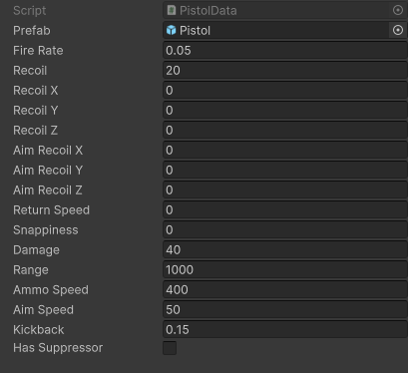Here is the gun data for my first weapon, my pistol:

Here is the data for my second gun, my first rifle:

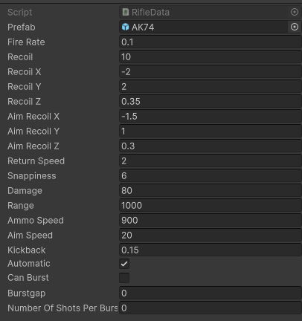

Here is the gun data for my third weapon, my shotgun:

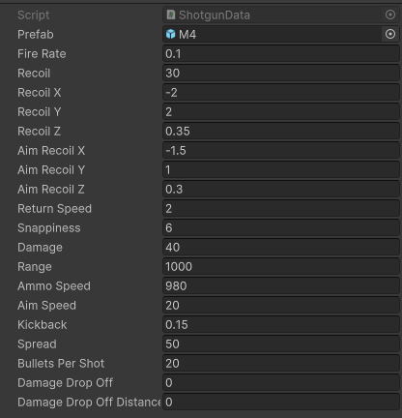

Here is my gun data for my fourth weapon, my second rifle:

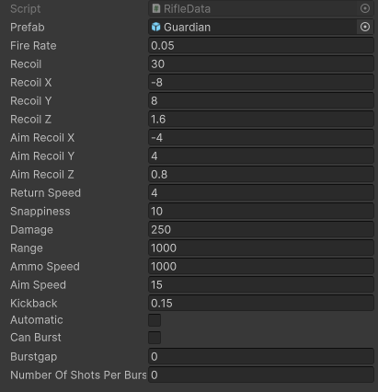

Here is my gun data for my fifth gun, my burst rifle:

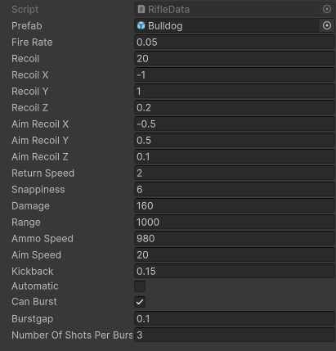

# Evaluation

## Comparing my performance against my current objectives

Below I have described how I have completed each of my objectives:

1. **Guns Attributes:**
   * + Define Physical Element (GameObject): I have successfully defined the physical aspect of guns using a GameObject prefab, ensuring a tangible representation in the game.
     + Specify Rate of Fire (fireRate): The rate of fire (shots per second) has been effectively specified for each gun type.
     + Integrate Recoil Attributes: Recoil attributes, including overall kickback, individual axis recoil, and ADS-specific recoil, have been integrated. The varying return speeds and recoil resetting enhance the realism of gun behavior.
     + Design Recoil Spray Pattern: Recoil spray patterns for my guns have been designed, adding a layer of authenticity to the shooting experience.
2. **Bullet Attributes:**
   * 2.1 - Set Bullet Speed: Bullet speed in meters per second has been successfully set, ensuring a consistent and realistic projectile motion.
3. **Aim Mechanism:**
   * 3.1 - Determine Aim Speed: The aim speed mechanism has been implemented, allowing players to experience varying speeds when aiming, enhancing gameplay dynamics.
4. **Additional Gun Feature (Rifle Specific):**
   * 4.1 - Burst and Automatic Gun Types: The distinction between burst and automatic gun types has been established, providing multible choices for players.
   * 4.2 - Specify Burst Gap: The gap between bursts has been precisely specified, influencing the rhythm and pacing of burst firing.
   * 4.3 - Define Shots in a Burst: The number of shots fired in a burst has been defined.
5. **Additional Gun Feature (Shotgun Specific):**
   * 5.1 - Integrate Spread Attribute: A spread attribute has been integrated for shotguns, affecting the dispersion of bullets upon firing.
   * 5.2 - Define Bullets Per Shot: The number of bullets fired per shot has been specified, adding realism to shotgun behavior.
6. **Static Targets (Target Behaviour):**
   * 6.1 - Targets Stay Stationary: Static targets have been implemented to remain stationary during gameplay.
   * 6.2 - Targets Have Lifetime: Targets possess a lifetime value, resetting when reaching zero.
   * 6.3 - Targets Reset on Destruction: Targets efficiently reset upon destruction by bullets, ensuring accurate score tracking.
   * 6.4 - Targets' Color Chance: The implementation of color chances for targets (red or cyan) directly influences their base score worth.
7. **Basic Moving Targets:**
   * 7.1 - Predictable Movement: Targets exhibit predictable left or right movement within a specified range.
   * 7.2 - Timely Reset: Moving targets effectively reset after a designated time.
8. **Advanced Moving Targets:**
   * 8.1 - Exponential Speed Influence: Advanced moving targets showcase an exponential speed pattern, resulting in acceleration and deceleration.
   * 8.2 - Smooth Movement Dynamics: Exponential speed introduces a smooth movement dynamic.
9. **Each Target Attribute:**
   * 9.1 - Health Attribute: All targets possess a health attribute..
   * 9.2 - Adjustable Size: Each target's size can be dynamically adjusted, offering scalability for increasing difficulty levels.
10. **Crosshair Changer:**

* 10.1 - Main Menu Option: Successfully provided players with an option in the main menu to change the crosshair.
* 10.2 - Crosshair Styles: Included a diverse selection of crosshair styles for players to choose from.
* 10.3 - Reflect Chosen Crosshair: Ensured that the chosen crosshair style is accurately reflected in the game.

1. **Exit Button:**

* 11.1 - Implementation: Implemented a functional exit button on the main menu, allowing users to exit the game.
* 11.2 - Confirmation Prompt: Implemented a confirmation prompt before exiting to prevent accidental exits.

1. **Pause Button:**

* 12.1 - In-Game Pause Button: Successfully included a pause button during gameplay, allowing players to temporarily halt the game as needed.
* 12.2 - Effective Halting: Ensured the pause button effectively halts the game, providing a responsive and user-friendly pause mechanism.
* 12.3 - Menu Overlay: Implemented a menu overlay when the game is paused, offering resume and exit options for a seamless experiance.

1. **UI Menu for Starting Tasks:**

* 13.1 - Task Selection UI: Designed a user interface for selecting and starting tasks, providing a clear and intuitive menu for task navigation.
* 13.2 - Task Options: Included options for different tasks, offering players a variety of tasks.
* 13.3 - Difficulty Selection: Provided options for different difficulty levels within the task menu, allowing players to tailor their gaming experience.

1. **HUD (Crosshair, Score, Accuracy):**

* 14.1 - Crosshair HUD: Successfully implemented a heads-up display (HUD) that includes a crosshair.
* 14.2 - Score Display: Implemented a HUD that includes a real-time updating score display, allowing players to track their progress and performance.
* 14.3 - Accuracy HUD: Successfully implemented an accuracy HUD that updates in real time, providing valuable feedback to players..

1. **Timer Display:**

* 15.1 - Timer on HUD: Implemented a timer display on the HUD during tasks, providing players with information about the remaining time or elapsed time.
* 15.2 - Clarity in Time Display: Ensured clear visibility and presentation of the time remaining or elapsed time on the HUD..

1. **Enable Jumping:**

* 17.1 - Jump Mechanic: Successfully implemented a jump mechanic, allowing the player to execute jumps within the game environment.

**Camera Movement Objectives:**

1. **Implement Free-Look Camera Movement:**

* 18.1 - Free Camera Movement: Implemented a free-look camera movement system that enables players to freely move the camera in all directions using mouse input.

**End Game Screen Objective:**

1. **End Game Screen:**

* 19.1 - Implementation: Successfully implemented an end game screen, providing players with a comprehensive display of statistics throughout the round. This screen serves as a valuable summary of the player's performance.

**Extension Objectives:**

* Game Progress Saving: Although an extension objective was mentioned regarding the ability for players to save their game progress to a file, this functionality was not implemented. After careful consideration, it was decided that the complexity of this feature outweighs its benefits for the game. Given the nature of the game and its objectives, a save game functionality may not contribute alot to the overall gameplay. So the decision was made to prioritize other essential features.

These implemented features contribute more towards the players experience. The decision not to pursue the extension objective was based on evaluating my game's design and prioritizing essential functionalities to create the best experience for the user.

## Getting feedback from my end user

Now that I have finished my game, I went back to my end-user and gave them the a chance to play it and then asked them questions about it to know how they felt about my aim trainer. Here is the questions and the responses I got.

**Player Feedback on Completed Objectives:**

**Me:** Would there be anything else you may of wanted to be added into the UI?

**EndUser:** Having a setting option may be cool or like maybe being able to change the video settings.

**Me:** Do you think there is anything else you would have wanted added to the in game UI?

**EndUser:** I think having maybe a better way to know which gun is in what slot, maybe like a small inventory or have like faded out images of the guns on the right so that you can see what guns next in the inventory.

**Me:** how do you feel about my main menu? Is there anything that you may want changed in the future?

**EndUser:** I think that the buttons and stuff work perfectly, I do like the layout but the menu does feel painfully plain, even though I specified the main menu doesn’t matter as much I do still think a bit of colour wouldn’t hurt.

**Me:** Was the keybinds in game easy to use or did you have any difficulties regarding them?

**EndUser:** I liked the controls they were very basic and mimic common game movement mechanics.

**Me:** Did you like how the task would be started in game?

**EndUser:** I do think that starting it by shooting a blank target is very unique, I find that quite cool actually and think you should keep it in the game.

**Me:** Do you like how the player has a box that they can move around in? Do you think it should be bigger?

**EndUser:** I think the boxes size is fine, I don’t think being able to sprint makes lots of sense but again it does mimic how movement is fps games work.

**Me:** What task did you enjoy the most and why?

**EndUser:** I quite enjoyed the advanced movement targets as it was quite fun how they would move, I also liked how they all sort of synced up and moved as a unit I found that quite satisfying to shoot at.

**Me:** Are there any things you would like to get redone and remade in my aim trainer?

**EndUser:** I think the crosshair selection wasn’t great, the options were very small, I would like to be able to make my own crosshair and save it instead of picking a preexisting one.

**Me:** How do you feel about my tasks?

**EndUser:** I think you should have included more tasks, that would make the game more diverse and fun.

**Me:** Did you like the gun selection you had?

**EndUser:** Yes, I did think the variety of guns was good although I didn’t think having a shotgun made much sense for an aimtrainer.

**Me:** Did you think that the difficulty changing implementation was good?

**EndUser:** I think that its good as the targets get smaller although the moving ones don’t get any faster, making them move faster may increase difficulty.

**Me:** How did you feel about the stats found at the end of the game?

**EndUser:** I was good being able to see my stats as it made me want to play again and improve my score further compared to my last attempt.

**Me:** Did you like how the player gained score?

**EndUser:** Yes, I liked watching the number go really high as it would be boring if it only went up by 1, having it go into the thousands felt epic.

After the feedback from the end user, I have gained many insights for the improvement of my aim trainer. My end user showed interest in additional features such as an in-game settings option for video adjustments, a more intuitive representation of equipped guns in the UI, and the possibility of a personalized crosshair creation option. While the main menu functionality was effective, the user suggested including some color to improve on the plainness. The straightforward keybinds were liked a lot by my end user as they resembled common game movement mechanics. The unique method on starting the task, shooting a blank target, was appreciated and recommended to keep on my aim trainer. The box size for player movement was considered big enough, though sprint functionality didn’t seem to make sense to my end user in an aim trainer, which I partially agree with. My end user liked the advanced movement targets, appreciating their synchronized movements. However, my end-user discussed how they wanted to have more tasks. The gun selection was liked, although including a shotgun for an aim trainer didn’t make sense to the end user either which I disagree with as I think it’s a cool gun to use and could be used on closer targets. The ability to change the difficulty was liked very much, though my end user suggested to increase difficulty by making moving targets based off the game difficulty. The end-game stats were appreciated as they motivated my end user to improve their score. The scoring system was satisfying to my end user as it went up so high and felt ‘epic’. Overall, my end users feedback provided valuable insights for improving the aim trainer, focusing on user interface improvements and having more task diversity.

## Improvements

Below is a list of improvements I would make if I were to improve my aim trainer based on my end users feedback.

1. **In-Game Settings Option:** Adding an in-game settings menu would address the end user's desire for control over video settings, providing a more personalized gaming experience.
2. **Enhanced Gun Inventory Display:** Introducing a small inventory or faded out images of guns in the UI could improve the user experience by making it easier to identify the equipped gun. This aligns with the end user's suggestion for a more intuitive gun selection system.
3. **Main Menu Visual Enhancement:** Incorporating a bit of color into the main menu would address the perceived plainness, enhancing the overall aesthetic appeal and potentially making the menu more engaging for the end user.
4. **Improved Crosshair Selection:** Expanding crosshair customization options, allowing users to create and save their own crosshair designs, would enhance personalization and cater to the end user's desire for a more extensive crosshair selection.
5. **Additional Tasks for Diversity:** Including more diverse tasks within the aim trainer would address the end user's desire for increased variety, contributing to a more engaging and dynamic gaming experience.
6. **Reconsideration of Shotgun Inclusion:** While the end user questioned the inclusion of a shotgun in an aim trainer, the justification for its presence could be clarified, emphasizing its usage for close-range accuracy training or specific task scenarios.
7. **Sprint Functionality Evaluation:** Considering the end user's skepticism about sprint functionality in an aim trainer, evaluating and potentially modifying this feature based on user feedback could enhance the overall realism and logic within the game.
8. **Dynamic Difficulty Adjustment for Moving Targets:** Implementing a system where the speed of moving targets increases with the game difficulty level could add an extra layer of challenge, aligning with the end user's suggestion for a more dynamic difficulty scaling.
9. **More Task Variety:** Expanding the range of tasks available within the aim trainer would fulfill the end user's desire for increased diversity, ensuring that the gaming experience remains engaging and challenging over time.
10. **Scoring System Enhancement:** While the end user appreciated the scoring system, any potential improvements or additions to make the scoring mechanics even more compelling could contribute to sustained motivation and competitiveness.

# Appendix

In this section I will include an appendix of all my code I have made for my aim trainer:

using System.Collections;

using System.Collections.Generic;

using UnityEngine;

using TMPro;

using UnityEngine.SceneManagement;

using Microsoft.Unity.VisualStudio.Editor;

// Class to manage the game state

public class GameManager : MonoBehaviour

{

#region Fields

// Singleton

private static GameManager instance = null;

private TargetManager targetManager;

// Canvas reference

private Canvas canvasReference;

// Task values

public int taskType = 0;

public float targetSizeMultiplier = 0;

// Is the task playing?

public bool taskPlaying;

// Score

private TextMeshProUGUI scoreText;

private TextMeshProUGUI accuracyText;

public float scoreValue, accuracyValue, avgTimeBetweenShots;

public int noOfShotsFired, noOfShotsMissed, noOfShotsHit;

//Timer

public TextMeshProUGUI timerText;

public float timerValue;

//Crosshair

public GameObject crosshair;

private RectTransform crosshairRectTransform;

#endregion

#region Properties

public static GameManager Instance

{

get

{

if (instance == null)

{

instance = FindObjectOfType<GameManager>();

}

return instance;

}

}

public Canvas CanvasReference()

{

return canvasReference;

}

public Transform CanvasTransform => canvasReference != null ? canvasReference.transform : null;

#endregion

#region Methods

#region UnityMethods

void Awake()

{

Initialise();

SceneManager.sceneLoaded += OnSceneLoaded;

}

void OnSceneLoaded(Scene scene, LoadSceneMode mode)

{

switch (SceneManager.GetActiveScene().buildIndex)

{

case 0:

accuracyValue = 0; noOfShotsHit = 0; noOfShotsFired = 0; noOfShotsMissed = 0; avgTimeBetweenShots = 0;

break;

case 1:

taskPlaying = false;

targetManager = FindObjectOfType<TargetManager>();

canvasReference = FindObjectOfType<Canvas>();

Transform hudTransform = canvasReference.transform.Find("HUD");

if (hudTransform != null)

{

GameObject instantiatedCrosshair = Instantiate(GameManager.Instance.crosshair, Vector3.zero, Quaternion.identity);

Transform parentTransform = canvasReference.transform.GetChild(0);

// Set parent

instantiatedCrosshair.transform.SetParent(parentTransform);

// Set local position to (0, 0, 0) relative to its parent

instantiatedCrosshair.transform.localPosition = Vector3.zero;

// Move it to the last sibling in the hierarchy

instantiatedCrosshair.transform.SetAsLastSibling();

scoreText = hudTransform.GetChild(0).GetComponent<TextMeshProUGUI>();

timerText = hudTransform.GetChild(1).GetComponent<TextMeshProUGUI>();

accuracyText = hudTransform.GetChild(2).GetComponent<TextMeshProUGUI>();

scoreText = hudTransform.GetChild(0).GetComponent<TextMeshProUGUI>();

timerText = hudTransform.GetChild(1).GetComponent<TextMeshProUGUI>();

accuracyText = hudTransform.GetChild(2).GetComponent<TextMeshProUGUI>();

}

else

{

Debug.LogError("HUD object not found under Canvas.");

}

break;

case 2:

canvasReference = FindObjectOfType<Canvas>();

canvasReference.transform.GetChild(0).GetChild(2).GetComponent<TextMeshProUGUI>().text = "Accuracy: " + accuracyValue.ToString("F2") + "%";

canvasReference.transform.GetChild(0).GetChild(3).GetComponent<TextMeshProUGUI>().text = "Shots Fired: " + noOfShotsFired.ToString();

canvasReference.transform.GetChild(0).GetChild(4).GetComponent<TextMeshProUGUI>().text = "Shots Hit: " + noOfShotsHit.ToString();

canvasReference.transform.GetChild(0).GetChild(5).GetComponent<TextMeshProUGUI>().text = "Shots Missed: " + noOfShotsMissed.ToString();

canvasReference.transform.GetChild(0).GetChild(6).GetComponent<TextMeshProUGUI>().text = "Average Time Between Accurate Shots: " + avgTimeBetweenShots.ToString("F2") + "s";

canvasReference.transform.GetChild(0).GetChild(7).GetComponent<TextMeshProUGUI>().text = "Score: " + scoreValue.ToString("F2");

taskPlaying = false;

Cursor.lockState = CursorLockMode.None;

Cursor.visible = true;

break;

default:

break;

}

}

#endregion

#region NonUnityMethods

private void Initialise()

{

if (instance == null)

{

instance = this;

DontDestroyOnLoad(this);

} else

{

Destroy(this);

}

}

public void UpdateScore()

{

scoreText.text = "Score: " + scoreValue.ToString();

accuracyValue = (noOfShotsFired > 0) ? ((float)noOfShotsHit / noOfShotsFired) * 100f : 0f;

accuracyText.text = "Accuracy: " + accuracyValue.ToString("F2") + "%";

}

public void UpdateTimer()

{

// Decrease the timer over time

timerValue -= Time.deltaTime;

// Clamp the timer to never go below 0

timerValue = Mathf.Max(timerValue, 0f);

// Update the UI text

timerText.text = "Time: " + timerValue.ToString("F2");

// Check if the timer has reached 0

if (timerValue <= 0)

{

HandleTimeUp();

}

}

private void HandleTimeUp()

{

SceneManager.LoadScene("gameOver");

avgTimeBetweenShots = Mathf.Round((60f / noOfShotsHit) * Mathf.Pow(10f, 5)) / Mathf.Pow(10f, 5);

}

#endregion

#endregion

}

using System.Collections;

using System.Collections.Generic;

using System.Runtime.CompilerServices;

using Unity.VisualScripting;

using UnityEngine;

using UnityEngine.Animations;

public class FPSGunController : MonoBehaviour

{

#region Fields

[SerializeField] private GunData[] loadout;

private GunData gunData;

private float currentcooldown;

private int currentIndex;

private int layerMask;

// Booleans

private bool gunInhand;

private bool shooting;

private bool readyToShoot;

private int currentWeaponIndex;

//shotgun

[SerializeField] int inaccuracyDistance;

// Unity Components

public Transform weaponParent;

private Transform gunTip;

private Camera mainCamera;

ParticleSystem muzzleFlash;

// Other Components

FPSCameraController cameraData;

[SerializeField] private GameObject bulletholePrefab;

private GameObject currentWeapon;

[SerializeField] private GameObject bulletPrefab;

//burstfire

[SerializeField] private int currentBurstCount;

#endregion

#region UnityMethods

void Awake()

{

gunData = loadout[0];

mainCamera = GetComponent<Camera>();

cameraData = GetComponent<FPSCameraController>();

layerMask = LayerMask.GetMask("Target", "ShootableSurface", "Ground"); // Add the "CanBeShot" layer to the layerMask

readyToShoot = true;

}

void Update()

{

float scrollWheelInput = Input.GetAxis("Mouse ScrollWheel");

if (scrollWheelInput > 0f)

{

// Scroll up, cycle to the next weapon

CycleWeapon(1);

}

else if (scrollWheelInput < 0f)

{

// Scroll down, cycle to the previous weapon

CycleWeapon(-1);

}

// Weapon selection using number keys

if (Input.GetKeyDown(KeyCode.Alpha1))

{

Equip(0);

gunInhand = true;

}

if (Input.GetKeyDown(KeyCode.Alpha2))

{

Equip(1);

gunInhand = true;

}

if (Input.GetKeyDown(KeyCode.Alpha3))

{

Equip(2);

gunInhand = true;

}

if (Input.GetKeyDown(KeyCode.Alpha4))

{

Equip(3);

gunInhand = true;

}

if (Input.GetKeyDown(KeyCode.Alpha5))

{

Equip(4);

gunInhand = true;

}

if (gunInhand == true)

{

RifleData rifleData = gunData as RifleData;

if (rifleData != null)

{

if (rifleData.automatic)

{

shooting = Input.GetKey(KeyCode.Mouse0);

}

else if (rifleData.canBurst)

{

HandleBurstShooting();

}

else

{

// Add logic for non-automatic, non-burst rifles

shooting = Input.GetKeyDown(KeyCode.Mouse0);

}

}

else

{

// Add logic for non-rifle guns

shooting = Input.GetKeyDown(KeyCode.Mouse0);

}

if (readyToShoot && shooting)

{

Shoot();

}

//recoil

//weapon position elasticity

currentWeapon.transform.localPosition = Vector3.Lerp(currentWeapon.transform.localPosition, Vector3.zero, Time.deltaTime * 4f);

//cooldown

if (currentcooldown > 0)

{

currentcooldown -= Time.deltaTime;

}

// 1/how many shots you want per second = how long it will take to reset

}

if (currentWeapon != null)

{

Aim(Input.GetMouseButton(1));

}

}

#endregion

#region NonUnityMethods

private void Shoot()

{

if (GameManager.Instance.taskPlaying) { GameManager.Instance.noOfShotsFired++; }

readyToShoot = false;

if (gunData is ShotgunData shotgunData)

{

for (int i = 0; i < shotgunData.bulletsPerShot; i++)

{

var hitSuccess = Physics.Raycast(new Ray(transform.position, GetShootingDirection()), out RaycastHit hit, gunData.range, layerMask);

if (!hitSuccess)

{

if (GameManager.Instance.taskPlaying) { GameManager.Instance.noOfShotsMissed++; }

return;

}

if (hit.collider.gameObject.layer == LayerMask.NameToLayer("Target"))

{

hit.collider.SendMessage("TakeDamage", gunData.damage, SendMessageOptions.DontRequireReceiver);

if (GameManager.Instance.taskPlaying) { GameManager.Instance.noOfShotsHit++; }

} else

{

GameObject t_newHole = Instantiate(bulletholePrefab, hit.point + hit.normal * 0.001f, Quaternion.identity);

t_newHole.transform.LookAt(hit.point + hit.normal);

if (GameManager.Instance.taskPlaying) { GameManager.Instance.noOfShotsMissed++; }

Destroy(t_newHole, 2f);

}

//bullet coming out of gun

GameObject b = GameObject.Instantiate(bulletPrefab, gunTip.position, Quaternion.identity);

b.GetComponent<BulletBehaviour>().SetTarget(hit.point, gunData.ammoSpeed);

b.SetActive(true);

}

} else

{

var hitSuccess = Physics.Raycast(new Ray(transform.position, GetShootingDirection()), out RaycastHit hit, gunData.range, layerMask);

if (!hitSuccess)

{

if (GameManager.Instance.taskPlaying) { GameManager.Instance.noOfShotsMissed++; }

return;

}

//if bullet hits a target

if (hit.collider.gameObject.layer == LayerMask.NameToLayer("Target"))

{

hit.collider.SendMessage("TakeDamage", gunData.damage, SendMessageOptions.DontRequireReceiver);

if (GameManager.Instance.taskPlaying) { GameManager.Instance.noOfShotsHit++; }

}

//if bullet doesnt hit a target

else

{

GameObject t_newHole = Instantiate(bulletholePrefab, hit.point + hit.normal * 0.001f, Quaternion.identity);

t_newHole.transform.LookAt(hit.point + hit.normal);

if (GameManager.Instance.taskPlaying) { GameManager.Instance.noOfShotsMissed++; }

Destroy(t_newHole, 2f);

}

//bullet coming out of gun

GameObject b = GameObject.Instantiate(bulletPrefab, gunTip.position, Quaternion.identity);

b.GetComponent<BulletBehaviour>().SetTarget(hit.point, gunData.ammoSpeed);

b.SetActive(true);

}

//muzzle flash

muzzleFlash.Play();

//camera recoil

cameraData.RecoilFire(Input.GetMouseButton(1));

//prefab recoil and kickback

currentWeapon.transform.Rotate(-loadout[currentIndex].recoil, 0, 0);

currentWeapon.transform.position -= currentWeapon.transform.forward * loadout[currentIndex].kickback;

//cooldown

Invoke("ResetShot", gunData.fireRate);

if (gunData is RifleData rifleData && rifleData.canBurst)

{

StartCoroutine(ShotCooldown());

}

GameManager.Instance.UpdateScore();

}

void Equip(int p_ind)

{

if (currentWeapon != null) Destroy(currentWeapon);

currentIndex = p_ind;

GameObject t_newWeapon = Instantiate(loadout[p_ind].prefab, weaponParent.position, weaponParent.rotation, weaponParent);

gunData = loadout[p_ind];

cameraData.SetRecoilValues(gunData.returnSpeed, gunData.snappiness, gunData.recoilX, gunData.recoilY, gunData.recoilZ, gunData.aimRecoilX, gunData.aimRecoilY, gunData.aimRecoilZ);

t_newWeapon.transform.localPosition = Vector3.zero;

t_newWeapon.transform.eulerAngles = Vector3.zero;

// allows the gun to be pulled out to the correct place on the screen based on the cameras orientation

t_newWeapon.transform.rotation = Camera.main.transform.rotation;

// Really stupid, means the particle system has to be the 3rd child of the 1st child of the t_newWeapon gameobject

gunTip = t_newWeapon.transform.GetChild(0).GetChild(2);

muzzleFlash = gunTip.gameObject.GetComponent<ParticleSystem>();

currentWeapon = t_newWeapon;

}

// will be how the player can ads

void Aim(bool p_isAiming)

{

Transform t_anchor = currentWeapon.transform.Find("Anchor");

Transform t_state_ads = currentWeapon.transform.Find("States/ADS");

Transform t_state_hip = currentWeapon.transform.Find("States/Hip");

if (p_isAiming)

{

// Aim

t_anchor.position = Vector3.Lerp(t_anchor.position, t_state_ads.position, Time.deltaTime * loadout[currentIndex].aimSpeed);

}

else

{

// Hip

t_anchor.position = Vector3.Lerp(t_anchor.position, t_state_hip.position, Time.deltaTime * loadout[currentIndex].aimSpeed);

}

}

void ResetShot()

{

readyToShoot = true;

}

Vector3 GetShootingDirection()

{

Vector3 targetPos = transform.position + transform.forward * gunData.range;

if (gunData is ShotgunData shotgunData) targetPos = new Vector3(

targetPos.x + Random.Range(-shotgunData.spread, shotgunData.spread),

targetPos.y + Random.Range(-shotgunData.spread, shotgunData.spread),

targetPos.z + Random.Range(-shotgunData.spread, shotgunData.spread));

Vector3 direction = targetPos - transform.position;

return direction.normalized;

}

void HandleBurstShooting()

{

if (Input.GetKeyDown(KeyCode.Mouse0) && readyToShoot)

{

if (gunData is RifleData rifleData)

{

currentBurstCount = rifleData.numberOfShotsPerBurst;

StartCoroutine(BurstShoot());

}

}

}

IEnumerator BurstShoot()

{

while (currentBurstCount > 0)

{

Shoot();

currentBurstCount--;

if (currentBurstCount > 0)

{

if (gunData is RifleData rifleData)

{

yield return new WaitForSeconds(rifleData.burstgap);

}

}

}

}

IEnumerator ShotCooldown()

{

if (gunData is RifleData rifleData)

{

yield return new WaitForSeconds(rifleData.burstgap);

}

readyToShoot = true;

}

//cycle weapons with scroll wheel

void CycleWeapon(int direction)

{

// Adjust the current weapon index based on the direction

currentWeaponIndex += direction;

// Ensure the index is within valid bounds

currentWeaponIndex = Mathf.Clamp(currentWeaponIndex, 0, loadout.Length - 1);

// Equip the weapon at the new index

Equip(currentWeaponIndex);

gunInhand = true;

}

#endregion

}

using System.Collections;

using System.Collections.Generic;

using UnityEngine;

// A class for controlling the player

public class FPSPlayerController : MonoBehaviour

{

#region Fields

[SerializeField] private LayerMask ground; // contains ground layer mask, currently layer 6

[SerializeField] private Transform groundCheck; // At base of player by default

[SerializeField] private float moveSpeed; // 4f by default

[SerializeField] private float jumpHeight; //1.25f by default

private float x; // takes x input

private float z; // takes z input

private float gravity = -9.81f; // is gravity

private Vector3 moveDirectionHorizontal; // takes inputs for char controller method

private Vector3 jumpDirection; // takes inputs for char controller method

private bool isGrounded; // bool for if we're on the ground

[SerializeField] private CharacterController charCont; // contains char controller on player

#endregion

#region Methods

#region UnityMethods

void Update()

{

HorizontalMovement();

VerticalMovement();

}

#endregion

#region NonUnityMethods

// Enacts horizontal movement and checks for input

void HorizontalMovement()

{

x = Input.GetAxis("Horizontal");

z = Input.GetAxis("Vertical");

moveDirectionHorizontal = transform.right * x + transform.forward * z;

if (Input.GetKey(KeyCode.LeftShift)) charCont.Move(moveDirectionHorizontal * (moveSpeed * 2f) * Time.deltaTime);

else charCont.Move(moveDirectionHorizontal * (moveSpeed * 2f) * Time.deltaTime);

}

// Enacts vertical movement and checks for input

void VerticalMovement()

{

groundCheck.position = transform.position + new Vector3(0, -1.44f, 0);

isGrounded = Physics.CheckSphere(groundCheck.position, 0.3f, ground);

if (isGrounded && jumpDirection.y < 0)

{

jumpDirection.y=-10f;

}

jumpDirection.y += gravity * Time.deltaTime;

if (Input.GetKeyDown(KeyCode.Space) && isGrounded)

{

jumpDirection.y = Mathf.Sqrt(jumpHeight * -2 * gravity);

}

charCont.Move(jumpDirection * jumpHeight * Time.deltaTime);

}

#endregion

#endregion

}

using System.Collections;

using System.Collections.Generic;

using UnityEngine;

using UnityEngine.SceneManagement;

public class FPSCameraController : MonoBehaviour

{

#region Fields

// Sensitivity controls the speed of camera rotation

private float sensitivity = 2.0f; // Default sensitivity

// Limit the vertical rotation angle of the camera

public float verticalRotationLimit = 80.0f;

// Store the rotation around the X (vertical) axis

private float verticalRotation = 0.0f;

// Store the rotation around the Y (horizontal) axis

private float horizontalRotation = 0.0f;

// Extra Rotations

private Vector3 currentRotation;

private Vector3 targetRotation;

// Hipfire Recoil

[SerializeField] private float recoilX;

[SerializeField] private float recoilY;

[SerializeField] private float recoilZ;

// ADS Recoil

[SerializeField] private float aimRecoilX;

[SerializeField] private float aimRecoilY;

[SerializeField] private float aimRecoilZ;

// Settings

[SerializeField] private float snappiness;

[SerializeField] private float returnSpeed;

#endregion

#region UnityMethods

// Start is called before the first frame update

void Start()

{

// Check if the current scene is the MainGame scene

if (SceneManager.GetActiveScene().name == "mainGame")

{

// Hide the cursor and lock its position

Cursor.lockState = CursorLockMode.Locked;

Cursor.visible = false;

}

}

// Update is called once per frame

void Update()

{

// Check if the current scene is the MainGame scene

if (SceneManager.GetActiveScene().name != "mainGame")

{

// If not in MainGame scene, show the cursor and unlock it

Cursor.lockState = CursorLockMode.None;

Cursor.visible = true;

return;

}

// Get the mouse input for rotation

float mouseX = Input.GetAxis("Mouse X");

float mouseY = Input.GetAxis("Mouse Y");

// Calculate the new vertical rotation angle based on mouse input and sensitivity

verticalRotation -= mouseY * sensitivity;

// Calculate the new horizontal rotation angle based on mouse input and sensitivity

horizontalRotation += mouseX * sensitivity;

// Limit the vertical rotation to avoid camera flipping

verticalRotation = Mathf.Clamp(verticalRotation, -verticalRotationLimit, verticalRotationLimit);

// Apply the vertical rotation to the camera

Vector3 totalRot = new Vector3(verticalRotation, horizontalRotation, 0);

targetRotation = Vector3.Lerp(targetRotation, Vector3.zero, returnSpeed * Time.deltaTime);

currentRotation = Vector3.Slerp(currentRotation, targetRotation, snappiness * Time.fixedDeltaTime);

transform.localRotation = Quaternion.Euler(currentRotation + totalRot);

}

#endregion

#region NonUnityMethods

public void RecoilFire(bool ads)

{

if (ads) targetRotation += new Vector3(aimRecoilX, Random.Range(-aimRecoilY, aimRecoilY), Random.Range(-aimRecoilZ, aimRecoilZ));

else targetRotation += new Vector3(recoilX, Random.Range(-recoilY, recoilY), Random.Range(-recoilZ, recoilZ));

}

public void SetRecoilValues(float t_returnSpeed, float t_snappiness, float t_recoilX, float t_recoilY, float t_recoilZ, float t_aimRecoilX, float t_aimRecoilY, float t_aimRecoilZ)

{

recoilX = t_recoilX;

recoilY = t_recoilY;

recoilZ = t_recoilZ;

aimRecoilX = t_aimRecoilX;

aimRecoilY = t_aimRecoilY;

aimRecoilZ = t_aimRecoilZ;

returnSpeed = t_returnSpeed;

snappiness = t_snappiness;

}

#endregion

}

using System.Collections;

using System.Collections.Generic;

using UnityEngine;

using UnityEngine.UI;

public class HealthComponent : MonoBehaviour

{

// Needs to have TakeDamage called from something else that raycasts it

#region Fields

// Reference to the health bar prefab

[SerializeField] GameObject healthBarPrefab;

// Reference to the instantiated health bar and its filled part (Image)

private GameObject healthBar;

private Image filledPart;

private MeshRenderer meshRenderer;

// Health-related variables

[SerializeField] private float maxHealth = 1f;

[SerializeField] private float currentHealth = 1f;

// How long we want the health bar to be visible for

float healthBarVisibleTime = 2f;

// Variables for scaling the health bar based on distance to the player

float distanceFromPlayer;

float scaleFactor;

// Set + Get

public float GetHealth() { return currentHealth; }

public float GetMaxHealth() { return maxHealth; }

public void SetHealth(float health) { currentHealth = health; }

#endregion

#region Methods

#region UnityMethods

void Start()

{

// Instantiate the health bar prefab as a child of the Canvas

healthBar = Instantiate(healthBarPrefab, GameManager.Instance.CanvasTransform);

// Get the filled part (Image) component from the health bar

filledPart = healthBar.GetComponentInChildren<Image>();

meshRenderer = GetComponent<MeshRenderer>();

// Ensure we can't see the health bar until the target is damaged

DisableHealthBar();

}

void Update()

{

// Manage the health bar appearance and behavior

ManageHealthBar();

}

void OnDestroy()

{

// Destroy the health bar when the GameObject is destroyed

if (healthBar != null) Destroy(healthBar.gameObject);

}

#endregion

#region NonUnityMethods

// Method to apply damage to the health

public void TakeDamage(float damage)

{

// Decrease the current health and reset the health bar visibility timer

currentHealth -= damage;

if (currentHealth > 0) healthBar.SetActive(true);

else healthBar.SetActive(false);

if (healthBar.activeSelf) Invoke("DisableHealthBar", healthBarVisibleTime);

}

// Method to manage the appearance and behavior of the health bar

private void ManageHealthBar()

{

if(meshRenderer.enabled == false)

{

healthBar.SetActive(false);

return;

}

// Show health fraction on the health bar

ShowHealthFraction(currentHealth / maxHealth);

// Scaling: Adjust health bar size based on the distance from the player

distanceFromPlayer = Vector3.Distance(Camera.main.transform.position, transform.position);

scaleFactor = Mathf.Clamp(1.0f / distanceFromPlayer, 0.75f, 1.0f);

healthBar.transform.localScale = new Vector3(scaleFactor, scaleFactor, 1.0f);

// Positioning: Set health bar position slightly below the GameObject

healthBar.transform.position = Camera.main.WorldToScreenPoint(transform.position - new Vector3(0, .8f, 0));

}

public void DisableHealthBar()

{

healthBar.SetActive(false);

}

// Method to show the health fraction on the health bar

private void ShowHealthFraction(float fraction)

{

filledPart.rectTransform.localScale = new Vector3(fraction, 1, 1);

}

#endregion

#endregion

}

using System.Collections;

using System.Collections.Generic;

using UnityEngine;

public class Gunsway : MonoBehaviour

{

#region Fields

[SerializeField] private float intensity;

[SerializeField] private float smooth;

private Quaternion originalRotation;

#endregion

#region UnityMethods

private void Start()

{

originalRotation = transform.localRotation;

}

private void Update()

{

UpdateSway();

}

#endregion

#region Methods

private void UpdateSway()

{

//controls

float t_x_mouse = Input.GetAxis("Mouse X");

float t_y_mouse = Input.GetAxis("Mouse Y");

//calculate target rotation

Quaternion t_x_adj = Quaternion.AngleAxis(intensity * t_x_mouse, Vector3.up);

Quaternion t_y_adj = Quaternion.AngleAxis(-intensity * t_y_mouse, Vector3.right);

Quaternion target_rotation = originalRotation * t_x_adj * t_y_adj;

//rotate towards target rotation

transform.localRotation = Quaternion.Lerp(transform.localRotation, target_rotation, Time.deltaTime * smooth);

}

#endregion

}

using UnityEngine;

using System.Collections.Generic;

public class TargetBehaviour : MonoBehaviour

{

#region Fields

protected int chance;

protected float baseScoreWorth;

protected float lifetimeValue;

protected float startingLifetimeValue = 3f;

protected float randomX;

protected float randomY;

protected float randomZ;

protected Vector3 minSpawnPosition = new Vector3(-20f, 2f, 10f);

protected Vector3 maxSpawnPosition = new Vector3(20f, 12f, 40f);

protected HealthComponent healthComponent;

protected MeshRenderer meshRenderer;

float playerAccuracy;

// List to store shot distances

List<float> shotDistances = new List<float>();

#endregion

#region Methods

#region UnityMethods

protected void Start()

{

InitialiseTarget();

}

protected void Update()

{

lifetimeValue -= Time.deltaTime;

if (lifetimeValue <= 0)

{

ResetTarget();

}

}

private void OnCollisionStay(Collision collision)

{

// Make sure we don't collide with other targets

if (collision.collider.gameObject.tag != "Target")

{

float hp = healthComponent.GetHealth();

if (hp <= 0)

{

// Calculate distance from the bullet impact point to the center of the target

float distanceToCenter = Vector3.Distance(transform.position, collision.GetContact(0).point);

// Add the distance to the list

shotDistances.Add(distanceToCenter);

// Calculate score based on standard deviation

float scoreChange = CalculateScoreBasedOnDeviation();

// Update the score

float score = GameManager.Instance.scoreValue + scoreChange;

GameManager.Instance.scoreValue = score;

GameManager.Instance.UpdateScore();

// "Kill" the target

meshRenderer.enabled = false;

Invoke("ResetTarget", 0.2f);

}

}

}

#endregion

#region NonUnityMethods

protected virtual void InitialiseTarget()

{

healthComponent = GetComponent<HealthComponent>();

meshRenderer = GetComponent<MeshRenderer>();

transform.localScale = transform.localScale * GameManager.Instance.targetSizeMultiplier;

playerAccuracy = GameManager.Instance.accuracyValue;

ResetTarget();

}

protected virtual void ResetTarget()

{

lifetimeValue = startingLifetimeValue;

playerAccuracy = GameManager.Instance.accuracyValue;

chance = Random.Range(0, 100);

if (chance <= 20)

{

meshRenderer.material.color = Color.red;

baseScoreWorth = -1f;

}

else

{

meshRenderer.material.color = new Color(0, 1, 1, 1);

baseScoreWorth = 1f;

}

randomX = Random.Range(minSpawnPosition.x, maxSpawnPosition.x);

randomY = Random.Range(minSpawnPosition.y, maxSpawnPosition.y);

randomZ = Random.Range(minSpawnPosition.z, maxSpawnPosition.z);

transform.position = new Vector3(randomX, randomY, randomZ);

healthComponent.SetHealth(healthComponent.GetMaxHealth());

meshRenderer.enabled = true;

}

// New method to calculate the score based on the standard deviation

protected float CalculateScoreBasedOnDeviation()

{

// Calculate mean

float mean = 0f;

foreach (float distance in shotDistances)

{

mean += distance;

}

mean /= shotDistances.Count;

// Calculate variance

float variance = 0f;

foreach (float distance in shotDistances)

{

variance += Mathf.Pow(distance - mean, 2);

}

variance /= shotDistances.Count;

// Calculate standard deviation

float standardDeviation = Mathf.Sqrt(variance);

// You can modify this factor based on your requirements

float deviationFactor = 1.0f;

// Calculate the score based on the standard deviation and apply the deviation factor

float score = baseScoreWorth * deviationFactor / (standardDeviation + 1);

return score;

}

#endregion

#endregion

}

using System.Collections;

using System.Collections.Generic;

using UnityEngine;

public class MovingTargetBehaviour : TargetBehaviour

{

#region Fields

[Header("Movement Settings")]

[SerializeField] protected float standardBaseSpeed = 0.01f;

[SerializeField] protected float advancedBaseSpeed = 0.01f;

[SerializeField] protected float minSpeed = 0.001f;

[SerializeField] protected float maxSpeed = 0.002f;

[SerializeField] protected float speedAmplitude = 0.01f;

protected float endDistanceFromPoint;

protected float t = 0f;

protected bool leftMoving;

protected Vector3 pointA;

protected Vector3 pointB;

protected Vector3 waypointPosition;

protected bool movingToB = true; // Indicates whether the target is moving towards point B

#endregion

#region Methods

#region UnityMethods

protected new void Start()

{

base.Start();

SetWaypoint();

}

protected new void Update()

{

base.Update();

MoveTarget();

}

#endregion

#region NonUnityMethods

protected override void InitialiseTarget()

{

base.InitialiseTarget();

if (chance > 50) leftMoving = true;

}

protected override void ResetTarget()

{

base.ResetTarget();

float spawnRange = 5f;

// Set pointA more to the left for standard movement

pointA = new Vector3(Random.Range(-spawnRange, spawnRange), randomY, randomZ);

// Reduce the distance for the standard movement

pointB = new Vector3(Random.Range(-spawnRange, spawnRange), randomY, randomZ);

movingToB = true; // Start by moving towards point B

}

protected virtual void MoveTarget()

{

t += Time.deltaTime;

float distance = Vector3.Distance(pointA, pointB);

float totalDuration = distance / standardBaseSpeed;

// Calculate the position based on constant speed

Vector3 newPosition;

if (movingToB)

newPosition = Vector3.Lerp(pointA, pointB, t / totalDuration);

else

newPosition = Vector3.Lerp(pointB, pointA, t / totalDuration);

// Update the position

transform.position = newPosition;

if (t >= totalDuration)

{

SetWaypoint();

t = 0f;

movingToB = !movingToB; // Change direction

}

}

protected virtual void SetWaypoint()

{

t = 0.0f;

float randomFactor = Random.Range(0.3f, 0.7f);

// Choose the destination based on the current direction

waypointPosition = movingToB ? Vector3.Lerp(pointA, pointB, randomFactor) : Vector3.Lerp(pointB, pointA, randomFactor);

}

// Easing function for smooth acceleration and deceleration

protected float EaseInOutQuad(float t)

{

return t < 0.5 ? 2 * t * t : -1 + (4 - 2 * t) * t;

}

#endregion

#endregion

}

using System.Collections;

using System.Collections.Generic;

using UnityEngine;

public class AdvancedTargetBehaviour : MovingTargetBehaviour

{

// Start is called before the first frame update

private new void Start()

{

base.Start();

}

// Update is called once per frame

private new void Update()

{

base.Update();

}

protected override void MoveTarget()

{

t += Time.deltaTime;

// Calculate the current speed using an exponential function

float currentSpeed = Mathf.Clamp(advancedBaseSpeed + Mathf.Exp(t * speedAmplitude) * speedAmplitude, minSpeed, maxSpeed);

// Use an easing function for smoother acceleration and deceleration

float easedT = base.EaseInOutQuad(t);

Vector3 newPosition = Vector3.Lerp(transform.position, waypointPosition, easedT * currentSpeed);

// Update the position

transform.position = newPosition;

if (t >= 1.0f)

{

SetWaypoint();

t = 0f;

movingToB = !movingToB; // Change direction

}

}

}

using System.Collections;

using System.Collections.Generic;

using UnityEngine;

public class BulletBehaviour : MonoBehaviour

{

private bool dealtWith;

private Vector3 target;

private float bulletSpeed;

private Rigidbody rigidbodyComponent;

void Awake()

{

rigidbodyComponent = GetComponent<Rigidbody>();

}

/// <summary>

/// This function is called when the object becomes enabled and active.

/// </summary>

void OnEnable()

{

rigidbodyComponent.AddForce(Vector3.Normalize(target - transform.position) * bulletSpeed, ForceMode.VelocityChange);

}

void OnDisable()

{

rigidbodyComponent.velocity = Vector3.zero;

}

public void SetTarget(Vector3 t, float bs)

{

target = t;

bulletSpeed = bs;

}

void OnCollisionStay(Collision other)

{

Destroy(gameObject);

}

void OnCollisionExit(Collision other)

{

Destroy(gameObject);

}

}

using System.Collections;

using System.Collections.Generic;

using UnityEngine;

public class TargetManager : MonoBehaviour

{

// Class needs to instantiate targets and destroy targets as needed

// Acts as object pooler

#region Fields

int noOfActiveTargets;

float enableTimerValue;

float startingEnableTimerValue;

float timerValue;

float startingTimerValue = 60f;

[SerializeField] private int noOfTargets = 5;

private GameObject[] targets = new GameObject[5];

[SerializeField] private GameObject targetPrefab;

[SerializeField] private GameObject movingTargetPrefab;

[SerializeField] private GameObject complexTargetPrefab;

#endregion

#region Methods

#region UnityMethods

void Start()

{

timerValue = startingTimerValue;

enableTimerValue = 5f;

TaskInitialisation();

}

// Update is called once per frame

void Update()

{

GameManager.Instance.timerValue = timerValue;

GameManager.Instance.UpdateTimer();

if (GameManager.Instance.taskPlaying)

{

TargetManagement();

}

}

#endregion

#region NonUnityMethods

private void TaskInitialisation()

{

switch (GameManager.Instance.taskType)

{

case 0:

for (int i = 0; i < noOfTargets; i++)

{

GameObject newTarget = Instantiate(targetPrefab, new Vector3(0, -10, 0), Quaternion.identity);

newTarget.SetActive(false);

targets[i] = newTarget;

}

break;

case 1:

for (int i = 0; i < noOfTargets; i++)

{

GameObject newTarget = Instantiate(movingTargetPrefab, new Vector3(0, -10, 0), Quaternion.identity);

newTarget.SetActive(false);

targets[i] = newTarget;

}

break;

case 2:

for (int i = 0; i < noOfTargets; i++)

{

GameObject newTarget = Instantiate(complexTargetPrefab, new Vector3(0, -10, 0), Quaternion.identity);

newTarget.SetActive(false);

targets[i] = newTarget;

}

break;

default:

Debug.Log("Something's wrong.");

break;

}

}

private void TargetManagement()

{

timerValue -= Time.deltaTime;

if (timerValue <= 0)

{

for (int i = 0; i < targets.Length; i++)

{

targets[i].SetActive(false);

}

GameManager.Instance.taskPlaying = false;

timerValue = startingTimerValue;

}

else

{

enableTimerValue += Time.deltaTime;

if (enableTimerValue > 5f && noOfActiveTargets < targets.Length)

{

targets[noOfActiveTargets].SetActive(true);

enableTimerValue = startingEnableTimerValue;

noOfActiveTargets++;

}

}

}

#endregion

#endregion

}

using UnityEngine;

[CreateAssetMenu(fileName = "NewGunData", menuName = "GunType/GunData")]

public class GunData : ScriptableObject

{

[Tooltip("Physical element of the gun")]

public GameObject prefab;

[Tooltip("The rate of fire of the gun in shots per second.")]

public float fireRate;

[Tooltip("The recoil value for the gun transform, actualises kickback")]

public float recoil;

[Tooltip("The amount of x,y,z axis recoil experienced after each shot.")]

public float recoilX, recoilY, recoilZ;

[Tooltip("The amount of x,y,z axis recoil experienced after each shot while in ADS.")]

public float aimRecoilX, aimRecoilY, aimRecoilZ;

[Tooltip("How fast the gun resets after said recoil.")]

public float returnSpeed, snappiness;

[Tooltip("The damage inflicted by each bullet.")]

public float damage;

[Tooltip("The range of the gun.")]

public float range;

[Tooltip("The speed our bullets travel at in m/s.")]

public float ammoSpeed;

[Tooltip("How fast the gun will aim in.")]

public float aimSpeed;

[Tooltip("How much the gun kicks back.")]

public float kickback;

}

using System.Collections;

using System.Collections.Generic;

using UnityEngine;

[CreateAssetMenu(fileName = "NewPistolData", menuName = "GunType/PistolData")]

public class PistolData : GunData

{

[Tooltip("If it has a suppresor.")]

public bool hasSuppressor;

}

using System.Collections;

using System.Collections.Generic;

using UnityEngine;

[CreateAssetMenu(fileName = "NewShotgunData", menuName = "GunType/ShotgunData")]

public class ShotgunData : GunData

{

[Tooltip("The spread or deviation of bullets when fired.")]

public float spread;

[Tooltip("Number of bullets fired on each shot")]

public int bulletsPerShot;

[Tooltip("The multiplier for decreasing damage over distance")]

public float damageDropOff;

[Tooltip("Distance that damage starts to decrease at")]

public float damageDropOffDistance;

// some kind of value to indicate spray pattern

}

using System.Collections;

using System.Collections.Generic;

using UnityEngine;

[CreateAssetMenu(fileName = "NewRifleData", menuName = "GunType/RifleData")]

public class RifleData : GunData

{

[Tooltip("Whether the gun is automatic or semi-automatic.")]

public bool automatic;

[Tooltip("Whether the gun can burst fire or not")]

public bool canBurst;

[Tooltip("Gap inbetween each burst.")]

public float burstgap;

[Tooltip("Number of shots fired in a burst")]

public int numberOfShotsPerBurst;

}

using System.Collections;

using System.Collections.Generic;

using UnityEngine;

public class TargetData : ScriptableObject

{

float moveSpeed;

float health;

}

using System.Collections;

using System.Collections.Generic;

using UnityEngine;

using UnityEngine.SceneManagement;

using UnityEngine.UI;

public class ButtonFunctions : MonoBehaviour

{

bool difficultyWasSet = false, taskTypeWasSet = false;

[SerializeField] GameObject crosshair1, crosshair2, crosshair3, crosshair4;

// Variable to store the selected crosshair temporarily

private GameObject selectedCrosshair;

public void LoadTaskScene()

{

if (difficultyWasSet && taskTypeWasSet)

{

SceneManager.LoadScene(1);

}

}

public void BasicButtonClickEvent()

{

GameManager.Instance.taskType = 0;

taskTypeWasSet = true;

}

public void MovingButtonClickEvent()

{

GameManager.Instance.taskType = 1;

taskTypeWasSet = true;

}

public void MovingPlusButtonClickEvent()

{

GameManager.Instance.taskType = 2;

taskTypeWasSet = true;

}

public void EasyButtonClickEvent()

{

GameManager.Instance.targetSizeMultiplier = 1;

difficultyWasSet = true;

}

public void NormalButtonClickEvent()

{

GameManager.Instance.targetSizeMultiplier = 0.8f;

difficultyWasSet = true;

}

public void HardButtonClickEvent()

{

GameManager.Instance.targetSizeMultiplier = 0.6f;

difficultyWasSet = true;

}

public void Crosshair1Changer()

{

selectedCrosshair = crosshair1;

Debug.Log("Selected Crosshair: Crosshair1");

}

public void Crosshair2Changer()

{

selectedCrosshair = crosshair2;

Debug.Log("Selected Crosshair: Crosshair2");

}

public void Crosshair3Changer()

{

selectedCrosshair = crosshair3;

Debug.Log("Selected Crosshair: Crosshair3");

}

public void Crosshair4Changer()

{

selectedCrosshair = crosshair4;

Debug.Log("Selected Crosshair: Crosshair4");

}

public void ApplyCrosshair()

{

if (selectedCrosshair != null)

{

GameManager.Instance.crosshair = selectedCrosshair;

Debug.Log("Crosshair Applied: " + selectedCrosshair.name);

}

else

{

Debug.LogError("No crosshair selected. Please select a crosshair before applying.");

}

}

}

using UnityEngine;

using UnityEngine.UI;

public class DisableSection : MonoBehaviour

{

public Button toggleButton;

public GameObject imagePanel1;

public GameObject imagePanel2;

void Start()

{

// Add a listener to the button click event

toggleButton.onClick.AddListener(ToggleSections);

}

// Function to toggle visibility and enable/disable of image panels

void ToggleSections()

{

// Toggle visibility and enable/disable of image panel 1 and its children

ToggleVisibilityAndEnable(imagePanel1, false);

// Toggle visibility and enable/disable of image panel 2 and its children

ToggleVisibilityAndEnable(imagePanel2, true);

}

// Function to toggle visibility and enable/disable of a GameObject and its children

void ToggleVisibilityAndEnable(GameObject go, bool enable)

{

if (go != null)

{

// Set the visibility

go.SetActive(enable);

// Set the visibility for all children recursively

foreach (Transform child in go.transform)

{

ToggleVisibilityAndEnable(child.gameObject, enable);

}

}

}

}

using System.Collections;

using System.Collections.Generic;

using UnityEditor;

using UnityEngine;

using UnityEngine.SceneManagement;

public class ExitAndSceneChange : MonoBehaviour

{

public void ExitGameFunction()

{

Debug.Log("game exit");

#if UNITY_EDITOR

EditorApplication.ExitPlaymode();

#else

Application.Quit();

#endif

}

public void ChangeScene()

{

SceneManager.LoadScene("mainMenu");

}

}

using System.Collections;

using UnityEngine;

public class PauseScript : MonoBehaviour

{

[SerializeField] private GameObject HUD;

[SerializeField] private GameObject pauseMenu;

[SerializeField] private GameObject player; // Reference to the player GameObject

// Reference to the GunManager script

private FPSGunController FPSgunController;

// Reference to the CameraController script

private FPSCameraController FPScameraController;

private bool isPaused;

private void Start()

{

SetPauseMenuState(false);

SetHUDState(true);

CursorControl();

// Get references to the GunManager and CameraController scripts on the player object

if (player != null)

{

FPSgunController = player.GetComponentInChildren<FPSGunController>();

FPScameraController = player.GetComponentInChildren<FPSCameraController>();

}

else

{

Debug.LogError("Player reference not set in the inspector!");

}

}

private void Update()

{

if (Input.GetKeyDown(KeyCode.Escape))

{

if (isPaused)

{

ResumeGame();

}

else

{

PauseGame();

}

}

}

private void PauseGame()

{

SetPauseMenuState(true);

SetHUDState(false);

Time.timeScale = 0f;

isPaused = true;

CursorOff();

if (FPSgunController != null)

{

FPSgunController.enabled = false;

}

if (FPScameraController != null)

{

FPScameraController.enabled = false;

}

}

private void ResumeGame()

{

SetPauseMenuState(false);

SetHUDState(true);

Time.timeScale = 1f;

isPaused = false;

CursorControl();

if (FPSgunController != null)

{

FPSgunController.enabled = true;

}

if (FPScameraController != null)

{

FPScameraController.enabled = true;

}

}

private void CursorControl()

{

Cursor.visible = false;

Cursor.lockState = CursorLockMode.Locked;

}

private void CursorOff()

{

Cursor.visible = true;

Cursor.lockState = CursorLockMode.None;

}

private void SetPauseMenuState(bool state)

{

if (pauseMenu != null)

{

pauseMenu.SetActive(state);

}

}

private void SetHUDState(bool state)

{

if (HUD != null)

{

HUD.SetActive(state);

}

}

}